
Centers for Medicare & Medicaid Services (CMS)
CCIIO Enrollment Resolution & Reconciliation (ER&R), Form 1095-A Data Reporting
Volume I – Technical Proposal

Request for Quote (RFQ): 75FCMC26Q0068
May 07, 2026
Submitted By:
Deloitte Consulting LLP | 1919 North Lynn Street | Arlington, VA 22209

Centers for Medicare & Medicaid Services (CMS)
CCIIO Enrollment Resolution & Reconciliation (ER&R), Form 1095-A Data Reporting
Request for Quote (RFQ): 75FCMC26Q0068
Volume I – Technical Proposal
May 07, 2026
Submitted by:

Deloitte Consulting LLP , 1919 North Lynn Street, Arlington, VA 22209

Submitted to:
Amberly Kovalick, Contracting Officer
Email: Amberly.Kovalick@cms.hhs.gov.
Megan Famodu, Contract Specialist
Email: Megan.Famodu @cms.hhs.gov
DIV OF MEDICARE & MARKETPLACE CONTRACTS,
CMS - OAGM
7500 SECURITY BOULEVARD, MS: B3-30-03
BALTIMORE, MD 21244-1850

Submitted by:
Technical POC and  Authorized Negotiator:  Matt Siegel, Managing Director  Tel. +1 (617) 437-2646  Email: masiegel@deloitte.com | Contracts POC:  Teresa Sage, Contracts Administrator  Tel. +1 (571) 814-7707  Email: tsage@deloitte.com  Reference Number: JO-069714

This proposal or quotation includes data that shall not be disclosed outside of the Government and shall not be duplicated, used, or disclosed in whole or in part for any purpose other than to evaluate this proposal or quotation. If, however, a contract is awarded to this Offeror or Quoter as a result of or in connection with the submission of this data, the Government shall have the right to duplicate, use, or disclose the data to the extent provided in the resulting contract. This restriction does not limit the Government’s right to use information contained in this data if it is obtained from other sources without restriction. The data subject to this restriction are contained in this entire proposal.

May 07, 2026
Amberly Kovalick, Contracting Officer
Megan Famodu, Contract Specialist
DIV OF MEDICARE & MARKETPLACE CONTRACTS,
CMS - OAGM
7500 SECURITY BOULEVARD, MS: B3-30-03
BALTIMORE, MD 21244-1850
RE: | Request for Proposal (RFP): 75FCMC26Q0068, CCIIO Enrollment Resolution & Reconciliation (ER&R), Form 1095-A Data Reporting
Dear Ms. Kovalick and Ms. Famodu:
Deloitte is pleased to submit our proposal to provide Enrollment Resolution & Reconciliation (ER&R), Form 1095-A Data Reporting to the Centers for Medicare & Medicaid Services (CMS). We believe that our submission meets all of the requirements of the request, and demonstrates that Deloitte possesses the required level of skill and experience to perform the Statement of Work (SOW).
We are excited by the prospect of working with you, and we hope our proposal conveys our enthusiastic commitment to provide distinctive client service and highly specialized talent to this project. Our submission consists of 4 volumes: Volume I: Technical Quote, Volume II: Business Quote, Volume III: Conflict of Interest, and Volume IV: Section 508 Compliance.
We look forward to working with you to achieve optimum value to Centers for Medicare & Medicaid Services (CMS). If you have any questions or require additional information, please contact me at +1 (617) 437-2646. Should you have any contractual questions, please contact Teresa Sage, Contracts Administrator, +1 (571) 814-7707.
Sincerely,

Matt Siegel, Managing Director
Deloitte Consulting LLP

Table of Contents
1.0 Section 1: Technical Understanding and Approach (Total 40 Pages) 1
1.1 Sub-Section 1A: Understanding of CMS’ Program and Acquisition Objectives 1
1.2 Sub-Section 1B: Approach to Performing the Requirements in the SOW 1
1.2.1 Task 2: ER&R Issuer Disputes ^{(SOW 3.2)} 1
1.2.2 Task 3: Form 1095-A Consumer Disputes ^{(SOW 3.3)} 1
1.2.3 Task 4: Complex Case Help Center (CCHC) ^{(SOW 3.4)} 1
1.2.4 Task 5: Updating the FFE ^{(SOW 3.5)} 1
1.2.5 Task 6: Notice Generation ^{(SOW 3.6)} 1
1.2.6 Task 7: Telephone and Correspondence Support ^{(SOW 3.7)} 1
1.2.7 Task 8: IT Systems ^{(SOW 3.8)} 1
1.2.8 Task 9: Standard Operating Procedures (SOPs) Business Requirements and Quality Assurance^{(SOW 3.9)} 2
1.2.9 Task 10: Ad Hoc Work and Special Projects^{(SOW 3.10)} 2
1.3 Sub-Section 1C: Understanding and Mitigation of Risks 2
2.0 Section 2: Management Approach, Quality Assurance and Surveillance Plan, and Staffing Plan 3
2.1 Sub-Section 2A: Management Approach 3
2.1.1 Task 1: Program Implementation and Oversight (PI&O) ^{(SOW 3.1)} 3
2.1.2 Task 11: Transition-Out (Optional) ^{(SOW 3.11)} 3
2.1.3 Task 12: Transition-In (Optional) ^{(SOW 3.12)} 3
2.2 Sub-Section 2B: Quality Assurance Approach 3
2.3 Sub-Section 2C: Staffing Plan 4
3.0 Section 3: Key Personnel Qualifications and Corporate Experience 4
3.1 Sub-Section 3A: Key Personnel Qualifications 4
3.2 Sub-Section 3B: Corporate Experience 5
4.0 Section 4: Small Business Utilization (5 Pages) 1
Appendix A Key Personnel Resumes (2 Pages Each) A-1
A.1 Project Director A-1
A.2 Project Manager (ER&R) A-2
A.3 Project Manager (Form 1095-A & CCHC) A-3
A.4 Project Manager (IT Data and Technical Support) A-4
A.5 Technical Director A-5
A.6 Security and Privacy Officer A-6
1.0 Heading 1 Style example 1
1.1 Heading 2 1
1.1.1 Heading 3 1
List of Acronyms and Abbreviations 8
Compliance Matrix 10
List of Figures
Figure X.X-X. Provide Title. 1

List of Tables
Table X.X-X. Provide Title. 1

1.0 Section 1: Technical Understanding and Approach (Total 40 Pages)

1.1 Sub-Section 1A: Understanding of CMS’ Program and Acquisition Objectives (1 Page)
Our approach to this requirement aligns directly with the core mission of the Centers for Medicare & Medicaid Services (CMS) and the Center for Consumer Information and Insurance Oversight (CCIIO): to implement the Affordable Care Act's private insurance provisions and ensure Americans have reliable access to high-quality, affordable healthcare. We recognize that robust enrollment resolution and reconciliation (ER&R) is the operational linchpin of this mandate. Resolving data discrepancies across the Federal Data Services Hub, State-Based Marketplaces, and the issuer community is far more than an administrative IT task. It is the vital mechanism that keeps over 24 million Marketplace enrollees connected to their doctors, ensures Advance Premium Tax Credits (APTC) are perfectly calibrated, and prevents devastating tax liabilities. Team Deloitte is committed to bringing a refreshed methodology to sustain and modernize these mission-critical workstreams — treating program integrity not as a compliance obligation layered on top of operations, but as a design principle embedded in every platform control, business rule, workflow, and quality checkpoint — proactively identifying and neutralizing fraud, waste, and abuse before it propagates into casework, payments, or tax reporting, safeguarding federal taxpayer dollars and the health and financial security of consumers.
We bring a 360-degree perspective to this challenge, built upon our successful delivery of resolution and reconciliation solutions for five State-Based Marketplaces (SBMs) and leading national issuers such as Anthem and Kaiser Permanente. To address the full scope of CCIIO’s Statement of Work, we scale this state and commercial agility to the federal level by deploying a frontline workforce of highly experienced caseworkers equipped with modernized telephony and omnichannel support systems. By combining this human-centric operational expertise with comprehensive systems integration, advanced data analytics to detect and prevent improper payments, and Agile delivery, we ensure complex consumer disputes and Form 1095-A inquiries are resolved swiftly and accurately. Today, CMS, HHS, and the IRS trust Deloitte to secure, stabilize, and innovate their most complex, large-scale operations.
We understand a primary objective for this acquisition is to partner with a System Integrator capable of maintaining the operational stability of the ER&R program while actively driving innovation, efficiency, and continuous improvement to achieve the following:
Strategic Objective | Strategic Outcome
Uncompromising Enrollment Data Integrity | Deloitte will serve as the central steward of enrollment and financial data accuracy across the Federally facilitated Exchange (FFE) and all State-Based Exchanges (SBEs). We will systematically reconcile issuer data, accelerate discrepancy resolution, and ensure all corrections are seamlessly synchronized with the FFE. By empowering issuers to resolve disputes efficiently, we facilitate timely, accurate payments and enable the rapid cancellation of erroneous enrollments. Our ultimate outcome: the right enrollee is in the correct plan, receiving the precise amount of financial assistance, month after month.
Seamless Consumer Experience & Tax Accuracy | Deloitte will safeguard Marketplace enrollees' ability to file their federal taxes accurately and maintain their health coverage without disruption. We will resolve Form 1095-A disputes with urgency and precision—dynamically scaling our workforce to meet peak tax-season demands. Furthermore, we will ensure that consumers facing the most complex enrollment barriers receive dedicated, expert assistance through the Complex Case Help Center (CCHC), delivering lasting root-cause resolutions rather than mere case closures.
Technology modernization & AI innovation | Deloitte will continuously advance the technical capabilities that power the ER&R mission. We will modernize core systems—including CERRS, HICS, SEED, and EDA CORE—on a secure, Azure cloud-native architecture. To accelerate discrepancy resolution and system maintenance, we will integrate AI-driven innovations to streamline complex operational activities, ensuring full algorithmic transparency is documented in the PIOP. Concurrently, we will build an advanced data analytics infrastructure that empowers CMS and issuers with real-time visibility into enrollment alignment. We will treat every Agile release cycle as a strategic opportunity to reduce manual burden, improve system reliability, and deliver measurable, rapid-turnaround efficiency gains to the program.
Uncompromising Security, Privacy & Regulatory Compliance | Deloitte will partner with CCIIO to rigorously safeguard the sensitive personal, health, and tax information (PII, PHI, and FTI) entrusted to the ER&R program. To protect the system infrastructure from malicious users and evolving cyber threats, we will implement proactive, robust defenses while achieving strict security compliance. We will maintain continuous Authorizations to Operate (ATOs) without disruption and ensure our entire workforce is fully vetted and credentialed prior to accessing any CMS system. We commit to executing rapid incident response protocols within stipulated SLAs, treating the defense of enrollee data not merely as a compliance obligation, but as a fundamental commitment to the security and trust of the CMS and CCIIO.
Excellence in Program management & stakeholder partnership | Deloitte will operate as a true partner to CMS, ensuring complete, real-time visibility into the health of the ER&R program. Through disciplined governance and proactive communication, we will execute deliverables flawlessly, anticipating and mitigating risks before they materialize into issues. We are acutely aware of the stakes of contractor transitions; we will manage every phase of the handover with rigorous precision, guaranteeing that operational changes never translate into disruptions for the 24 million people relying on the Marketplace.
Protect against fraud, waste, and abuse

1.2 Sub-Section 1B: Approach to Performing the Requirements in the SOW (Total 18 Pages)
[avoid restating requirements – describe how work will be executed – end-to-end operating model, workflows, governance and tools]

1.2.1 Task 2: ER&R Issuer Disputes ^{(SOW 3.2)} (2 Pages)
Deloitte’s operating philosophy follows a deliberate phased approach to inheriting the ongoing ER&R operations. In the first horizon, Deloitte team is ready to deliver operational stability from Day 1; smooth transition, no disruption to in-flight cases, and serving consumers is a responsibility we do not take lightly. We achieve this through collaboratively working with CMS and its contractors, issuers, executing a smooth knowledge transfer and the use of technology provide additional system insight above and beyond what is already documented in the SOPS. Deloitte applies structured assessment and optimization -- improving rule performance, refining staffing models, and strengthening program intelligence -- with CMS visibility and approval at each step.
Program integrity is not a compliance layer in this operating model. It is a design principle embedded in every task from Day 1. Audit-ready case documentation, documented approval before any override or batch correction, elevated QA sampling for high-risk case types, and a cross-task integrity risk register established during transition-in are operational standards, not periodic reviews. Deloitte will surface integrity findings to CMS with root cause analysis and recommended corrective action -- not after an audit, but as a routine output of the operating model.

Shared Transition-In Approach: Tasks 2, 3, and 4
Deloitte operates ER&R, 1095-A and Complex Cases as an integrated ER&R program. An issuer data error becomes a payment dispute in Task 2 and a consumer tax problem in Task 3. An upstream system condition appears in Task 4 before it surfaces in aggregate dispute data. Deloitte's operational approach makes those connections visible in real time -- one coordinated response, one CMS briefing.
Deloitte will be operationally ready before the first case transfers. The transition-in approach -- detailed under Task 12 -- validates every system, workflow, and intake pipeline against live production behavior. Deloitte deploys TruNorth, our proprietary GenAI platform, to independently capture rule logic, routing rules, and classification behavior directly from source code across all tasks simultaneously -- producing a system understanding that supplements what is shared through SOPs and KT. This will give CMS the confidence in the transition being built on the solid foundation. Every function is validated through a structured readiness gate before going live, with progress confirmed through a daily cross-task dashboard that makes readiness visible and measurable to CMS throughout the transition period.
Deloitte brings pre-existing knowledge of the enrollment reconciliation and 1095-A through our work with the States and issuers and staffs each task with personnel who arrive scenario-trained on the actual case types, system configurations, and issuer patterns they will encounter. Each task's Key Personnel leads the knowledge transfer process for their workstream. The knowledge transfer model moves through four structured stages before any caseworker handles a live case. From Day 1, a weekly cross-task data share connects all three teams so patterns that originate in one workstream and surface in another are coordinated as a single corrective action -- not discovered independently weeks apart.
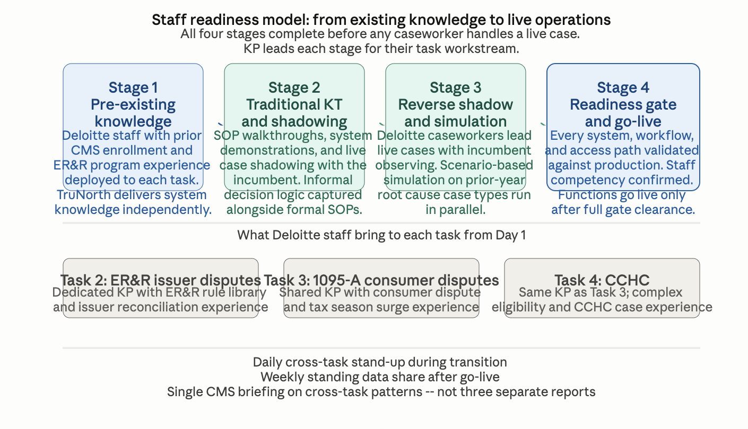
An integrity risk register covering all three tasks is established during transition-in, with control points and escalation playbooks for high-risk workflows documented before Day 1.
What the incumbent cannot offer at transition: The incumbent's knowledge of how these systems actually operate is experiential and partially captured in SOPs. TruNorth captures the same knowledge from the source code in weeks, independently, across all three tasks simultaneously. Deloitte arrives at contract start with a system understanding that the incumbent took years to accumulate -- and a daily transition cadence that makes readiness visible and measurable rather than assumed.

[Our Understanding]
Issuers depend on the ER&R dispute process to keep their enrollment and payment records aligned with the FFE. When the process runs well, issuers can reconcile efficiently, payment data stays accurate, and the downstream effects on consumer 1095-A forms and APTC payments remain clean. When it does not, the consequences compound: unresolved payment disputes create issuer financial exposure, enrollment mismatches produce incorrect tax statements, and the volume of downstream consumer disputes grows. The operational standard for this workstream is accuracy, consistency, and a feedback loop that tells CMS where the upstream reconciliation process is breaking down before the downstream consequences appear.
What makes this workstream hard to run well is the simultaneous demand for automation at scale and judgment in complexity. The approximately four million low-complexity disputes processed annually require a rule library that is accurate, well-maintained, and monitored at the dispute-type level -- not in aggregate. The high-complexity workload, including UIRs, PDI disputes, and cases requiring manual enrollment reconstruction, demands caseworker judgment that is consistent, documented, and auditable. Deloitte has operated high-consequence, rule-governed enrollment and payment environments at scale in federal health programs -- [insert relevant proof point program names here]. Our California SBE Maintenance and Operations takeover in 2019 is a direct precedent: Deloitte inherited a live operational system, validated production behavior independently of prior contractor documentation, and improved performance without disrupting the ongoing operation.

[Our Approach]
Deloitte operates Tasks 2.1 and 2.2 as a single integrated function — automated rule-based resolution at scale on the left, structured manual casework on the right, with exceptions flowing between them and dispute intelligence continuously feeding upstream improvements. The model below shows how both lanes operate and how what Deloitte learns from running them makes the program measurably better over time.
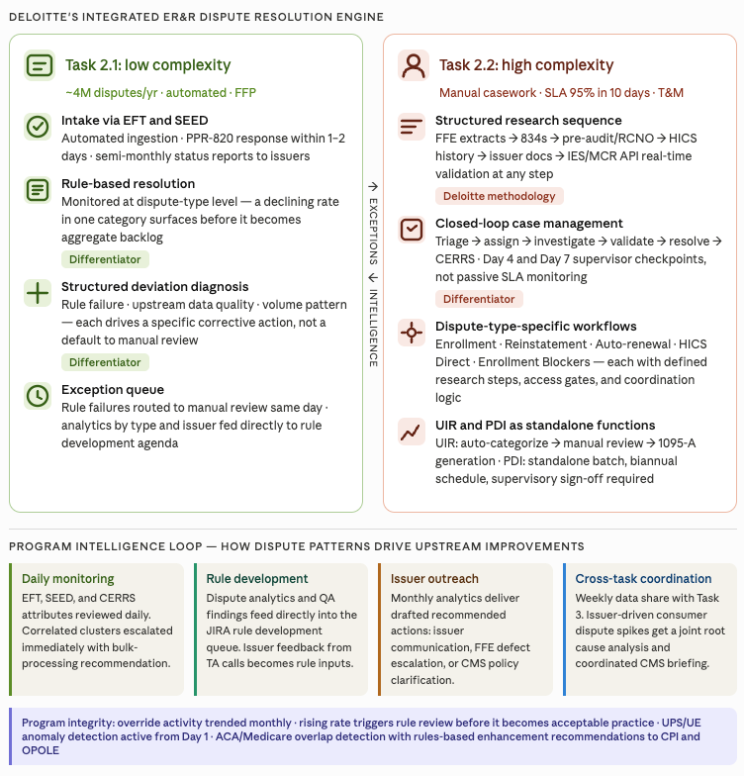

Low complexity (Task 2.1)
Deloitte will operate the automated rule library from Day 1 at the performance baseline established during transition-in. When a resolution rate deviates, Deloitte will diagnose whether the cause is a rule performance failure, an upstream data quality issue, or a volume pattern the rule was not designed to handle — each drives a different corrective action. The dispute analytics deliverable serves as both a CMS reporting output and Deloitte’s internal rule development agenda, made visible to CMS.
Enhancing automated rule library
Deloitte will manage the business rule library as a governed lifecycle: every rule change moves through a structured process shown below.

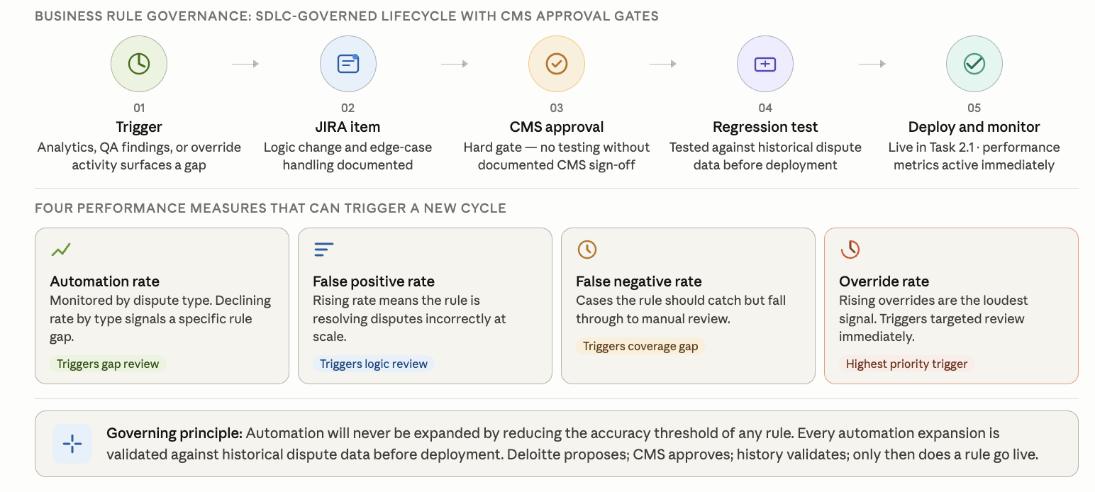

High complexity (Task 2.2): closed-loop case management
Deloitte manages every high-complexity case through a closed-loop workflow with governance gates at each stage. The process flow and research sequence below show how each case moves from intake to CERRS closure, and how supervisors intervene timely so disputes are resolved within the specified time.

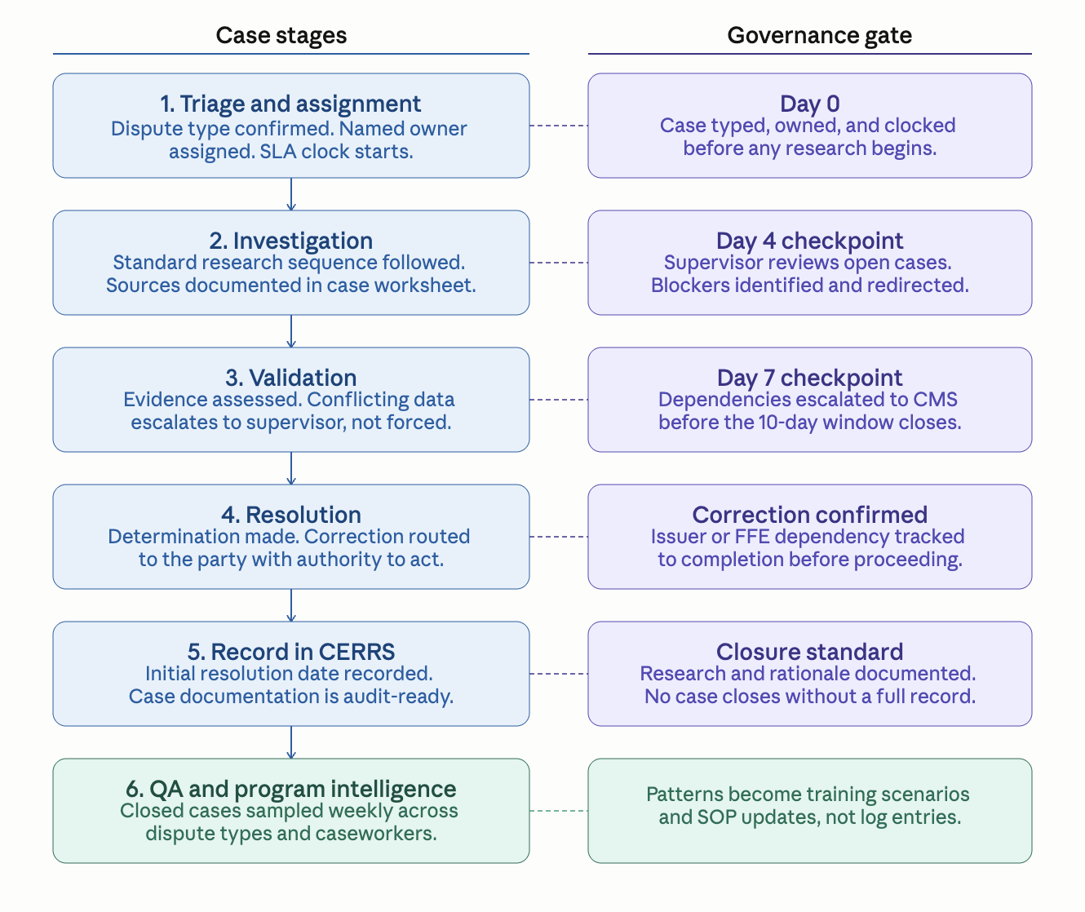
Deloitte's participation in daily operational reconciliation workgroup calls is an intelligence input, not an attendance obligation. Issues surfaced in those calls feed directly into the JIRA rule development backlog and the dispute analytics cycle, so CMS can remain confident that dispute patterns are being addressed methodically. Below is Deloitte’s approach to processing various dispute types.
Dispute type | Deloitte’s approach
Enrollment, Reinstatement, Auto-renewal, HICS Direct | Defined research steps per type: FFE extracts, 834s, pre-audit/RCNO, HICS history, issuer docs, IES/MCR API real-time validation at any step. Access gates and coordination logic applied to each.
Enrollment Blockers | Sustained cross-contractor coordination required. Deloitte tracks dependencies and drives resolution rather than waiting for external parties.
UIR records | UIR categorization accuracy matters because the category determines the issuer's resolution path — a miscategorized record generates a second dispute cycle. Deloitte's manual review step for uncategorized UIRs applies documented decision criteria rather than individual caseworker judgment, and every categorization decision is subject to QA sampling before the monthly report is issued.
PDI disputes | PDI disputes are governed as a standalone workflow because their regulatory deadline sensitivity means a processing error cannot be corrected through a routine cycle — supervisory sign-off is required before any biannual batch submission by Deloitte’s team.

Quality, issuer engagement, and program intelligence
QA is applied at the case level: closed cases sampled weekly across research completeness, determination accuracy, documentation, and consumer notification confirmation. APTC determinations, retroactive adjustments, and override actions are sampled at an elevated rate given downstream consequence. When QA surfaces an inconsistency, the finding becomes a training scenario and an SOP update. Technical assistance calls with issuers (3–4 per month) follow a structured agenda Deloitte prepares in advance. Every recurring pain point is logged as a JIRA item, categorized by whether the root cause is a rule gap, a data quality issue, or an issuer-side process failure — because each has a different resolution path. Issuers see their feedback is leading to process improvements through the reduction of disputes and friction in the interfaces.

Trend detection and program integrity
Deloitte will treat the incoming dispute queue as a live intelligence signal from Day 1, with daily monitoring and a monthly analytics cycle that delivers recommended actions to CMS rather than trend observations.
What Deloitte will do | What this means for CMS
Review HICS narratives and CERRS case attributes daily for emerging patterns | Deloitte will act on two or three correlated cases, not wait for a statistically significant trend to appear in monthly counts
Pull correlated case clusters from individual queues immediately and escalate to CMS with a bulk-processing recommendation and draft root cause summary | Cases with the same root cause will be worked once as a coordinated action, not repeatedly as separate cases
Deliver the monthly improvement report with a drafted recommended action for every finding, formatted for the appropriate channel (issuer webinar, email blast, REGTap, CMSzONE) | CMS will receive a decision package ready to act on, not a trend summary to interpret
Hold a weekly standing data share between the Task 2 issuer dispute team and the Task 3 consumer dispute team | An issuer-driven consumer dispute will be identified as such before it reaches a caseworker queue
Deploy AI-assisted narrative analysis on incoming HICS case text to surface semantic patterns that precede a visible case count spike | Gives Deloitte a detection window that manual daily review alone cannot match; introduced in Months 3–9 with CMS approval

Program integrity workstream | Deloitte’s approach
UPS and UE anomaly detection | UPS and UE detection is only as good as the model being run against enrollment data. Deloitte treats each confirmed unauthorized plan switch or unauthorized enrollment as a training input for that model — not a case to close and move past. When a new obfuscation pattern is confirmed, Deloitte documents the demographic and enrollment characteristics that flagged it, proposes a detection logic enhancement, and tracks whether the enhancement holds against the next enrollment cohort. The goal is a detection model that gets measurably harder to evade over the period of performance, not one that identifies the same patterns year after year while new ones go undetected.
ACA and Medicare overlap identification | ACA and Medicare overlap identification is a program integrity function where the financial consequence of inaction compounds monthly. An undetected overlap means CMS is advancing premium tax credits on coverage the consumer is ineligible to receive, the issuer is billing for a duplicate coverage period, and the consumer is accumulating tax liability they may not know about until filing. Deloitte's cross-program analysis with OPOLE and CPI is designed to surface these cases before they age — not to process them after a consumer complaint or an audit finding triggers the review. For each confirmed overlap, Deloitte determines the correct ACA termination date against the Medicare entitlement record, quantifies the APTC overpayment exposure, and coordinates the correction sequence across the relevant stakeholders. The more durable contribution is the detection logic recommendations Deloitte brings to CMS after each case cohort — rules-based enhancements that push overlap identification upstream to the enrollment decision point rather than leaving it as a manual case review function.

[Challenges & Mitigations: Our understanding of pain points and challenges of the technical work that requires or is alleviated by the approach that we’re proposing – note that this content will be pulled out and summarized across tasks in section 1c]
Challenge | Deloitte mitigation
Transition risk: inherited rule library and queue inventory may have undocumented gaps or aging disputes at SLA risk | TruNorth performs automated static code analysis during transition-in, capturing rule logic independent of incumbent documentation. Open queue reconciled within X days and stratified by type, aging, complexity, and dependency profile. High-risk categories isolated before go-live.
Rule performance degradation: automated resolution rates may drift without active monitoring | Resolution rates monitored at the dispute-type level, not in aggregate. Deviations trigger structured diagnosis distinguishing rule failure, data quality issue, and volume pattern change. Rising override activity triggers targeted rule review through the JIRA governance process.
PDI complexity: post-deadline inaccuracy disputes require manual adjustments and biannual batch processing outside the standard cycle | PDI operated as a standalone function with its own intake, audit comparison, batch schedule, attestation forms, and manual adjustment files. Supervisory sign-off required before every PDI batch action. Audit trail maintained from intake through adjustment file generation.
UPS and UE detection: unauthorized enrollment patterns may not be visible in standard dispute reporting | Deloitte analyzes new Marketplace enrollments for anomalies consistent with UPS and UE patterns, including demographic obfuscation. Mitigations include overlap cancellations and detection logic enhancements. Findings reported to CPI.
Cross-contractor coordination: BUU submission failures and OA Contractor handoff gaps can cause downstream FFE errors | Interface playbook documented during transition-in. Post-submission FFE validation completed before case closure. Gaps escalated same day, not held for weekly status.

[Proof Points: List out projects where we’ve done similar work or where the details of our approach have been proven]

Subtask 2.1: Low Complexity Issuer Disputes ^{(SOW 3.2.1)}

Subtask 2.2: High Complexity Issuer Disputes ^{(SOW 3.2.2)}

1.2.2 Task 3: Form 1095-A Consumer Disputes ^{(SOW 3.3)} (2 Pages)
[Our Understanding]
For consumers, an incorrect Form 1095-A is not a data issue; it can mean a wrong tax return, an unexpected coverage gap, or a problem they do not discover until the IRS contacts them. Form 1095-A consumer disputes affect enrollment operations, tax compliance, and consumer trust in the Marketplace. This work requires accurate, timely resolution and a feedback loop that helps CMS identify and prevent repeat issues.
Dispute volume increases more than tenfold from December to January and peaks in February. A contractor who restarts the learning curve each January introduces quality risk at the worst possible moment. Deloitte will carry institutional knowledge forward season over season through a returner-first model, so the caseworker handling a consumer's February dispute is more capable than the one who handled the same case type the year before.

[Our Approach]
Deloitte will operate the Form 1095-A consumer dispute function as a three-lane resolution operation from Day 1, building on the shared transition-in approach. Our approach is organized across four dimensions; Steady-state case resolution, tax season surge readiness, trend identification and process improvement, and Quality assurance.
[IMAGE: Task 3 anchor: three-lane operating model with tax season calendar, surge staffing overlay, and monthly improvement loop]
The anchor image shows the three-lane routing model alongside the monthly volume curve by complexity tier and the feedback loop that drives upstream dispute prevention.

Steady State Case Resolution
Deloitte will route each incoming dispute to one of three complexity-based lanes, start the SLA at intake, and trigger early intervention on cases trending toward SLA risk.
Low complexity | 2-day SLA | Medium complexity | 5-day SLA | High complexity | 10-day SLA
Mailing Address Update (MAU) cases run through automation with pre-submit checks  Failed automations move to same-day fallout triage  Fallout reviewed weekly to refine rules and reduce manual touch  Resolved when change is submitted to processing queue | Standard research sequence across MCR, MIDAS, TM, MCU, and issuer records  SEP MAU cases handled in a separate tracked workflow  Live outbound call first; written correspondence as needed  Aging alerts flag at-risk cases for supervisor action  Resolved after consumer notification and change queued | Named owner assigned at intake; VIP flags routed same business day to senior staff  CMS-directed cases worked from recommended action and supporting documentation  Structured research and compliance check completed before determination  Retroactive/APTC changes require documented basis and pre-validation  CMS/issuer dependencies tracked separately as SLA-excluded and visible in reporting  Resolved after consumer notification and change queued

For high-complexity disputes, the process below describes how Deloitte will move a case from intake to confirmed closure. The brief description that follows sets up each control in the process.
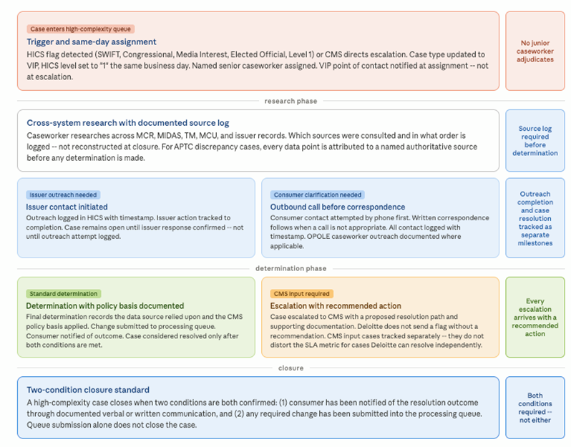
For cases where resolution requires a change to the FFE, the determination does not end at closure — it triggers a controlled submission sequence that protects both the consumer's tax record and the integrity of the correction cycle. Before any retroactive action reaches the FFE, Deloitte will map the full downstream consequence: which correction cycle it falls into, whether a corrected or voided 1095-A will be generated, and the correct submission order for related enrollment segments. Sequencing errors generate new disputes; catching them before submission is less costly than resolving them after. For SBEs, Deloitte will document findings with enough specificity for direct SBE action. Batch corrections and manual overrides will carry supervisory sign-off with a complete time-stamped audit trail before submission.

Tax season surge readiness
Recruitment begins in November and clearance begins at offer acceptance, enabling the first deployment wave to be cleared and trained before January 1. Additional caseworkers are deployed just in time for February and March peak volumes, then released in phases as volumes decline through June. Returner caseworkers skip baseline training and complete only a policy update refresher, reaching full productivity from their first day back. New hires train on the prior year's actual root-cause case types under peer certification by returners before touching live cases. The result is a surge workforce that improves in quality each year rather than repeating the same ramp.

Surge operating standard | Deloitte commitment
QA and supervision | Maintained at base-period standards throughout January–May
Daily aging review | Aging dashboard reviewed each morning; at-risk cases flagged same day
Reserve capacity | Pre-cleared reserve staff activate at defined volume thresholds

Trend identification and process improvement
Deloitte will treat the incoming dispute queue as an early-warning signal rather than a workload to process. The table below shows the specific actions and what each means for CMS's ability to reduce future dispute volume.

What Deloitte will do | What this means for CMS
Review HICS narratives and CERRS attributes daily | Give CMS early visibility into emerging 1095-A dispute patterns
Pull correlated cases and escalate root cause with bulk-action recommendation | Enable CMS to resolve shared-root-cause cases through one coordinated action
Deliver monthly improvement actions by channel | Equip CMS to issue targeted guidance through issuer webinar, email blast, REGTap, or CMSzONE
Share Task 2 and Task 3 data weekly | Help CMS identify issuer-driven consumer disputes earlier
Deploy AI-assisted HICS text analysis, with CMS approval | Help CMS detect emerging dispute trends faster than manual review alone

Quality assurance
QA is Deloitte's mechanism for ensuring the three-lane model performs consistently, not just on average. The table below shows how each QA element translates into a specific outcome for CMS.

Quality assurance element | What it means to CMS
Elevated sampling categories: APTC, retroactive adjustments, override actions | The highest-risk case types are reviewed most frequently -- errors caught before they generate corrected 1095-As, amended returns, or new disputes
Case note review and quality scoring: closed cases reviewed against defined criteria for research sequence, documentation completeness, rationale, and audit-ready closure | CMS has a structured, case-level quality method -- not just spot checks -- confirming that determinations are correct, fully documented, and ready for oversight review
Inconsistencies become training and SOP updates | Inconsistent determinations eliminated systematically, not managed one caseworker at a time
Targeted coaching for recurring errors or low-quality case handling | Caseworkers with repeat documentation or determination issues receive focused corrective coaching before error patterns spread into production
Systemic pattern detection escalated to CMS with root cause and recommended fix | CMS receives a diagnosis and a proposed fix, not a performance report
Emerging issue notification: new error pattern surfaced with documented finding and proposed corrective action | CMS is first to know about a quality risk in the program

[Challenges & Mitigations: Our understanding of pain points and challenges of the technical work that requires or is alleviated by the approach that we’re proposing – note that this content will be pulled out and summarized across tasks in section 1c]
Table X.X-X. Provide Title.
Challenge | Deloitte mitigation
Transition risk and Day 1 continuity: lost files, broken SLA clocks, and intake disruption if inherited workflows are not validated quickly | Deloitte validates inherited workflows, reconciles open inventory against CERRS during transition-in, and confirms HICS-to-CERRS intake, classification logic, and reporting before steady-state operations begin.
Tax season volume spikes: volume may triple January through May, threatening service levels if surge planning is not built in ahead of time | Returner-first staffing strategy with recruitment beginning November. All temporary caseworkers cleared and trained before January. QA rigor, aging oversight, and SLA monitoring maintained at base period standards throughout surge.
Complexity-driven SLA risk: low, medium, and high complexity require different research paths and SLA definitions; mis-routing ages cases unnecessarily | Automated case typing at intake with trained caseworker fallout queue for ambiguous cases. Experience-based assignment ensures senior capacity is reserved for complex cases. SLA-excluded exceptions tracked separately with documented reasons.
Retroactive correction sequencing errors: out-of-sequence FFE submissions create new data conflicts that become new disputes | Deloitte maps the full downstream consequence before any retroactive action is submitted: correction cycle, 1095-A impact, and submission sequence confirmed before execution. Sequencing errors caught before submission rather than resolved after.
Recurring disputes driven by upstream root causes: processing cases individually is inefficient when multiple cases share the same origin | Daily monitoring of HICS narratives and CERRS attributes surfaces correlated clusters same-day. Correlated cases escalated to CMS with bulk-processing recommendation and root cause summary rather than worked individually.

[Proof Points: List out projects where we’ve done similar work or where the details of our approach have been proven]

Subtask 3.1: Low Complexity 1095-A Disputes ^{(SOW 3.3.1)}

Subtask 3.2: Medium Complexity 1095-A Disputes ^{(SOW 3.3.2)}

Subtask 3.3: High Complexity 1095-A Disputes

1.2.3 Task 4: Complex Case Help Center (CCHC) ^{(SOW 3.4)} (2.5 Pages)
[Our Understanding]
Consumers referred to the CCHC have already contacted the Call Center, engaged with an issuer or assister, and still could not resolve their coverage situation through standard channels. The cases that arrive here - DMIs, delayed enrollments, retroactive terminations, APTC discrepancies -- sit at the intersection of policy complexity, multi-system data conflicts, and human circumstances that standard processes were not designed to handle. For these consumers, coverage uncertainty is not a data problem. It is a barrier to care and a source of financial stress.
Getting this right requires more than process adherence. It requires caseworkers who arrive trained for the cases they will actually encounter and an escalation discipline that surfaces the right issues to CMS before they become visible problems. CCHC is the only workstream in this contract where the human cost of a process failure is visible in real time.
Beyond case resolution, CCHC serves as a critical feedback mechanism for CMS. Analysis of recurring trends, root causes, and resolution patterns provides visibility into upstream breakdowns across the broader Exchange ecosystem. Monthly casework reveals where cases could have been resolved upstream, where HICS categorization is inconsistent, where policy clarification is needed, where issuer actions diverge from CMS requirements, and where FFE system defects are generating avoidable case volume. Weekly and monthly reporting are not administrative byproducts. They are how CMS prevents the next wave of escalations.
[Our Approach]
Deloitte will operate CCHC as a live, consumer-facing resolution function from Day 1, staffed by caseworkers who will have completed scenario-based training before any live case is assigned. The approach builds directly on the shared transition-in and weekly cross-task data share described in Section 1B.1, and is organized across three dimensions: steady-state case operations, reporting and program intelligence and capacity management.
Steady-state case operations
Figure X.X-X. Provide Title.
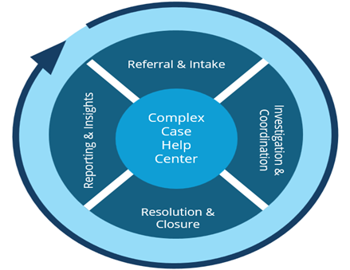
Deloitte will apply a channel-agnostic triage protocol so that case classification is governed by the case type, not by which intake channel referred it. A retroactive termination case referred from the Exchange Call Center will receive the same classification logic, research path, and documentation standard as one referred from OPOLE or CMS leadership. This consistency is what makes QA sampling meaningful: when every caseworker follows the same protocol, deviations are detectable and correctable rather than buried in channel-specific variation.
Unlike Task 2 issuer dispute processing, which resolves data discrepancies reported by issuers, CCHC casework resolves coverage problems often originated by consumers. The five-stage workflow below governs how every CCHC case will move from intake to confirmed closure.
Table X.X-X. Provide Title.
Stage | What Deloitte will do and why it matters
Intake and triage | Every case is triaged on four dimensions: issue type, complexity, referral source urgency, CMS prioritization. Channel-agnostic protocol eliminates categorization inconsistency, improving downstream reporting accuracy and enabling reliable root cause analysis.
Assignment | Cases routed based on agent expertise and specialization. Senior agents handle VIP cases (SWIFT, Congressional, Media Interest, Level 1 HICS flags). Specialized queues manage DMIs, delayed enrollment, retroactive terminations, APTC, and difficult-to-enroll populations. A named point of contact will be assigned to every VIP case at intake and will remain accountable through closure, ensuring the consumer has a single, consistent point of contact regardless of how the case was referred or how long resolution takes.
Investigation | Issue-specific checklists and required-evidence prompts will guide caseworkers through a defined research sequence across MCR, TM, MCU, MIDAS, HICS, and SEED. Anomalies will be flagged in the workflow as they arise. Documentation will be captured in real time, not reconstructed at closure, and all communications with issuers and consumers -- including content, channel, and outcome -- will be recorded as they occur, ensuring a complete and auditable case record.
Resolution | CMS-aligned playbooks define resolution steps and policy basis. Resolution outcomes include clear, actionable instructions for each stakeholder (consumer, issuer, assister, agent/broker, FFE update) with accountability established prior to closure. Issuer actions documented and tracked to completion. Escalations include a recommended resolution with supporting documentation - not just issue flagging. Submitted documentation is reviewed for consistency and completeness before any determination proceeds.
Closure | Cases close only when three conditions are met: action completed and confirmed, consumer notified verbally or in writing, and complete metadata captured. Required-field validation is enforced at workflow level.

The five-stage workflow is only as consistent as the caseworkers executing it. No caseworker will handle a live case until completing training and demonstrating readiness against a defined competency threshold. The training curriculum will be built from prior-year CCHC root cause data: caseworkers will be trained on the actual case types and issuer patterns that drove the most volume and complexity in the prior season, not on generic system orientation. This is the same scenario-based approach applied to the Task 3 surge workforce, applied here to the permanent CCHC team. Training will emphasize both technical resolution and consumer-centered handling, equipping caseworkers to resolve complex cases with accuracy, empathy, and clear communication. Returner caseworkers will serve as peer certifiers for new hires. Within the first 90 days, Deloitte will conduct a structured SOP gap assessment and submit recommendations to CMS as a formal deliverable.
QRGs will be reviewed quarterly and updated promptly following any CMS policy change, with updates versioned, distributed, and confirmed as received before caseworkers begin applying new procedures. QA sampling will include integrity-focused review. Unusual resolution patterns, override activity, and inconsistent determinations across similar cases will be flagged for supervisor review. When QA surfaces a pattern, it will become a training scenario and an SOP update, not a quality log entry.
Reporting and program intelligence
CMS does not need a contractor who compiles what happened last month. CMS needs a contractor who shares with CMS what to do about it. Every reporting deliverable under Task 4 closes with specific recommended actions -- drafted, evidence-supported, ready to act on.
Table X.X-X. Provide Title.
Deliverable | Frequency | Deloitte's commitment beyond the requirement
Operational report | Weekly | Cases flagged by name at SLA risk, not aggregate counts. Escalations include a recommended next step, not just a flag.
Root cause analysis | Monthly | Each finding closes with a drafted CMS action. Issuer pattern communications arrive formatted and ready to distribute, not as a summary requiring further drafting.
Root cause analysis | Quarterly | Multi-month patterns surfaced with a prioritized action agenda for CMS review.
Issuer pattern escalation | Ongoing | Patterns identified at intake through CERRS metadata, not discovered weeks later in reporting. Surfaced to the Task 2 issuer dispute team through the weekly cross-task data share so CMS sees a consistent picture across both workstreams.
Tax season cross-task coordination | Jan through May | APTC cases spanning CCHC and Task 3 resolved through a single workflow with a single consumer point of contact. Issuer non-compliance documented with volume and pattern analysis for targeted CMS action.

Reporting data will be a byproduct of operational execution. CERRS metadata captured at every workflow step will feed EDA CORE dashboards directly, creating a unified live view across Tasks 2, 3, and 4 without separate compilation.
Issuer coordination and cross-task integration
Issuer coordination in CCHC will be pattern-driven, not case-by-case. When the same issuer drives a similar issue across cases, those patterns will be identified at intake through CERRS metadata association, not discovered weeks later in monthly reporting. This is made possible by the same metadata framework that supports issuer analytics in Task 2. Deloitte will surface CCHC-identified issuer patterns to the Task 2 issuer dispute team through the weekly cross-task data share, so CMS sees a consistent picture across both reports. CCHC will coordinate directly with Task 3 during tax season when APTC cases may span both workstreams. Overlapping issues will be resolved through a single workflow with a single consumer point of contact. Issuer non-compliance will be documented, categorized, and reported with volume and pattern analysis enabling CMS to take targeted action.
Capacity management
Deloitte will build the CCHC staffing model around the actual volume curve, not an annual average, applying the same surge readiness principles as Task 3: caseworkers scenario-trained before volume arrives, supervisory ratios maintained at peak, and a defined reserve pool that activates on a threshold rather than requiring a new recruitment cycle. Supervisory ratios, QA coverage, call monitoring standards, and reporting timelines are operational commitments that will hold at peak volume, not targets that degrade when caseload increases. The staffing plan submitted at kickoff will show coverage at each volume scenario, and flex capacity will be drawn through cross-trained reserve staff, temporary reallocation from aligned workstreams, and targeted short-term support as directed by CMS. is verified
[Challenges & Mitigations: Our understanding of pain points and challenges of the technical work that requires or is alleviated by the approach that we’re proposing – note that this content will be pulled out and summarized across tasks in section 1c]
Table X.X-X. Provide Title.
Challenge | Deloitte mitigation
Transition risk: CCHC operations rely on informal decision logic that SOPs do not capture -- gaps emerge only after go-live if not captured during transition | TruNorth captures routing rules and escalation dependencies from source code independently. Full production workflow shadowed during transition-in to document informal decision points. Readiness confirmed against a structured runbook before case transfer begins.
Agent readiness: complex eligibility and enrollment scenarios cannot be learned on live consumer cases involving stressed or vulnerable individuals | Scenario-based curriculum built from prior-year root cause data. Agents trained on actual case types before handling live cases. Competency assessed before independent case handling. Returner agents serve as peer certifiers for new hires.
Reporting quality: descriptive monthly reports tell CMS what happened but not what to do about it | Every reporting deliverable closes with specific recommended actions drafted for CMS review. Monthly root cause analysis goes further, closing each analytical category with a prioritized action and supporting evidence. CMS receives a decision package, not a trend summary.
Seasonal volume fluctuation: referral volume peaks during Open Enrollment and tax season, threatening quality and reporting timelines if only headcount is added | Surge model deploys trained headcount, not just headcount. Supervisory ratios, QA coverage, and reporting timelines held constant at all volume levels. Staffing plan shows coverage at each volume scenario, not a single average-volume number.
Issuer non-compliance visibility: issuer patterns that drive CCHC cases may not be visible to issuers or CMS without structured analysis | Issuer coordination is pattern-driven, not case-by-case. Patterns identified at intake through metadata association. Deloitte drafts recommended issuer communications for CMS review and distribution through all-issuer webinars, REGTap, and CMSzONE.

[Proof Points: List out projects where we’ve done similar work or where the details of our approach have been proven]

1.2.4 Task 5: Updating the FFE ^{(SOW 3.5)} (0.5 Pages)
[Our Understanding]
FFE update accuracy is not a Task 5 function in isolation. It is the mechanism by which every dispute resolution in Tasks 2 and 3 actually takes effect. A case closed correctly in CERRS but submitted to the FFE with a sequencing error or a missed pre-validation has not been resolved -- it has created a new data problem that will surface as a downstream dispute or an incorrect 1095-A. Deloitte treats this workstream as a precision execution function: every submission type (standard BUU, non-standard BUU, Hard Case, Update Policy API) governed by the same cycle discipline, every action logged from compilation through confirmed FFE update, and CMS notified of any exception before it becomes a rework cycle.
[Our Approach]
Deloitte will be operationally ready before the first submission window opens. During transition-in, the pipeline is validated end-to-end against live system behavior -- compilation logic, pre-validation rules, OA Contractor interface, and QA Team handoff -- so there are no surprises in the first correction cycle. Prior-year submission history is reviewed to surface informal compensating controls that are not in current SOPs, and those gaps are formalized before Deloitte takes ownership. The table below shows how Deloitte will manage each submission type, what CMS sees, and what the control is.
Table X.X-X. Provide Title.
Submission type | How Deloitte manages it | What CMS sees
Standard and non-standard BUU | Compiled against each of ~22 Correction Cycles and the monthly Recon Run Calendar. Internal pre-validation completed before any file reaches the OA Contractor. | Cycle-level status dashboard: compiled, validated, submitted, confirmed -- updated after each stage
Hard Case updates | Scheduled into the same correction cycle calendar as standard BUU. Not treated as ad hoc exceptions. | Hard Case volume and disposition tracked in the same weekly report as standard submissions
Update Policy API (Rejected Enrollment, Undetected Overlap) | Pre-validation completed before API submission. Confirmation logged before associated case is closed. | API submission outcomes included in the weekly corrections report
Retroactive adjustments | Downstream consequence mapped before submission: correction cycle, 1095-A impact, segment submission order. Sequencing errors caught at compilation. | Exception report when a submission requires resequencing, with root cause and resolution path

[Challenges & Mitigations: Our understanding of pain points and challenges of the technical work that requires or is alleviated by the approach that we’re proposing – note that this content will be pulled out and summarized across tasks in section 1c]
[Proof Points: List out projects where we’ve done similar work or where the details of our approach have been proven]

1.2.5 Task 6: Notice Generation ^{(SOW 3.6)} (0.5 Pages)
[Our Understanding]
Task 6 notices are operational program communications triggered by specific enrollment and reconciliation events, Death Periodic Data Matching alerts, ER&R third failed attempt letters and similar notices that inform consumers of a specific action taken or required in their case. These are not the original 1095-A tax forms. They are the communications that accompany or explain program decisions, and their accuracy, timing, and language compliance matter because consumers act on them.
The work is primarily a pipeline execution and compliance function: merge consumer data into CMS-provided templates, transmit to the Federal Marketplace Print contractor via EFT, upload to DSRS, and confirm delivery. Approximately 40 notices require updating annually, and each must meet statutory multilingual requirements that can change during the contract period. Deloitte will run this as a precision compliance function with full pipeline visibility to CMS at every stage.
[Our Approach]
Transition-in establishes the baseline: full notice library inventory, translation status by notice and language, current print vendor specifications, and EFT and DSRS configuration -- validated against live system behavior before the first notice file is generated.
In steady-state, Deloitte manages the pipeline through a simple operating discipline: validate before generating, confirm before closing. No notice file is transmitted without a successful EFT confirmation. No batch closes without a confirmed DSRS upload. Every content change triggers a translation review before the updated notice enters production. CMS sees pipeline status through a standing notice generation report covering volume, timing, translation status, and any exceptions -- no surprises, no quiet resolutions.
Table X.X-X. Provide Title.
What Deloitte tracks | Reported to CMS | Escalation trigger
Data merge validation against source records | Pre-generation status per notice type | Missing fields or data anomalies caught before file generation
EFT transmission confirmation | Transmission status and timestamp per batch | Failure triggers same-day CMS notification and remediation path
DSRS upload confirmation | Upload completion and file count per batch | Failure triggers immediate remediation before batch is closed
Translation currency per notice and language | Translation status in standing notice report | Content change without confirmed translation update escalated before production
508 compliance per notice update | Compliance confirmation per design change | Design-stage failure escalated before the notice enters the production queue

[Challenges & Mitigations: Our understanding of pain points and challenges of the technical work that requires or is alleviated by the approach that we’re proposing – note that this content will be pulled out and summarized across tasks in section 1c]
Table X.X-X. Provide Title.
Challenge | Deloitte mitigation
Translation dependencies are not always triggered when English content changes, creating out-of-sync translated notices that may not surface until a consumer complaint | Translation update trigger built into the notice change workflow. Every content change initiates a translation review before production. Translated notices confirmed accurate before EFT transmission.
Print vendor specification mismatches discovered at transmission cause rework and delay consumer delivery | Transition-in pipeline audit validates current print specifications and identifies pending spec changes before Deloitte generates its first notice. Spec changes managed through a documented workflow before production.
Approximately 40 annual notice updates create compression risk when multiple notices update simultaneously near a filing deadline | Annual update schedule tracked against Correction Cycle and consumer filing deadlines from contract start. Updates sequenced to avoid compression near high-impact windows.
DSRS upload failures may not be discovered until a consumer or issuer attempts to retrieve a notice | DSRS upload confirmation logged per notice file before batch closes. Failures trigger immediate remediation, not next-day discovery.

[Proof Points: List out projects where we’ve done similar work or where the details of our approach have been proven]
During CA SBM take over, we took over the notice generation from the incumbent’s print vendor to a high volume print vendor Deloitte chose. We were able to migrate the inbound documents and outbound notices interfaces, processes and controls in-flight seamlessly.
**Focus on Ops

1.2.6 Task 7: Telephone and Correspondence Support ^{(SOW 3.7)} (2 Pages)
[Our Understanding]
Task 7 is a multi-stakeholder, multi-channel resolution function that serves as the connected front door for stakeholder engagement across ER&R, not a generic contact center. It supports consumers, issuers, Federally-facilitated Exchange (FFE) staff, State-based Exchanges (SBEs), employers, and related Marketplace partners through coordinated inbound and outbound calls, voicemail, issuer email support, and written correspondence. These channels are designed to move cases toward resolution with consistency, visibility, compliance, and continuous improvement. In this role, Task 7 helps CMS maintain trusted core operations while strengthening program performance over time through efficient workflows, deep Marketplace coordination, and integrity-embedded controls.
- Case resolution across a complex Marketplace ecosystem. The SOW requires support for consumers, issuers, FFE staff, and SBEs, with direct handling of phone inquiries, voicemail, issuer call and email support, and outbound outreach where it can significantly expedite resolution. This requires end-to-end understanding of how consumer disputes, issuer coordination, Form 1095-A casework, Exchange Call Center interactions, system-enabled research, and written correspondence intersect within the resolution lifecycle.
- Multi-stakeholder by design with necessary coordinated handoffs. Stakeholders include CMS, issuers, states, the Exchange Call Center, the Eligibility Support contractor, the Print contractor, FMPS, and other Marketplace support teams. Consumers need clear, plain-language support and sensitive handling of enrollment and eligibility issues. Issuers need precise operational coordination, documented communications, and timely follow-up. FFE staff, SBEs, and other partners need clear transfers, current case status, and dependable follow-through across organizational boundaries.
- Closed-loop support workflow, not a set of disconnected channels. Calls, voicemails, issuer emails, and written correspondence operate as a single integrated workflow so that each interaction advances the case, contributes to one visible case history, and supports downstream actions, formal decisions, and accurate status communication.
- Outbound support is a proactive resolution lever. When live outreach can resolve missing information, confirm next steps, or unblock action faster than waiting for additional inbound contacts or written exchanges, Deloitte will use outbound support to reduce avoidable repeat effort for CMS, other contractor teams, issuers, consumers, and federal and state partners while improving speed to closure and overall stakeholder experience.
- Voicemail is a managed intake and follow-up channel, not overflow coverage. CMS requires direct phone numbers with voicemail for after-hours, weekend, and holiday contacts, with response within one business day. That makes clear ownership, prioritization, age tracking, and timely follow-up important to performance.
- Issuer support is a distinct operating lane. The contractor must provide issuer call and email support through the ER&R Support Center, document communications in Enrollment Community, support mass issuer communications, and provide recommendations and testing support for enhancements tied to Enrollment Data Alignment.
- Workforce management (WFM), quality assurance (QA), and training are core delivery enablers. Because volumes fluctuate, policy direction evolves, and case complexity varies by stakeholder, Deloitte will use forecasting, scheduling, QA monitoring, script adherence, refresh training, and knowledge updates to sustain performance.
- Training, scripts, SOPs, and QRGs are control points for consistency, compliance, and program integrity. The SOW requires representatives to follow CMS-approved scripts and SOPs, receive additional training as direction changes, and maintain supporting job aids and reference materials. Deloitte pairs these controls with efficient review and update processes to keep the operation current without slowing delivery, while strengthening auditability, exception management, and prevention of process error and fraud, waste, and abuse risk.
Improvement engine and operational hub for the broader scope. Because it sits at the intersection of stakeholder contact, case status, recurring issues, and written communications, it provides CMS with a practical mechanism to identify trends, recommend script and workflow refinements, improve stakeholder outreach effectiveness, and inform system-support enhancements while maintaining stable day-to-day operations.
Taken together, Task 7 is best understood as an integrated contact and correspondence resolution hub with built-in improvement levers, helping CMS maintain accurate, compliant, and responsive Marketplace operations at scale for stakeholders across the country.
[Our Approach]
**PLACEHOLDER- For technical solution description and architecture diagram**
Positioning
Deloitte will provide a connected, integrated, and CMS-compliant multi-channel stakeholder support operation that accelerates resolution, improves stakeholder experience, and embeds program integrity into every interaction. Calls, voicemails, emails, written correspondence, and follow-up actions will contribute to one coordinated resolution path, while Task 7 serves as connective tissue across written correspondence, CMS-provided case systems, SOP and QA governance, issuer coordination, Exchange Call Center interactions, and special-project support under the broader SOW.
Task 7 will be delivered through a controlled, closed‑loop resolution model that (1) governs stakeholder contact through CMS‑approved scripts and workflows, (2) integrates multi‑channel interactions into a single, traceable case flow, and (3) uses operational insight to inform continuous, CMS‑aligned improvement.
1. Operate as a stakeholder-based resolution function
We will organize Task 7 by stakeholder and case type, not just by channel, because consumers, issuers, FFE staff, SBEs, and related partners bring different questions, dependencies, documentation standards, escalation paths, and sensitivities. That stakeholder-aware model will allow Deloitte to tailor triage, routing, outreach, and communications while maintaining consistent controls across the operation.
2. Run a unified multi-channel workflow with closed-loop case visibility
We will integrate inbound calls, outbound calls, voicemail, issuer email support, and written correspondence so each touch advances resolution and contributes to one traceable case history. Interactions will be documented in CERRS to support case status visibility, downstream processing, formal actions, and stakeholder communications. This closed-loop model supports Task 6 written correspondence, Task 8 system-enabled case research and tracking, Task 9 SOP and QA governance, and Task 10 helpdesk and special-project activities. In all telephone and correspondence support, Deloitte will follow CMS-approved SOPs and use CERRS and integrated systems to record communications, generate responses, and trigger formal decisions or planned actions so correspondence remains current, accurate, traceable, and governance-aligned.
3. Use outbound support proactively to improve speed, efficiency, and experience
We will treat outbound support as a proactive resolution lever, not just reactive follow-up. When live outreach can resolve missing information, confirm next steps, reduce back-and-forth, or unblock a case faster than written exchanges alone, Deloitte will prioritize outbound calls to reduce overall effort across consumers, issuers, CMS, and partner organizations while improving speed to closure and stakeholder experience.
4. Manage voicemail as an SLA-driven workflow with AI-assisted triage opportunities
We will manage voicemail as an active intake and follow-up queue with clear ownership, age tracking, prioritization, and one-business-day response compliance. Where approved by CMS, Deloitte may apply approved automation capabilities, such as transcription and categorization, to help staff route messages faster, identify urgent or complex issues sooner, and improve responsiveness while preserving human oversight and script compliance.
5. Deliver a distinct issuer-support operating lane
We will provide a dedicated issuer-support workflow through the ER&R Support Center for issuer calls and emails, documentation in Enrollment Community, coordinated mass issuer communications, and support for testing and recommending technical enhancements that improve Enrollment Data Alignment. This will help CMS address issuer needs with greater consistency, speed, and operational visibility.
6. Embed WFM, QA, training, and knowledge management into daily delivery
We will use WFM to forecast demand, align staffing to seasonal and intraday volume patterns, and maintain service continuity as volumes rise and fall. We will use QA to monitor call quality, script adherence, documentation accuracy, and stakeholder experience. We will use training and knowledge management to keep representatives current on Exchange policy, enrollment and eligibility processes, script changes, SOP updates, and improvement actions so support remains consistent and compliant over time.
7. Coordinate handoffs across the Marketplace ecosystem
We will manage a handoff-heavy operating environment with explicit ownership, standard transfer points, escalation triggers, and shared status visibility across CMS, issuers, states, SBEs, the Exchange Call Center, and related contractors. This will reduce rework, shorten cycle times, and lower the risk of dropped transfers or inconsistent stakeholder guidance. This model also supports casework originating in other tasks, where issuer disputes, Form 1095-A consumer disputes, complex case referrals, FFE updates, and ad hoc stakeholder needs require coordinated contact, follow-up, and documented status communication.
8. Pair operations with continuous improvement
Using trends from calls, voicemails, issuer inquiries, escalations, and case activity, Deloitte will help CMS identify recurring pain points, recommend script updates, propose workflow refinements, and support practical system and process improvements. We will treat Task 7 as both a service-delivery function and a source of insight to improve Marketplace operations over time.
Stakeholder-based operating model
- Consumers: plain-language support, efficient follow-up, sensitivity to complex eligibility and enrollment issues, surge readiness for dispute periods and seasonal spikes.
- Issuers: Operationally precise coordination, documented communications, targeted outreach, issue pattern analysis, and collective communications where recurring issues emerge.
- FFE staff / CMS partners: escalation discipline, status visibility, clear transfers, and timely follow-through.
- SBEs / state partners / related contractors: coordination across different resolution paths, documented interactions, and dependable turnaround.
- Employer-related stakeholders under Task 10: call-center support, script-governed inquiries, transfers, triage, and recurring reporting.
Key differentiators
- Multi-stakeholder support model tailored to the Marketplace ecosystem, not generic queue management.
- Proactive outbound resolution used to reduce cycle time, repeat contacts, and stakeholder burden.
- Unified contact and correspondence workflow with full documentation and auditability.
- Formal script, SOP, QA, and training governance tied to CMS-approved processes.
- Continuous-improvement engine that turns contact trends into better scripts, communications, and workflows.
Illustrative metrics aligned to SOW reporting and KPI expectations.
Access and responsiveness
- Speed to answer
- Abandon rate
- Voicemail response timeliness
- Service level
Resolution
- First-contact resolution
- Average days to case closure
- Aging backlog by stakeholder and issue type
- Outbound contact success rate
Quality and compliance
- QA accuracy
- Script adherence
- Documentation completeness
- Training completion / refresh timeliness
Stakeholder service
- Issuer inquiry turnaround
- Correspondence timeliness
- Escalation volume and aging
- Trend-to-action closure rate
[Challenges & Mitigations: Our understanding of pain points and challenges of the technical work that requires or is alleviated by the approach that we’re proposing – note that this content will be pulled out and summarized across tasks in section 1c]
1 Challenge: fragmented systems and swivel-chair work
Mitigation: standard workflows, clear ownership, unified documentation, and visible case status across channels and handoffs.
2 Challenge: multiple handoffs across CMS, issuers, states, SBEs, and contractors
Mitigation: defined transfer points, escalation rules, closed-loop follow-up, and case aging visibility, supported by an integrated QA model that identifies cross-stakeholder improvement opportunities, routes updates to CMS partners, and tracks review and concurrence through completion.
3 Challenge: evolving policy, process, and script direction
Mitigation: governed knowledge management, refresh training, QA monitoring, and controlled script updates.
4 Challenge: seasonal surges and uneven demand
Mitigation: WFM forecasting, flexible staffing, targeted outbound campaigns, and queue monitoring to maintain service continuity.
5 Challenge: need for compliant innovation without operational disruption
Mitigation: CMS-approved pilots, human-in-the-loop AI-assisted triage, and transparent documentation of technical solutions and use cases.
[Proof Points: List out projects where we’ve done similar work or where the details of our approach have been proven]
- Covered California Health Insurance Exchange Contact Center. Deloitte stood up Amazon Connect in about 40 hours during annual enrollment, when contact volume peaks near 300,000 contacts per month. Deloitte provided project management, engineering, testing, training, and hypercare, led go-live and SSO migration with zero critical or high-impact issues, and continues to support enhancements such as courtesy callback, post-call survey, conversational IVR, custom agent desktop, and advanced reporting. Proof for: digital exchange support, continuity under load, and practical contact-center modernization.
- CDC Vaccine Administration Management System (VAMS). Deloitte supported CDC’s national VAMS environment and rapidly deployed an AWS Connect-based call center to support end users, jurisdictions, and clinics when high call volume accompanied system rollout. Deloitte provided call center oversight, reporting, SLA monitoring, training, knowledge management, continuous process improvement, and centralized QA reporting across five workstreams, while building a Salesforce-based knowledge repository with 300+ artifacts. The effort supported a multi-tier call center solution used in administering 9.5M vaccines. Proof for: federal stakeholder support, high-volume contact center oversight, training and QA governance, and knowledge-management-enabled continuous improvement.
- Financial Crimes Enforcement Network (FinCEN) Beneficial Ownership Contact Center. Deloitte stood up and operates a federal compliance-oriented contact center built on Salesforce Government Cloud Plus, Amazon Connect, and AWS Lex in a FedRAMP High environment. The team launched command center operations, deployed chatbot capabilities, supported outbound calls and web-to-case inquiries, published 141 business and 86 technical knowledge articles, ran a QA program for outbound calls and web-to-case responses, and used dashboards to monitor daily performance, schedules, and productivity. Results include eliminating a 5K-case backlog within three months, closing 350K+ cases to date, conducting 23K+ outbound calls, auditing 11K+ cases at an average score of 96%, and reducing closure time to within a day of receipt by July 2025. Proof for: federal case-management operations, outbound support, dashboard-driven performance management, quality auditing, and knowledge-centered service delivery.
- United States Navy MyNavy Career Center (MNCC). Deloitte helped the Navy redesign and modernize a tiered omnichannel HR service-delivery model supporting 330,000+ Sailors, including Salesforce CRM, Cisco telephony, IVR, post-call survey capabilities, command center development, and implementation of WFM, QA, and reporting and analytics. Deloitte also conducted contact-driver analysis, recommended a content-management approach, created knowledge materials, established a maintenance model for the knowledge base, and helped shift lower-complexity work to the left. The resulting model supports 36,000+ contacts per month and has enabled the creation and resolution of 1.5M customer requests and inquiries since launch. Proof for: federal omnichannel operating-model design, command-center integration, contact-driver analysis, knowledge management, and scalable service-delivery improvement.
- State health and human services contact center operations. Deloitte rapidly mobilized and stabilized state contact center operations supporting time-sensitive public health and benefits programs. In New York, Deloitte took over an overwhelmed vaccine hotline, deployed 4,000+ surge support agents, handled 5M+ calls including 100K+ per day at peak, and improved performance through QA, WFM, reporting, knowledge management, and micro-learning, contributing to a 53% reduction in hold time and a 75% reduction in Tier 2 escalations. In the District of Columbia, Deloitte launched a contact center in 25 days, implemented a cloud-based solution in five weeks, handled nearly 24,000 calls, and supported an end-to-end managed service model with QA, command center oversight, and reporting. Proof for: rapid mobilization, surge operations, disciplined service delivery, and government contact center execution.

1.2.7 Task 8: IT Systems ^{(SOW 3.8)} (5 Pages)
Our Understanding
The ER&R technology environment spans four core systems, CERRS, SEED, HICS, and EDA CORE, all operating within the CMS Microsoft Azure Government (MAG) cloud enclave. These systems connect through a layer of APIs, data pipelines, security controls, and infrastructure services that must function reliably together. A change to one system has consequences across the others.
Figure X.X-X. The ER&R Ecosystem: Core Systems, Integrations, Security Infrastructure, and Operational Stakeholder Network.
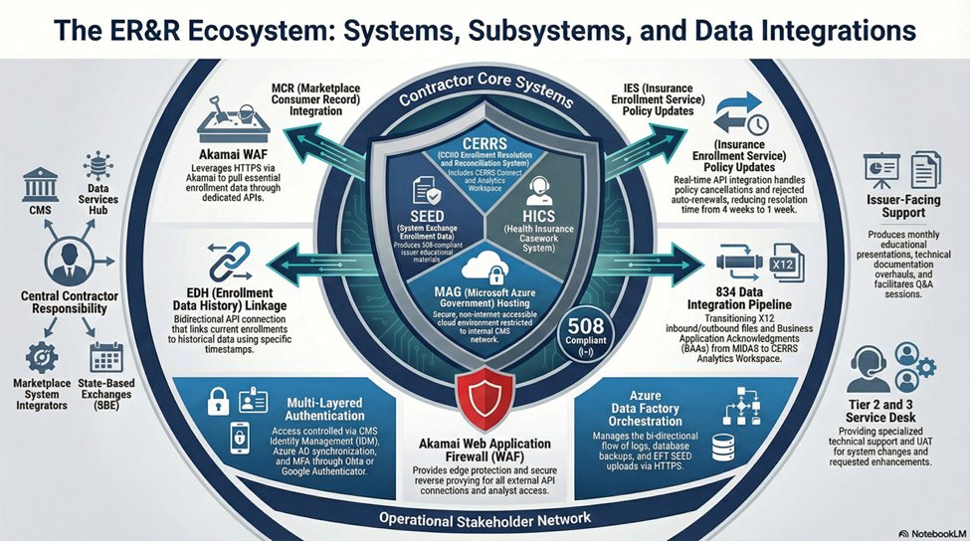

All external API traffic routes through an Akamai Web Application Firewall before reaching the MAG environment. Azure Data Factory manages bidirectional log, backup, and file transfer orchestration. The 834 X12 data integration pipeline processes thousands of transactions per hour during Open Enrollment. Access across all systems is governed by CMS Identity Management, Azure AD synchronization, and multi-factor authentication through Okta Authenticator. Each of these dependencies must be maintained, monitored, and validated across every release cycle.
Sustaining this environment requires a delivery model capable of governing operations, planned change, and cross-program coordination simultaneously without disruption to live casework. That is the baseline. Deloitte's approach is built to deliver that baseline from day one and then go further.
Our Approach
CMS deserves a contractor that does more than keep the lights on. Deloitte is that contractor. Deloitte's approach to Task 8 is designed to operate this environment reliably and securely from day one and systematically raise the bar from there. Our approach is structured around two objectives. The first is operational: assume responsibility without disruption, govern the live environment with discipline, protect mission-critical infrastructure and sensitive data in full alignment with CMS security and privacy requirements, and build the confidence that comes from consistent, reliable delivery. The second is transformational: once that foundation is established, apply AI-enabled automation to reduce manual effort across technology and business operations, simplify how staff, issuers, and consumers interact with the environment, and create a credible path to long-term architectural consolidation.
These two objectives are not sequential in a strict sense. Operations and improvement run in parallel. Each phase builds on the one before it and delivers value before the next begins in full.
Figure X.X-X. Deloitte's Six-Phase ER&R Delivery Model
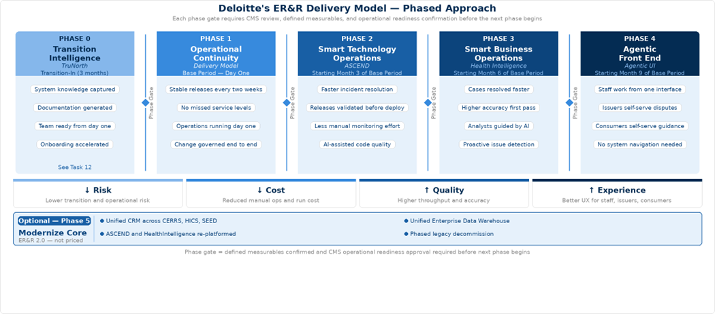

Phase 0, Transition Intelligence, is addressed under Task 12. Phase 1 delivers the operational objective. Phases 2 through 4 deliver the transformational objective, each building on the foundation Phase 0 and 1 establishes. Phase 5, Modernize Core, is a future-state direction that is not proposed or priced as part of this bid.
Phase 1: Operational Continuity
Operational Continuity — Assuming Responsibility Without Disruption
Deloitte will staff two dedicated teams under Task 8. The Operations and Maintenance team owns production stability: incident response, after-hours data loads, ingestion monitoring, service desk support, and the daily operational continuity of CERRS, SEED, HICS, and EDA CORE. The Enhancement and Modernization team owns planned change: bi-weekly releases, quarterly rule updates, annual form changes, code modernization, and CMS-prioritized improvements. Both teams operate under one integrated delivery framework, so work is coordinated, not siloed.
Maintaining stability while introducing change is the central operational challenge in this environment. What makes this model effective is not the separation itself but the discipline at the boundary between the two teams. Nothing moves from Enhancement into Operations without a validated cross-system impact assessment, release readiness review, and rollback plan in place. That handoff, governed through shared intake, a coordinated release calendar, and dependency review across CERRS, SEED, HICS, and EDA CORE, is where system stability is preserved as the environment continuously evolves.
From day one, Deloitte manages the following recurring obligations across all systems:
- Bi-weekly sprint releases and Change Control Board coordination across CERRS, MCR, SEED, HICS, and EDA CORE
- SAFE Agile PI Planning participation quarterly
- TRB preparation, presentation, and findings remediation
- After-hours data loads, file ingestion monitoring, data remediation, cleansing, and file scanning
- Annual Enrollment Dispute Form updates and quarterly issuer dispute rule updates
- Annual documentation suite updates — ICD, DDD, SDD, RTM, Testing SOP
- CMS governance activities — penetration testing, ACT assessments, IV&V support, FedRAMP sponsorship for Snowflake
- 508 compliance across all system documentation, issuer materials, and presentations
Table X.X-X. Provide Title.
Capability | What Deloitte Delivers | Benefit to CMS
Integrated Delivery Model | Two dedicated teams: Operations and Maintenance, and Enhancement and Modernization, both governed through shared intake and a single release framework. | Both teams operate without competing for the same priorities or capacity.
Shared Intake and Prioritization | Single intake path for incidents, recurring updates, and approved enhancements across CERRS, SEED, HICS, and EDA CORE | CMS has one visible queue for all Task 8 work; priorities are set once and honored across both teams
Coordinated Release Management | Integrated release calendar with cross-system dependency review before every deployment | No release is approved without a validated view of downstream effects across all four systems and their interfaces
Documentation Embedded in Delivery | Runbooks, SOPs, and system documentation updated within the same release cycle that changes the behavior they describe | Service desk staff and caseworkers always work from documentation that reflects the live environment
Recurring Manual Operation Reduction | Repeat manual activities identified and reduced through standardized procedures, automated alerting, and targeted engineering fixes | Operational labor cost decreases over the contract period as manual steps are replaced with governed automation

1.2.7.1 CERRS — CCIIO Enrollment Resolution and Reconciliation System
Microsoft Dynamics CRM | Azure Government | .NET | Custom APIs
CERRS is the Microsoft Dynamics CRM-based platform that serves as the central technical backbone for issuer disputes, Form 1095-A consumer disputes, and CCHC casework. It is the primary integration point for inbound source data from HICS, MIDAS, and other Exchange systems, and the origin of downstream updates to the FFE. Beyond the program-wide obligations covered in Phase 1, Deloitte will specifically deliver for CERRS: 24/7 outage support; annual Enrollment Dispute Form updates and quarterly issuer dispute rule updates; after-hours data loads, ingestion monitoring, and data remediation; code base modernization to Azure cloud services; CRM optimization; Power BI migration; and disaster recovery and business continuity planning.
How Deloitte Will Operate CERRS
Deloitte will manage CERRS daily through platform monitoring, integration health, deployment discipline, and security operations, each running concurrently as standing obligations.
Plugin execution logs will be reviewed daily for synchronous failures that block casework transactions in real time, asynchronous backlogs that delay case status updates, and workflow errors that stall dispute routing. CRM job queues will be actively managed against defined thresholds, so queue saturation is addressed before it affects casework throughput. Integration monitoring will cover the CERRS Connect interfaces to HICS, MIDAS, MCR, and the FFE with transaction logs reviewed daily for failed records, mapping errors, and timeout patterns. After-hours data loads will run against defined monitoring ownership, automated failure alerts, and documented escalation procedures so a failed load is identified, and recovery initiated within minutes, not at the start of the next business day.
Every CERRS release will follow managed solution discipline: customizations contained in properly structured solutions with publisher prefix controls, changes promoted through DEV, TEST, and PROD with configuration data migration handled separately from solution deployment, and rollback plans prepared before production deployment. Dynamics storage quotas and API rate limits will be monitored proactively because breaching either causes platform-wide impact, particularly during the concurrent high-volume periods of Open Enrollment and Form 1095-A season.
Security operations will be maintained continuously. Role-based security profiles, field-level security for PII-containing casework fields, and team memberships will be updated as staff changes occur and as temporary analysts onboard during Form 1095-A ramps. Audit log compliance for sensitive fields will be a standing obligation, not a periodic review.

1.2.7.1.1 MCR — Marketplace Consumer Record
Deloitte will operate the MCR integration as a governed dependency within the CERRS release and monitoring framework. Daily monitoring will cover API response times, error rates, and timeout patterns across the consumer and enrollment data calls CERRS makes to support dispute research and casework resolution. Data mapping between MCR and CERRS will be maintained as a versioned artifact updated whenever either system changes, with integration regression tests validating field-level mapping accuracy, not just successful API responses, as part of every release cycle. As an MCR Data Contributor, Deloitte will govern consumer action and interaction data written back into MCR with automated confirmation monitoring, so contribution failures are detected before gaps accumulate and affect downstream case research.

3.8.1.2 SEED — System of Exchange Enrollment Data
.NET Application | CMS Enterprise Portal | Issuer-Facing | Real-Time FFE Data
SEED is the issuer-facing .NET portal hosted on the CMS Enterprise Portal that provides real-time FFE enrollment data access and supports dispute submission, prior-year dispute handling, post-deadline inaccuracy requests, and related approval workflows. Beyond the program-wide obligations covered in Phase 1, Deloitte will specifically deliver for SEED: four issuer-facing slide presentations per month; two half-hour interactive issuer sessions with live Q&A monthly; monthly CMS/SEED coordination meetings; quarterly improvement recommendations; two comprehensive technical documentation overhauls per year; approver and user administration including submitting approver requests to CMS and maintaining issuer rosters; outage notification; performance monitoring; and release coordination.
How Deloitte Will Operate SEED
Deloitte will operate SEED across three concurrent responsibilities: application operations, issuer engagement delivery, and approver and user administration.
On the application side, Deloitte will monitor SEED performance daily including portal response times, dispute submission success rates, API call volumes to the Enrollment Modernization APIs, and error patterns in the real-time FFE data retrieval layer. Submission path behavior will be validated against underlying API contracts before each release, specifically targeting dispute submission, status display, and approval workflow surfaces where misalignment generates the highest volume of issuer support demand. Release coordination will follow the same managed solution discipline applied across CERRS, with changes moving through DEV, TEST, and PROD and outage notifications issued to CMS and issuers in advance of any planned downtime.
Issuer engagement will be managed as a standing delivery commitment with defined ownership, not as an ad hoc activity. The four monthly slide presentations, two live issuer sessions with Q&A, monthly CMS coordination meetings, and quarterly improvement recommendations will each have a designated owner, a preparation timeline, and a delivery standard. Issuer feedback captured through sessions and Q&A will be documented and fed into the quarterly improvement recommendation cycle so CMS receives a structured view of issuer priorities rather than anecdotal input.
Approver and user administration will be governed through a defined workflow with turnaround standards for each step. Issuer approver requests will be submitted to CMS within a defined timeframe of receipt, roster reconciliation will be performed on a regular cycle to identify and address access discrepancies, and offboarding will be completed promptly when issuer staff changes are reported. Administration will not be treated as a background task competing for engineering bandwidth.

1.2.7.2 HICS — Health Insurance Casework System
Custom .NET | Azure Government | Casework Routing | Stakeholder Integration
HICS is the official tracking system for Exchange casework — the intake and routing layer through which the FFE Call Center and other stakeholders route cases requiring investigation and resolution before they reach CERRS. Beyond the program-wide obligations covered in Phase 1, Deloitte will specifically deliver for HICS: Tier 1, 2, and 3 service desk support; bug fixes and technical debt reduction; data integrations with NGD, NDW, MIDAS, EDL, EDA, SERCO, and CERRS; CCB coordination specific to HICS stakeholders; performance monitoring; outage notification; and disaster recovery and business continuity planning.
How Deloitte Will Operate HICS
Deloitte will operate HICS with particular focus on routing integrity, release validation, and service desk consistency — the three areas where HICS operational failures have the most direct downstream consequences for casework SLA performance.
Routing and queue health will be monitored daily. Deloitte will track case assignment accuracy, queue aging, and handoff completion rates across all active routing paths to identify misrouted cases, stalled queues, and failed CERRS handoffs before they age beyond SLA thresholds. When routing anomalies are detected, Deloitte will trace them to their origin — whether a routing rule, a status transition, a field value, or an integration failure with MIDAS, NGD, or CERRS — and remediate at the source rather than manually reassigning affected cases as a workaround.
Release validation for HICS will be more rigorous than for systems where errors are more easily contained. Because a routing rule change or intake field modification can silently misroute cases across all active queues, Deloitte will maintain regression test coverage mapped to every active routing path and handoff condition. No change affecting intake logic, queue configuration, or the CERRS handoff interface will be promoted to production without that coverage validated and signed off.
Service desk operations across Tier 1, 2, and 3 will be governed through defined resolution timeframes, documented escalation criteria, and runbooks that are updated within the same release cycle that changes the HICS behavior they describe. Deloitte will track first contact resolution rates and escalation patterns by issue type so that recurring service desk issues are identified as candidates for permanent engineering fixes rather than repeated manual handling.

1.2.7.3 EDA CORE — Enrollment Data Alignment CERRS Operations Reporting Environment
Snowflake | Azure Government | 834 Ingestion | Analytics | FedRAMP
EDA CORE is the Snowflake-based central analytics repository that ingests high-volume 834 transaction data and provides the shared reporting foundation for issuer performance, enrollment alignment, and payment analytics across the ER&R program. Beyond the program-wide obligations covered in Phase 1, Deloitte will specifically deliver for EDA Core: high-volume 834 data ingestion daily including thousands of transactions per hour during Open Enrollment; monthly EAPS reporting to issuers and CMS stakeholders; Account Manager Dashboard development and maintenance; payment anomaly, enrollment alignment, and dispute processing reports updated monthly; Tier 2 and 3 service desk support; Snowflake performance tuning and SQL query optimization; UAT facilitation; dataset maintenance and onboarding; and FedRAMP sponsorship for the Azure Government Snowflake deployment.
How Deloitte Will Operate EDA Core
Deloitte will operate EDA CORE across pipeline operations, data quality management, reporting delivery, and Snowflake platform administration as concurrent standing obligations.
The 834 ingestion pipeline operations will be governed through automated job monitoring with defined failure detection thresholds, alerting, and escalation procedures for every scheduled load. During Open Enrollment when pipeline volumes reach thousands of transactions per hour, Deloitte will maintain heightened monitoring coverage with pre-positioned escalation contacts and documented recovery procedures for the most likely failure scenarios. Pipeline failures will be triaged to root cause — whether a source file format issue, a transformation logic error, a Snowflake loading failure, or an upstream MIDAS extraction problem — so remediation targets the origin rather than reprocessing data without understanding why it failed.
Data quality will be managed through validation rules applied at ingestion that check 834 transaction completeness, field conformance, and referential integrity before data enters the EDA CORE transformation layer. Records failing validation will be quarantined, logged, and reported to CMS rather than silently dropped or passed through with errors. Deloitte will maintain data lineage documentation from source 834 file through each transformation step to every reporting output so that when a metric in an EAPS report or Account Manager Dashboard is questioned, the answer can be traced and provided quickly without manual reconstruction.
Reporting delivery will be managed against defined production schedules. Monthly EAPS reports, Account Manager Dashboard updates, payment anomaly reports, and dispute processing reports will each have an owner, a production timeline, a quality review step, and a defined distribution process. Deloitte will maintain a shared metric definition library across all EDA CORE reporting outputs so that the same underlying data produces consistent results regardless of which report surface a stakeholder is viewing.
Snowflake platform administration will include continuous query performance monitoring, storage management, and warehouse sizing reviews conducted on a regular cycle. Deloitte will identify and address query performance degradation before it affects reporting response times, manage Snowflake credit consumption against defined thresholds, and coordinate the FedRAMP sponsorship obligations for the Azure Government Snowflake deployment as a standing governance responsibility.
Phase 2: Smart Technology Operations
Smart Technology Operations — ASCEND Agentic AI Platform
Once the current environment is operating under a controlled delivery model, Deloitte will systematically reduce the manual effort, reactive posture, and technical fragility that characterize complex multi-system environments over time. We apply ASCEND — Deloitte's proprietary Agentic AI platform for technology maintenance, operations, and software delivery — progressively across CERRS, HICS, SEED, and EDA CORE as a governed, human-supervised improvement layer.
ASCEND is a library of purpose-built AI agents organized across two capability domains: Intelligent Operations and SDLC Acceleration. Deployment begins with passive observation and AI-assisted diagnostics, then expands into guided automation and enhancement support as operational evidence accumulates. All agent actions operate under human oversight with defined approval gates.
Table X.X-X. Intelligent Operations — AIOps Across All Systems.
Capability | What Deloitte Delivers | Benefit to CMS
ITSM Incident Management | Unified Level 1 and Level 2 incident classification, triaging, and routing across CERRS, HICS, SEED, and EDA CORE service desk operations. Context-aware resolution recommendations drawn from historical tickets, knowledge base articles, and system-specific SOPs with human-in-the-loop review. | Mean Time to Resolution (MTTR) improves by 60% across CERRS casework disruptions and HICS routing issues. Escalation rates drop 20-30% as service desk staff resolve known patterns without escalation. Staff productivity increases 40-60% across Tier 1, 2, and 3 handling of CERRS, HICS, and EDA CORE incidents.
Root Cause Analysis and Issue Detection | Event-driven automated log analysis and multi-agent diagnostic workflows across CMS MAG applications, correlating signals across CERRS plug-ins, HICS queues, SEED API interfaces, and EDA CORE pipelines. Integrates with Azure Monitor and Application Insights. | Root Cause Analysis (RCA) time is reduced by 70% for production failures that currently require manual log traversal across CERRS, HICS, and EDA CORE layers. Consistent data-driven analysis reduces repeat incidents across all systems.
Intelligent Alert Management | Monitors alert volume across all systems and suppresses low-priority and duplicate notifications during maintenance windows, so operations teams focus only on alerts that require action. Frequency-based escalation ensures recurring anomalies across CERRS, HICS, SEED, and EDA CORE reach the right team without delay. | Alert volume is reduced by 60% so operations staff are not overwhelmed by notifications that do not require action. Critical incident detection improves by 70% for CERRS after-hours failures and EDA CORE ingestion anomalies. Response time to high-priority alerts improves by 50% across all systems.
Batch Job and Pipeline Monitoring | Near real-time detection of CERRS after-hours data load failures and EDA CORE 834 ingestion job failures. Automated RCA using a knowledge base of historical incidents and runbooks. Engineer-approved remediation execution. | Detection and remediation of CERRS data load failures and EDA CORE 834 ingestion failures improves by 70%. Continuous Known Error Database (KEDB) updates mean repeat failures across both systems are resolved faster with each occurrence.
Change Impact Assessment | AI-powered analysis of change requests across CERRS, SEED, HICS, and EDA CORE, extracting impacted systems, interface dependencies, and downstream effects before each bi-weekly release. Automated routing and effort estimation. | Change request processing time is reduced by 85% across the bi-weekly release cycle. Impact assessment accuracy of 90% ensures CERRS plug-in changes, SEED API updates, and EDA CORE pipeline modifications are validated against downstream dependencies before production deployment.

Table X.X-X. SDLC Acceleration — AI-Assisted Development and Maintenance.
Capability | What Deloitte Delivers | Benefit to CMS
Developer Assistant and Code Quality | Developer Assistant agents integrated with CERRS, HICS, SEED, and EDA CORE code repositories and Continuous Integration/Continuous Delivery (CI/CD) pipelines. Automated code quality review, security vulnerability scanning, and unit and integration test generation for every code submission across all four systems. | Code quality issues and security vulnerabilities are identified before they reach production across CERRS, HICS, SEED, and EDA CORE. Developers spend less time on manual review and more time on engineering work that requires human judgment.
Automated Bug Remediation | For identified low-risk production bugs across CERRS, HICS, SEED, and EDA CORE, agents perform Root Cause Analysis (RCA), generate a code fix, and submit for developer review and approval. Proactive dependency scanning identifies outdated or vulnerable libraries with auto-generated update tickets. | Routine bug remediation cycle time is reduced by 60% across all systems. Dependency vulnerabilities in CERRS plug-ins, HICS integrations, and EDA CORE pipelines are identified and addressed before they become production incidents.
AI-Assisted Enhancement Delivery | For bounded CMS-prioritized enhancements across CERRS, SEED, HICS, and EDA CORE, agents take a technical specification, generate code, produce tests, update documentation, and package for deployment under senior developer supervision and approval. | Enhancement delivery cycle time is reduced by 50% from approved requirement to production deployment. CMS-prioritized improvements move through the Software Development Life Cycle (SDLC) faster without reducing governance or quality controls.
Sprint Planning and Estimation | Automated effort estimation with complexity classification, user story generation with acceptance criteria, and capacity-aware sprint distribution applied to the ER&R bi-weekly release calendar across all systems. | Sprint estimation time is reduced by 60% across the bi-weekly release cycle. Sprint planning accuracy improves by 85% so delivery commitments across CERRS, SEED, HICS, and EDA CORE are more predictable and reliable for CMS.
Documentation and Knowledge Currency | Agents generate and refresh technical documentation, dependency maps, runbooks, and support artifacts from code changes, configurations, and ticket resolution patterns across all systems, synchronized with every release cycle. | Technical documentation across CERRS, HICS, SEED, and EDA CORE stays aligned with what is running in production. Onboarding time for new staff is reduced, and service desk staff always work from current guidance rather than documentation that predates the last release.

Phase 3: Smart Business Operations
Smart Business Operations — Health Intelligence Agentic AI Platform
HealthIntelligence is Deloitte's purpose-built operational intelligence platform designed for policy-heavy, judgment-intensive environments. It combines CMS-approved SOPs, business rules, approved playbooks, and case-specific data to help analysts work faster and more consistently while preserving human accountability for every final decision and action.
Deployed as a governed intelligence layer across CERRS, HICS, SEED, and EDA CORE, HealthIntelligence will help analysts assemble cross-system case context, navigate approved resolution playbooks, and produce audit-traceable outputs without manually traversing multiple systems. All outputs are traceable to source policy, approved procedures, and case-specific facts, making every recommendation explainable and auditable for CMS oversight and contractor performance review.
The full application of HealthIntelligence across issuer disputes, Form 1095-A consumer disputes, CCHC, notice generation, telephone and correspondence support, and quality assurance is addressed in Tasks 2 through 9.
Phase 4: Agentic Front End
Agentic Front End — Unified Role-Aware Interface
Today, a case worker navigates two systems to assemble the context needed to resolve a single dispute. An issuer searches across multiple screens to track down an enrollment discrepancy such as an incorrect coverage start date. A consumer calls the FFE Call Center for guidance they should be able to access themselves. Phase 4 changes that. Deloitte will introduce a unified, role-aware conversational interface that gives every user a single point of interaction with the ER&R environment. Staff, issuers, and consumers engage through natural language. The interface resolves their role and intent in the background, surfaces only what they are authorized to see, and connects them directly to the workflows, case context, and guidance they need.
Figure X.X-X. ER&R Conversational Interface — Stage 1 Internal Command Center.
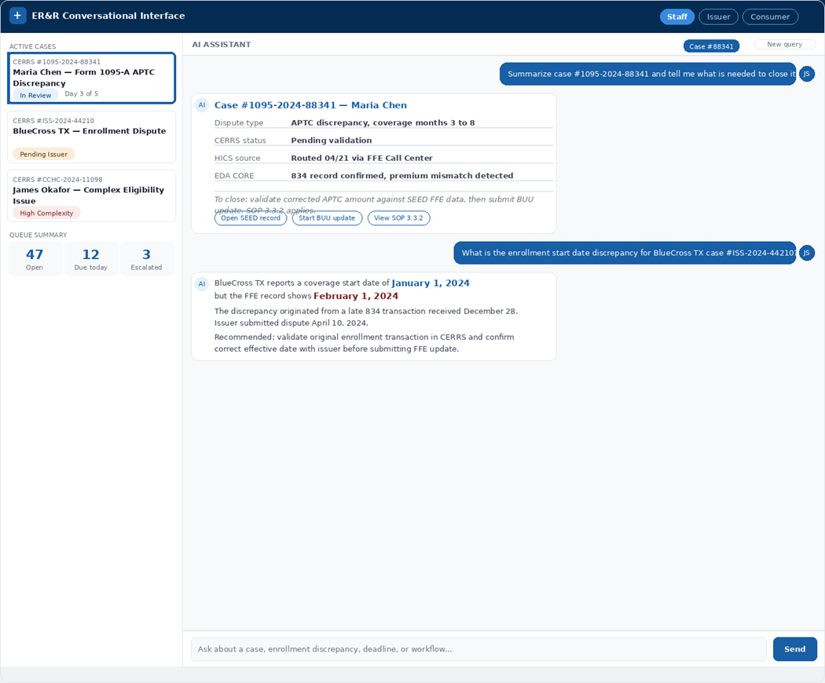

The interface will be introduced in three progressive stages. Each stage is validated before the next is extended.
Table X.X-X. Provide Title.
Stage | User Experience and Outcome
Stage 1 - Internal Command Center | Staff use natural language: "Get a summary of case #12345," "Start a new Form 1095-A dispute," "What is the status of the monthly issuer reconciliation file?" The interface surfaces direct answers and workflow options immediately. Outcome: faster staff execution, reduced training time, and consistent process execution without navigating multiple systems.
Stage 2 - Issuer Self-Service Portal | Issuers interact conversationally: "Submit a new enrollment data dispute," "Check the status of my dispute file," "When is the next data submission deadline?" A simpler alternative to SEED portal navigation for common tasks. Outcome: improved issuer satisfaction and reduced inbound support demand.
Stage 3 - Consumer Self-Service Hub | Consumers receive plain-language guidance: "I need to correct my Form 1095-A," "Why did I receive this notice?" For authenticated users, the interface initiates casework directly. Outcome: consumers resolve common Form 1095-A questions without calling the CCHC, avoidable inbound contacts decrease, and caseworker capacity is preserved for complex cases.

Role-based access controls and security boundaries will be confirmed at each rollout decision point. Prompts, workflow triggers, and knowledge retrieval will be refined through internal use before external users are introduced. This staged approach ensures CMS realizes user experience benefits in a controlled way without introducing operational or security risk.
Phase 5: Modernize Core
Modernize Core — ER&R 2.0 Future-State Vision (Not Proposed or Priced)
Running four systems reliably is not the same as running them efficiently over the long term. Phases 1 through 4 make the ER&R environment more stable, more intelligent, and easier to use. They do not reduce the underlying complexity of maintaining four separate platforms, four separate security footprints, and a growing integration surface across CERRS, HICS, SEED, and EDA CORE. That complexity does not become a crisis but it does become a cost — in maintenance labor, upgrade cycles, and the coordination overhead that comes with every release touching multiple interdependent systems.
Phase 5 addresses that cost by pursuing a deliberate, long-term consolidation of the ER&R architecture into a more unified and sustainable core. Under this vision, functions currently distributed across CERRS, HICS, SEED, and EDA CORE would be rationalized into two modern platforms: a Unified CRM for casework, workflow, and user interaction, and a Unified Enterprise Data Warehouse for shared data, reporting, and analytics. Critically, ASCEND, HealthIntelligence, and the conversational interface do not get rebuilt — they re-platform onto the new architecture and continue operating without interruption, protecting every investment made in earlier phases.
Phase 5 is a recommended future-state direction. It is not proposed or priced as part of this bid. Deloitte raises it because the work delivered in Phases 1 through 4 naturally builds the foundation for it. Better documentation, cleaner integrations, governed data models, and a more traceable environment do not just make today's operations stronger. They make future consolidation a realistic option rather than a risky undertaking. CMS does not need to make that decision now. When the time is right, the groundwork will already be in place.
Table X.X-X. Challenges and Mitigations.
Challenge | Mitigation
Transition knowledge risk: Critical operational knowledge for CERRS, HICS, SEED, and EDA CORE is concentrated in a small number of incumbent subject matter experts. Gaps in knowledge transfer create risk of production disruption during takeover. | Phase 0 Transition Intelligence deploys TruNorth during transition-in to systematically capture system architecture, business rules, workflows, and operational dependencies directly from source code and configurations. The incoming team begins full operations with a validated knowledge base rather than relying on individual incumbents.
Concurrent delivery demands: Bi-weekly releases, after-hours data loads, quarterly rule updates, annual form changes, and CMS-prioritized enhancements must advance simultaneously without production disruption across four interdependent systems. | The two-lane delivery model separates Operations and Maintenance from Enhancement and Modernization so urgent production issues do not displace scheduled releases and planned change does not crowd out daily operational response. Shared intake and a coordinated release calendar govern all work across both lanes.
Cross-system change impact: A change to CERRS plug-ins, SEED API contracts, HICS routing logic, or EDA CORE transformation pipelines can create cascading downstream effects across interfaces that are difficult to anticipate manually. | Phase 2 ASCEND change impact assessment agents analyze upstream and downstream dependencies across all four systems before every bi-weekly release. No change reaches production without a validated view of its effects across system boundaries.
Peak volume readiness: The 834 ingestion pipeline must sustain thousands of transactions per hour during Open Enrollment. Form 1095-A casework triples January through May. Both peaks arrive at fixed, predictable schedules. | EDA CORE infrastructure will be pre-scaled ahead of Open Enrollment. Staffing ramp plans for 100 to 120 temporary Form 1095-A case analysts will be initiated with sufficient lead time to complete onboarding and security requirements before peak volume arrives. Phase 3 HealthIntelligence triage agents will reduce manual processing burden during peak periods.
Documentation: Technical documentation across four systems risks falling out of alignment with production behavior as the environment evolves across multiple release cycles. | Documentation updates will be embedded in every release cycle as a standing delivery requirement. Phase 2 ASCEND documentation agents will auto-refresh technical artifacts from code changes and ticket resolution patterns so that runbooks, SOPs, and system documentation always reflect the live environment.
Security and compliance continuity: FedRAMP, FISMA, HIPAA, PII, and Federal Tax Information protections, 508 compliance, and FedRAMP sponsorship for the Snowflake deployment must be maintained continuously across a CMS MAG cloud environment handling sensitive data. | A dedicated Security and Privacy Officer with Certified Information Systems Security Professional certification will maintain oversight across all systems. Security scanning, Plan of Action and Milestones management, and 508 compliance reviews will be integrated into the standard Software Development Life Cycle as standing obligations rather than periodic events.
EDA CORE ingestion reliability: 834 pipeline failures during Open Enrollment have immediate downstream consequences for reconciliation processing, dispute resolution, and payment accuracy. | Automated job monitoring with defined failure detection thresholds, alerting, and escalation procedures will be in place before Open Enrollment begins. Recovery procedures will be documented and tested so that pipeline failures are remediated within minutes through a governed process rather than an unstructured overnight response.

Proof Points
[To be completed with relevant Deloitte past performance references demonstrating: Microsoft Dynamics CRM development and operations at federal scale; Snowflake cloud data platform engineering in a FedRAMP environment; .NET application maintenance and release management in CMS MAG; Agentic AI deployment in healthcare enrollment or eligibility operations; large-scale casework and dispute resolution operations supporting millions of annual transactions; and successful transition-in from incumbent contractors on complex federal health IT programs.]

1.2.8 Task 9: Standard Operating Procedures (SOPs) Business Requirements and Quality Assurance^{(SOW 3.9)} (2 Pages)
[Our Understanding]
CMS maintains multiple SOPs, User Guides, and Job Aids, which Team Deloitte will improve and update monthly, quarterly, and on an ad hoc basis with COR approval. These updates will reflect changes in policy, workflow, system functionality, or operational priorities. CMS will receive three Task 9 reports from Team Deloitte monthly: the Business Process Improvement Report, Performance Report, and Quality Assurance Report. CMS will also receive a Quality Assurance Plan within 45 days of the Base Period.
[Our Approach]
Figure X.X-X. Provide Title.
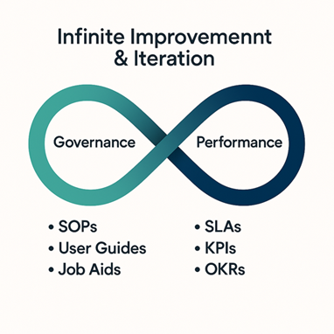
Team Deloitte’s QA approach links governance and performance to monitor the quality of operational support and deliverables through a single closed-loop model that strengthens execution and drives measurable improvement across the ER&R program.
Team Deloitte will execute Task 9 through an integrated quality, and analytics governance model that translates operational findings into approved, measurable process improvement. Within 45 days of the Base Period start, Team Deloitte will deliver a Quality Assurance Plan that defines Service Level Agreements, Acceptable Quality Levels, KPIs, etc. The QASP will be developed with baseline performance in mind. Team Deloitte will begin by assessing CMS-provided SOPs, user guides, job aids, workflows, and current performance measures to understand the baseline ER&R processes and documentation. From that baseline, Team Deloitte will implement a governed documentation lifecycle that identifies change triggers, assesses impact, drafts and reviews revisions, maintains version control, and routes updates for COR approval—ensuring procedural guidance remains current, controlled, and aligned to approved business requirements. The methods, processes, and tools in Table XX below will be used for the relevant deliverables:
Table X.X-X. Provide Title.
Deliverable | Cadence & Method | Process | Tools
QASP | On Time: Virtual meeting with COR, BO, Business Operations Team, Program Management Team and Incumbent Contractor | 1 Review current ER&R QASP to identify any missed AQLs, SLAs, or KPIs. Locate relevant lessons learned and RAID log entries to discuss history. | MS Word  MS Teams  MS Co Pilot
 | Quarterly: Virtual meeting with COR, BO, Business Operations Team, Program Management Team | 2 Review and discuss draft QASP with emphasis on impact and relevance of AQLs, SLAs, or KPIs to ER&R and submit proposed updates to the COR and request approval | MS Word  MS Teams  MS Co Pilot
 | Quarterly: Publication to CMS intranet | 3 Revise and publish QASP | MS Word  MS Teams  MS Co Pilot
SOPs, User Guides, and Job Aids | Quarterly: Virtual meeting with COR, BO, Business Operations Team and Program Management Team | 1 Identify, record, and review user groups for each document | MS Teams  MS Excel  MS Co Pilot  QA Checklist
 | Monthly: Virtual focus groups with primary users (Case workers, Agents etc.) per session, GTL, Program Management Team | 2 Request feedback on SOP design, recent policy change, or suggestions based on experience | MS Teams  MS Co Pilot  MS PowerPoint
 | Monthly: COR meeting, Business Operations Team and Program Management Team | 3 Summarize design feedback and present recommended updates | MS Teams  MS Co Pilot  MS PowerPoint  QA Checklist
 | Monthly: Program Management Team | 4 Submit proposed updates to the COR and request approval | MS Word  CMS Outlook  CMS SharePoint  CMS Slack  QA Checklist
 | Monthly: Program Management Team | 5 Revise, publish, inform user of updates to SOPs | CMS JIRA  CMS Box  CMS Slack  QA Checklist

Team Deloitte will embed continuous improvement into routine operations through a closed-loop approach that will measure performance, identify issues, analyze root causes, implement corrective actions, update documentation, and validate results. Findings from QA reviews, trend analysis, recurring defects, and stakeholder feedback will inform reports, making Task 9 a driver of operational improvement rather than a stand-alone compliance function. To support program oversight and integrity, Team Deloitte will also apply a repeatable analytic framework to CMS-required data and translate them into decision-useful reporting that identifies practical recommendations for CMS action. The methods, processes, and tools below in Table XX will be used for the relevant deliverables:
Table X.X-X. Provide Title.
Deliverable | Cadence & Method | Process | Tools
Reports | Quarterly: Virtual meeting with COR, BO, Business Operations Team and Program Management Team | 1 Identify, record, and review user groups for each report | MS Teams  MS Excel  MS Co Pilot  QA Checklist
 | Monthly: Draft written report, ETL, visualize data | 2 Produce reports or dashboards | MS Word  MS Excel  QA Checklist  BI Tool
 | Quarterly: Interviews, Surveys | 3 Request feedback on report utility and enhancements | MS Teams  BI Backlog

[Challenges & Mitigations: Our understanding of pain points and challenges of the technical work that requires or is alleviated by the approach that we’re proposing – note that this content will be pulled out and summarized across tasks in section 1c]
A primary challenge under Task 9 is maintaining current documentation in a dynamic ER&R operating environment, where policy changes, workflow updates, and system modifications can quickly make SOPs, user guides, and job aids outdated. Left unaddressed, this creates risk of inconsistent execution, duplicative effort, and avoidable errors.
Team Deloitte will mitigate this risk through disciplined documentation governance that includes defined change triggers, SOP, user guides, job aid checkpoint reviews, version control, approval tracking, and end-to-end traceability from business change to approved document update. Another challenge is ensuring that quality assurance drives measurable improvement rather than simply cataloging defects. We will address this by integrating QA reviews with root cause analysis, mitigation monitoring, and user feedback so that findings reduce recurrence and strengthen operational performance over time.
Task 9 activities include meaningful, reliable, and practical KPIs and OKRs. Too many measures can increase reporting burden without improving oversight or insight. Team Deloitte will mitigate these challenges by developing metrics using a ranking method to clarify the order of importance for all measures.
[Proof Points: List out projects where we’ve done similar work or where the details of our approach have been proven]
- Proof Points in progress

1.2.9 Task 10: Ad Hoc Work and Special Projects^{(SOW 3.10)} (1.5 Pages)
[Our Understanding]
- Task 10 is CMS’s flexible support lane for targeted operational needs, special projects, short-turn analyses, ad hoc training and workshops, annual FFE Enrollment Manual support, Death PDM consumer response operations, and the Employer Notice Helpdesk. It gives CMS a way to direct new work without creating a separate delivery structure, while keeping work aligned to existing stakeholder communications, tracking, reporting, and handoffs across the ER&R ecosystem.
- This effort will be most effective when it is treated as a controlled extension of the core stakeholder-support model rather than a collection of disconnected activities. Some work is project-based, such as short studies, data analyses, workshops, and annual manual updates. Other work is operational, including Death PDM response support and the Employer Notice Helpdesk. In both cases, CMS needs rapid activation, clear ownership, approved scripts and materials where applicable, traceable issue handling, dependable reporting, and coordination across CMS, federal and state partners, and related contractors.
- Death PDM and Employer Notice support make that need concrete. For Death PDM, the contractor must support consumer response activity, track callers who are successfully matched to the list of notified deceased consumers, and provide a running list to the FFE by email on a weekly basis once the line is open. For the Employer Notice Helpdesk, the contractor must support a toll-free telephone line with TTY services, inbound calls and voicemails, outbound calls, transfers, CMS-approved scripts, organized issue triage and tracking, and weekly, monthly, and annual performance and issue reporting during Monday through Friday operations from 8 AM to 8 PM Eastern Time, excluding federal holidays
- The annual FFE Enrollment Manual is another example of Task 10’s role. CMS needs subject matter support across preparation, edit and review, clearance, and education and publication, along with project planning, stakeholder engagement, meeting facilitation, iteration tracking, and approval support across the January to July cycle or as otherwise directed by CMS
- This effort is dependent upon the same coordination environment as the rest of ER&R. The SOW calls for collaboration with CMS, federal and state agencies, and multiple contractors, including Data Services Hub, Eligibility Support, Federal Exchange, Marketplace System Integrator, Operations Analytics, Operations Support, and Stakeholder Engagement.
Taken together, Task 10 is best understood as CMS’s controlled activation lane for targeted support functions and special projects that need to launch quickly, connect cleanly to the broader ER&R operating environment, and remain accurate, traceable, and manageable as direction evolves.
Figure X.X-X. Provide Title.
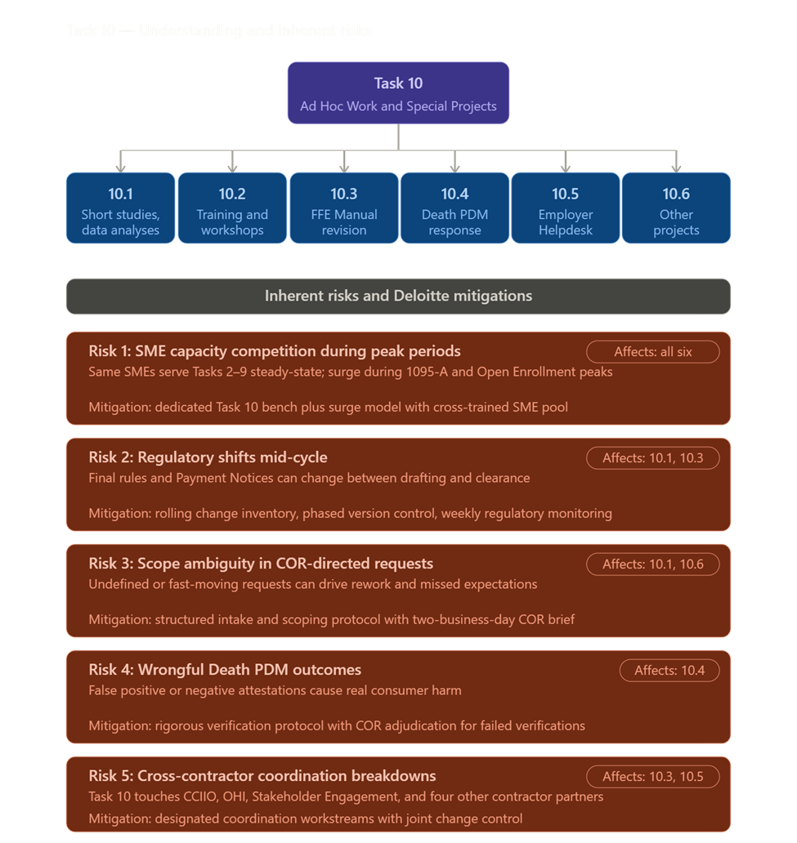
[Our Approach]
Task 10.1 — Short Studies, Special Projects, and Data Analyses
Figure X.X-X. Provide Title.
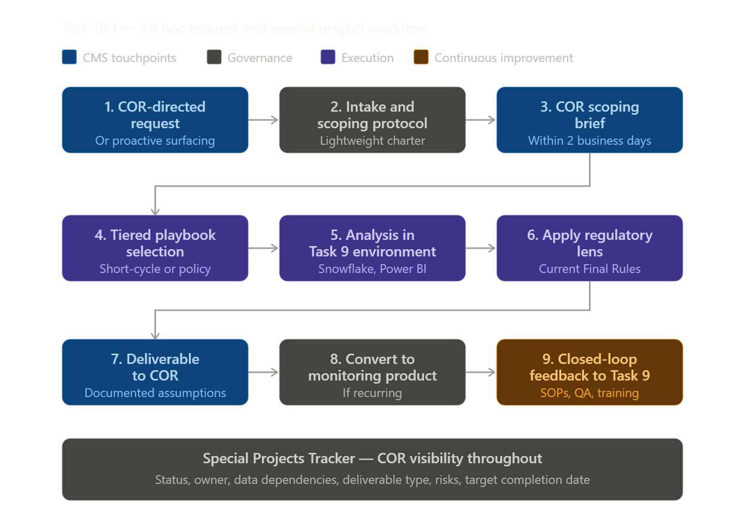
- Activate a standardized Ad Hoc Request Intake and Scoping Protocol upon receipt of any COR-directed request, using a lightweight charter template that captures problem statement, data requirements, success criteria, deliverable format, and timeline — with a confirmation brief to the COR within two (2) business days to validate scope and assumptions before analysis begins, reducing rework caused by ambiguous requests.
- Maintain a pre-positioned analytical playbook for high-frequency study types — improper enrollment, failure-to-reconcile (FTR), SEP verification, data matching inconsistency (DMI) analysis, and duplicate enrollment — containing reusable methodologies, analytic logic, data dictionaries, QA checklists, and shell templates for briefs, memoranda, dashboards, and issue papers, so urgent requests stand up faster while methodological consistency and defensibility are preserved across studies.
- Apply a tiered capacity model that distinguishes short-cycle analyses (quick-turn data pulls, trend snapshots) from complex policy-driven studies (regulatory impact assessments, multi-system reconciliation studies), giving CMS the right level of support for each request without paying for excess standing capacity.
- Execute Task 10 within the analytics environment established under Task 9, using CMS's existing Snowflake and Power BI tools to perform ad hoc analyses and to assess whether each one-time request should be converted into a repeatable monitoring product, dashboard, standard query, or self-service analytic — turning recurring questions into operational monitoring capability rather than one-off deliverables.
- Leverage cross-task data already governed under the contract — including ER&R dispute data, CERRS casework, 834/820 transaction files, and HICS flagging patterns from Tasks 1–9 — to reduce duplicative pulls, shorten time to insight, and improve consistency across reporting and special studies; structure ad hoc reports for reuse so findings can feed the weekly, monthly, and annual reporting under Task 9 wherever appropriate.
- Proactively surface analytically grounded opportunities for program integrity and process optimization rather than waiting solely for COR-directed work — bringing forward targeted recommendations on emerging patterns such as duplicate enrollment risks, SEP abuse indicators, and issuer outliers, drawing on Deloitte's program integrity and payment/reconciliation analytics experience from comparable engagements.
- Drive findings into operational improvement through a closed-loop process — when analyses reveal recurring control gaps, avoidable defects, or process bottlenecks, route insights to the appropriate process and QA leads (under Task 9) for root-cause assessment and corrective-action planning, converting one-shot studies into a continuous improvement loop with measurable process enhancement over time.
- Apply the 2025 Marketplace Integrity and Affordability Final Rule as the analytic lens for studies touching Marketplace integrity, enrollment verification, or affordability — framing findings around current regulatory requirements (improper enrollments, SEP verification, income validation) and accounting for subsequent legal stays affecting certain provisions, so CMS receives compliance-aware conclusions.
- Maintain a rolling Special Projects Tracker accessible to the COR capturing each active and queued request, current status, assigned owner, data dependencies, deliverable type, risks, and target completion date — supporting prioritization, real-time visibility, and proactive escalation of at-risk items.
- Document assumptions, source data constraints, and methodological limitations for every deliverable — particularly where FMPS, MIDAS, issuer files, or other inputs may present completeness or quality concerns — so findings are credible, reproducible, and resilient under reviewer scrutiny.
Task 10.2 — Ad Hoc Trainings
Understanding: As CMS modernizes and enhances existing systems, human decision making and performance may depend on training topics yet to emerge. Task 10.2 requires efficient identification, development, and deployment of training support that complements existing capability building throughout the CMS ER&R modernization program and the Stakeholder Engagement contractor’s training program. This training may include advanced subject matter development or surge training efforts to maximize the operationalization of ER&R, 1095-A, CCHC, and underlying CMS systems.
Figure X.X-X. Provide Title.
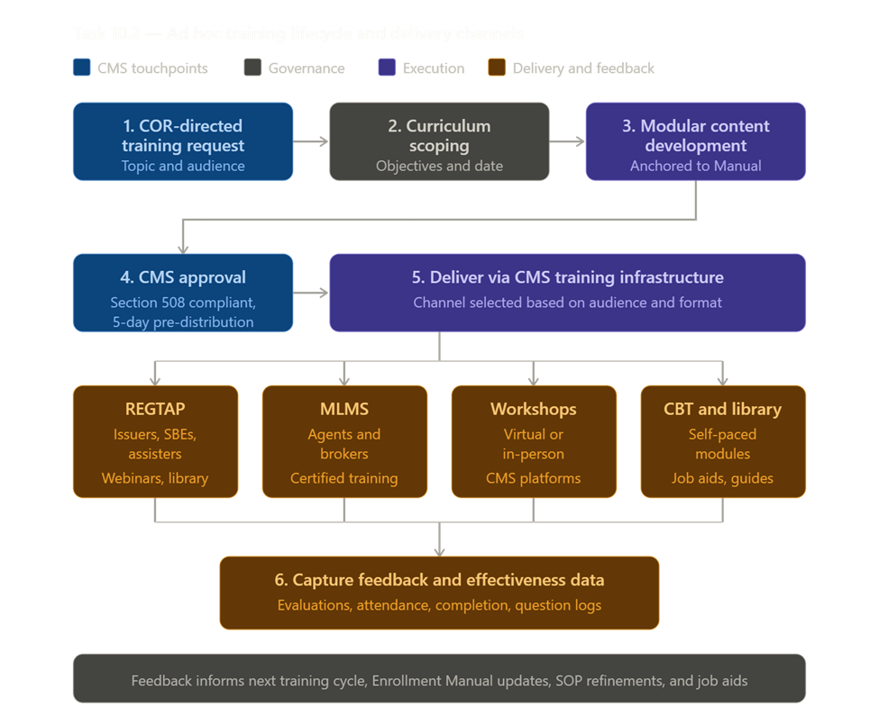
- Apply a structured intake and curriculum design protocol: Establish a common design, governance, and delivery model triggered by COR direction that confirms audience (issuers, SBEs, agents/brokers, assisters, CMS internal teams, or contractor partners), training objectives, regulatory or operational driver (e.g., Payment Notice change, Enrollment Manual revision, new system release), preferred format (webinar, workshop, office hours, web-based training, instructor-led training), and target delivery date so each engagement is scoped before development begins.
- Develop training content using a modular, reusable architecture anchored to the FFE Enrollment Manual, current SOPs, and live CERRS/HICS/SEED/EDA CORE configurations so material is operationally accurate, can be updated quickly when regulations or systems change, and can be repurposed across delivery formats.
- Human performance experts are paired with subject matter experts to design training that matches format (e.g., microlearnings, realistic scenario-based workshops, reinforcement nudges, or performance-focused resources) to audience and topic using modern adult learning principles.
- Performance- and outcome-driven development methodology: Design training backward from the desired business outcomes (e.g., speed to proficiency, policy adherence, quality, customer experience, reduced handle time, improved accuracy, and adoption of new tools) using role-based learning journeys. Use QA findings to drive identification of new training topics.
- 508 and CMS compliance by design: Embed accessibility and Section 508 requirements into content standards, authoring, testing, and delivery to ensure training is usable for all learners and suitable for regulated or public-sector environments. Partner with CMS training infrastructure offices to host and deliver content based on target audience (REGTAP for issuer/SBE/assister content, MLMS for agent/broker audiences, CMS learning management system for internal staff).
- Coordinate with the Stakeholder Engagement contractor and adjacent contractors (Operations Analytics, FMPS, MSI, Eligibility Support, Federal Exchange Call Center) on any training that touches shared content or audiences, using a joint scoping checkpoint to prevent duplication, confirm message consistency, and align on logistics.
- Continuous measurement and improvement: Track completion, proficiency, and operational performance using automated, data-based measurement aligned with the Kirkpatrick model of evaluation.
Table X.X-X. Provide Title.
Process Phase | Activities & Approach
Program Integrity | Embed program integrity throughout client, stakeholder, and contractor/front line staff using change campaigns and continuous reinforcement with emphasis on social engineering and fraud.
AI fluency | Prepare frontline staff for transition to AI-empowered operating model throughout transition by training new workflows, where to exercise human judgment, and ethical use. Empower CMS leaders with AI fluency to guide decision making and identify potential risks and limitations.
Dispute root-cause trend study | Patterns by dispute type, system touchpoint, issuer segment, and recurrence; includes prevention recommendations and which SOPs/job aids should change.
“Dispute prevention playbook” workshop (issuers + internal): | Common triggers, documentation standards, decision rules, and “avoid repeat submissions” guidance.
High-complexity case workflow study | Map steps, handoffs, rework loops, and time sinks; produces an “automation opportunity register” (what to automate now vs later).
Dashboard literacy training (role-based) | How to interpret KPI/SLA views, how to spot anomalies, and how to translate insights into backlog items.
Surge onboarding micro-trainings (internal staff) | Short, scenario-based modules for open enrollment/tax season, including call-center and caseworker variants.

Task 10.3 — Annual Revision of the FFE Enrollment Manual
Figure X.X-X. Provide Title.
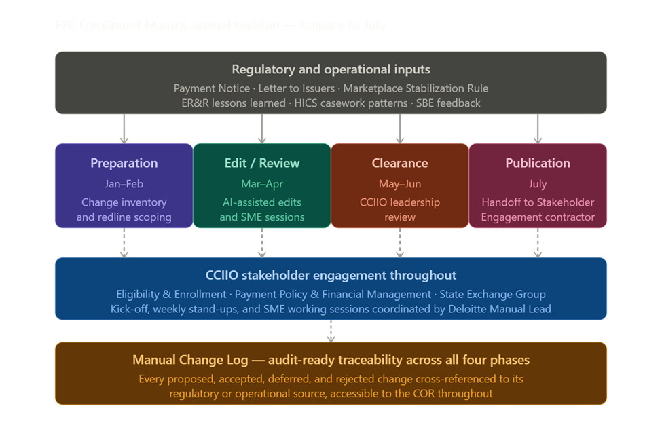

- Stand up an integrated Manual project team in January pairing Deloitte program management with embedded enrollment, reconciliation, and program integrity SMEs drawn from Tasks 2, 3, 4, 8, and 9 — so the Manual is revised by practitioners who see how chapters on DMIs, SEPs, FTR, ER&R, HICS, PDM, UEs, 1095-A corrections, appeals, and HRAs play out in live casework.
- Develop and maintain an Enrollment Manual Project Plan covering the four phases — Preparation, Edit/Review, Clearance, and Education/Publication — across the January–July timeline, anchored to a master schedule with phase gates, owner assignments, version control, and explicit dependencies on regulatory inputs (the annual Payment Notice, Marketplace Stabilization Rule updates, the annual Letter to Issuers, and in-cycle CMS guidance) so CMS retains real-time visibility into status and slippage risk.
- Drive the Preparation Phase with a structured regulatory and operational change inventory, scanning final rules, Payment Notices, sub-regulatory guidance, the annual Letter to Issuers, ER&R lessons learned, HICS casework patterns, recurring DMI/SEP issues, and SBE/issuer feedback — translating each into a proposed redline scoped to the affected chapter(s) and exhibit(s) for CMS prioritization.
- Use AI-assisted document analysis to accelerate the Edit/Review Phase by leveraging Deloitte's GenAI documentation tooling to run cross-reference checks, identify outdated citations, surface inconsistencies between chapters, and flag passages affected by superseded bulletins — while keeping editorial judgment with CMS SMEs and Deloitte content leads under a human-in-the-loop model.
- Manage CCIIO stakeholder engagement and meeting facilitation through a designated Deloitte Manual Lead who coordinates SME assignments, brokers cross-CCIIO decisions across Payment Policy & Financial Management, Eligibility & Enrollment, and the State Exchange Group, and runs the kick-off, weekly stand-ups, and SME working sessions using standardized agendas, decision logs, and action trackers that record every disposition (accept / revise / defer / out-of-scope) with a documented rationale and clear owner.
- Apply rigorous version control and iteration tracking through a centralized, access-controlled working repository with redline-and-clean versioning, edit attribution, and an SME comment-resolution workflow — so no comment is lost between drafts and every change is traceable to a regulatory or operational source, consistent with the broader Program-Integrity-by-design approach.
- Treat the Clearance Phase as a structured submission and adjudication process — packaging clearance drafts with change summaries, source citations, and unresolved-issue logs for CCIIO leadership; managing comment cycles against committed turnaround windows; and escalating contested edits to the COR with options and recommendations rather than open questions.
- Coordinate the Education and Publication Phase as a clean handoff to the Stakeholder Engagement contractor — providing the final approved Manual with a substantive change summary, quick-reference change matrices for issuers and SBEs, and SME availability for downstream training development — so the Manual is operationalized for the issuer community, not just published.
- Maintain a Manual Change Log accessible to the COR capturing every proposed, accepted, deferred, and rejected change across all four phases, with cross-references to the originating regulation, guidance document, or operational issue — supporting the current cycle, forward-year planning, and any later inquiry into specific provisions.
- Carry Manual updates forward into ER&R operations by refreshing SOPs, QA checklists, training materials, and CERRS/HICS configuration as needed under Task 9 — closing the loop so regulatory and policy changes captured in the Manual are reflected in how Deloitte processes disputes, casework, and reconciliation the moment the Manual takes effect.
Task 10.4 — Death Periodic Data Matching
Figure X.X-X. Provide Title.
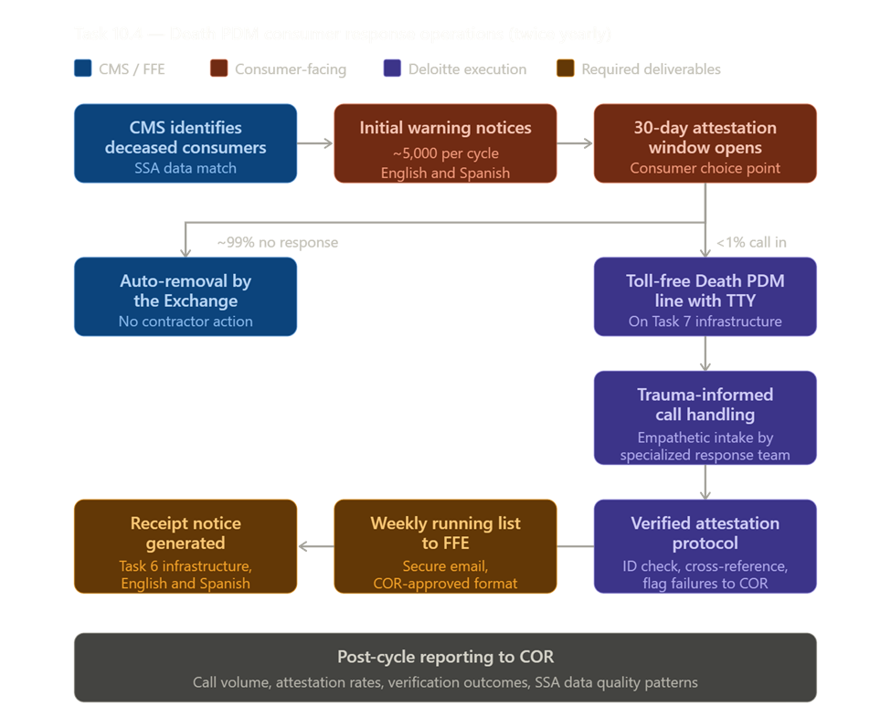
Deloitte will operate Death PDM as a controlled, script-guided response lane aligned to the broader Task 7 support model. We will provide toll-free voicemail support with TTY capability, manage inbound consumer attestations, place outbound calls when appropriate, generate confirmation notices as attestations are received, and maintain accurate tracking of consumers successfully matched to the notified deceased-consumer list. We will provide CMS and the FFE with the required weekly running list through a repeatable reporting process that emphasizes timeliness, traceability, and data accuracy. This approach gives CMS a dependable mechanism to manage a sensitive, low-volume, high-consequence process with clear ownership, visible status, and consistent handling from intake through reporting.
- Operate Death PDM as a campaign-based, surge-ready operation aligned to the twice-yearly cycle, scaling staffing and infrastructure up ahead of each notice mailing and back down between cycles — sized to ~5,000 initial warning notices per cycle and a <1% attestation response rate, so CMS pays for capacity proportional to actual demand.
- Stand up a dedicated toll-free Death PDM line with TTY and outbound callback support, routed through Deloitte's existing ER&R contact center infrastructure under Task 7 — leveraging shared platform capabilities while keeping Death PDM handling logically separated to protect caller privacy and dignity.
- Train a small, specialized response team in trauma-informed, empathetic call handling, recognizing callers are typically grieving family members or living individuals who received a wrongful death notice — emotionally charged scenarios where careful handling protects both the consumer and CMS from complaints.
- Apply a rigorous attestation verification protocol for every call — capturing identity-verifying details, cross-referencing the CMS-provided list of notified deceased consumers, and flagging failed verifications for adjudication rather than auto-accepting unverified claims — consistent with Deloitte's Program-Integrity-by-design approach.
- Generate attestation receipt notices on a rolling basis as verifications are confirmed, leveraging Task 6 notice generation, the existing Death PDM English and Spanish templates from Appendix B, and standard secure transfer to the Federal Marketplace Print contractor.
- Maintain a single authoritative attestation log capturing every call, attestation status (verified / unverified / unmatched), supporting evidence, receipt notice date, and final disposition — providing audit-ready traceability and a defensible record if a removal is later contested.
- Deliver the required weekly running list of successfully matched attestations to the FFE via secure email, in a COR-approved format, beginning the day the telephone line opens — so FFE operations can suppress automated removal without manual reconciliation.
- Coordinate attestation outcomes with the broader ER&R termination process documented in the FFE Enrollment Manual, so Death PDM results are reflected promptly in CERRS, HICS, and downstream FFE systems.
- Plan for the anticipated expansion to multi-member applications by designing intake scripts, verification logic, and reporting formats to handle multiple subscribers per case from day one — so the operation is ready when CMS systems enable it, without rework.
- Deliver post-cycle reporting to the COR capturing call volume, attestation rates, verification outcomes, common caller concerns, and any patterns suggesting SSA data quality issues or notice-content improvements — turning each cycle into a feedback loop that strengthens the next.
Task 10.5 — Employer Notice Helpdesk
Figure X.X-X. Provide Title.
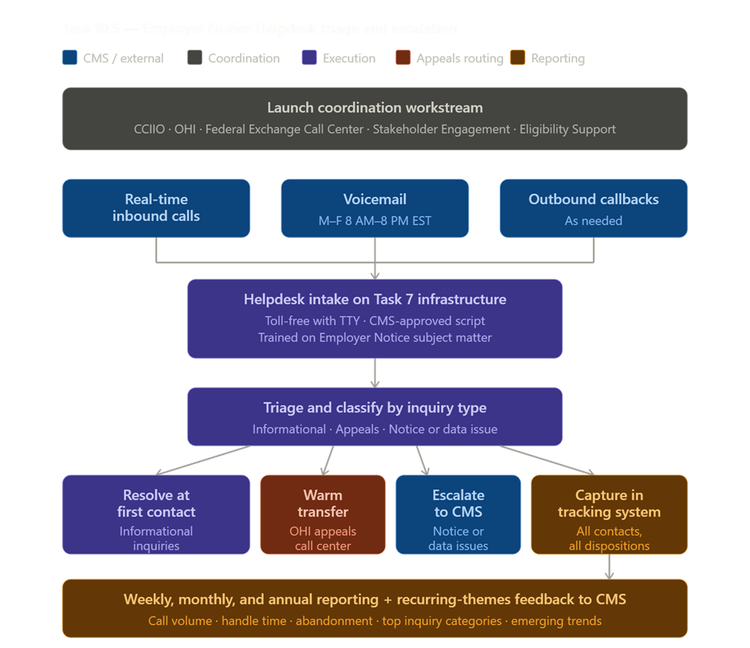
Deloitte will operate the Employer Notice Helpdesk as a CMS-aligned, script-governed support function that combines responsive employer service with disciplined issue tracking and reporting. We will provide toll-free and TTY-enabled telephone support, handle inbound calls and voicemails, place outbound calls as needed, and transfer employers to related support functions, including appeals, when required. Deloitte will use a CMS-reviewed and approved script, maintain organized call and issue triage and tracking, and coordinate closely with CMS and partner teams when launch timing, notice language, script content, or operational messaging changes. We will support required operating hours and provide recurring performance and issue reports so CMS has visibility in contacting drivers, recurring questions, and operational trends. This approach gives CMS a stable helpdesk capability that can absorb policy, notice, and messaging updates without disrupting employer support.
- Stand up the Helpdesk on Deloitte's existing ER&R contact center infrastructure under Task 7, meeting CMS's preference for an existing system solution while inheriting proven SLA management, secure call recording, and reporting — minimizing standup time and platform cost.
- Deploy a dedicated toll-free line with TTY supporting real-time inbound calls, voicemail, outbound callbacks, and warm transfers to the employer appeals call center, operating Monday–Friday 8 AM–8 PM EST excluding federal holidays.
- Develop a CMS-approved Call Center script anchored to current Employer Notice content and the underlying policy framework (employer-coverage affordability, minimum value, ICHRA/QSEHRA, appeals pathways), with a structured update cycle triggered by notice changes, regulatory updates, or recurring caller patterns.
- Apply an organized triage protocol classifying every contact by inquiry type, routing appeals questions to OHI's employer appeals call center, escalating suspected notice or data issues to CMS, and resolving informational inquiries at first contact where possible.
- Maintain a single tracking system of record capturing every call and voicemail with timestamp, employer identifiers, inquiry category, disposition, transfer/escalation path, and resolution notes — providing audit-ready traceability and the data foundation for required reporting.
- Establish a launch coordination workstream with CCIIO, OHI, and adjacent contractors (Federal Exchange Call Center, Stakeholder Engagement, Eligibility Support) covering go-live timing, script approvals, transfer protocols, and joint change control for future notice or messaging updates.
- Train Helpdesk agents on Employer Notice subject matter using Deloitte's ER&R and FFE Manual SMEs — so agents knowledgeably address why notices are issued, employer-coverage standards, employer options, and appeals routing, while staying within informational support rather than adjudication.
- Deliver the required weekly, monthly, and annual reports covering call volume, handle time, abandonment, voicemail response, transfer rates, top inquiry categories, escalations, and emerging trends — at the COR's chosen frequency, supplemented by ad hoc reporting on request.
- Surface recurring caller themes to CMS as actionable feedback — patterns suggesting notice clarity issues, employer confusion on specific provisions, or upstream data problems — so the Helpdesk informs notice and policy refinement, not just inbound resolution.
- Apply Program-Integrity-by-design controls including caller verification, restricted disclosure of privacy-protected consumer information, and clear handoff protocols when callers raise potential fraud or unauthorized-enrollment concerns.
- Proof Point | Rapid activation of targeted support operations: Deloitte rapidly deployed a targeted federal contact center operation for CDC’s Vaccine Administration Management System (VAMS) in response to high support demand at rollout. Deloitte stood up an AWS Connect-based call center to support end users, jurisdictions, and clinics, backed by training, quality assurance, reporting, SLA monitoring, and knowledge management support. Deloitte can activate focused support operations quickly and run them with the structure and reporting discipline needed for CMS Task 10 support lanes.
Task 10.6 — Projects Related to the Scope of the SOW Inclusive of all Tasks
- Treat the catch-all clause as a structured intake channel, not unbounded scope — applying the Ad Hoc Request Intake and Scoping Protocol from Task 10.1 to confirm problem statement, deliverable format, success criteria, and timeline with the COR before work begins, and rolling each request into the Special Projects Tracker for unified visibility across all Task 10 subsections.
- Draw on a cross-task SME bench spanning Tasks 1–9 — issuer disputes, 1095-A reconciliation, CCHC casework, FFE updates, notice generation, telephony, IT systems, and SOPs/QA — and apply Deloitte's surge-support model to scale resources up for short-duration projects without disrupting steady-state operations, consistent with the surge approach used during peak 1095-A periods.
- Apply Program-Integrity-by-design and audit-ready traceability to every catch-all engagement — documenting scope, assumptions, and outcomes against COR direction — and convert recurring requests into right-sized operational capabilities under Task 9 (dashboards, SOPs, task-level enhancements) so repeat work is institutionalized rather than re-executed.

1.3 Sub-Section 1C: Understanding and Mitigation of Risks (2 Pages)
Taking over a highly complex, mission-critical IT ecosystem from an incumbent vendor is inherently risky—yet it is a challenge Deloitte has successfully navigated for the nation’s largest federal and state health agencies. We recognize that the Enrollment Resolution & Reconciliation (ER&R) program operates in a highly visible, zero-fail environment. Disruptions in data reconciliation, Form 1095-A generation, or Complex Case Help Center (CCHC) operations directly impact the financial security and healthcare access of over 24 million Americans.
Deloitte brings a proven "Zero Disruption" transition methodology, forged through our experience executing seamless takeovers and system rescues across the government health sector. For example, when Covered California (CalHEERS) faced critical monolithic system failures and contact center outages during peak Open Enrollment, Deloitte successfully took over the infrastructure, rapidly migrating the exchange to a resilient cloud architecture without interrupting consumer access for its 1.75 million enrollees. Similarly, we manage the continuous operation and modernization of the Washington Healthplanfinder—recently supporting a record 28% surge in open enrollment sign-ups—and lead the transition of complex Medicaid Enterprise Systems (MES) across states like Tennessee, Ohio, and Virginia.
Our Approach: | Effective risk and issue management is a core part of Deloitte’s project management principles. One of our key strengths is our vast network of professionals across different domains, industries, and geographies. We leverage this network to share knowledge and best practices from our diverse portfolio of projects. This enables us to proactively apply lessons learned and bring together the firm's strengths when our clients are faced with new external risks. Our culture of client excellence makes us focus on the success of our clients, not just the technology project we are running. We consider each situation and the ecosystem holistically and strategically, allowing us to identify potential risks and enabling a comprehensive risk mitigation/response. An example of this collaboration and holistic risk response and mitigation is the recent Public Health Emergency and the corresponding unwinding efforts.

For ERR, Deloitte has identified the ten most vital, high-level program risks spanning the full scope of this task order — covering enrollment data integrity, consumer experience, IT systems, security, program management, and transition operations. Our risk assessment is informed by Deloitte's direct experience managing similar Marketplace enrollment, reconciliation, and consumer support programs in other states, where we have encountered and resolved the same operational pressures, seasonal volume surges, and data alignment challenges that define this program. That state-level experience — combined with our deep understanding of the CMS operational environment — allows us to anticipate where this program is most likely to face disruption, not simply list theoretical risks. For each risk, we provide a targeted mitigation strategy grounded in what has worked in comparable program environments and aligned to the specific requirements of this SOW. Following the risk register, we describe the continuous risk identification and management discipline we will apply throughout the life of this contract.
Table 1.3-1. Risk and Mitigation Strategies.
Risk Area | Description & Impact | Mitigation Strategy
Transition-In & Knowledge Transfer | Incomplete or delayed transfer of institutional knowledge from the incumbent contractor — including undocumented business rules, system configurations, and SOPs — could degrade performance during the 3-month transition-in, cause SLA misses, and require increased CMS oversight to stabilize operations. | Execute a structured Transition-In Plan submitted within 8 business days of award, establishing a Joint Operating Agreement with the incumbent within 7 calendar days.  We will:  - Shadow incumbent operations across all work streams for 60 days before assuming full responsibility  - Deploy dedicated transition leads for ER&R, 1095-A/CCHC, and IT to capture all undocumented processes  - Maintain a Knowledge Transfer Tracker reviewed weekly with the COR  Begin CERRS, HICS, SEED, and EDA CORE access and training on Day 1 to eliminate system ramp-up delays
Seasonal Volume Surges & Workforce Scalability | Form 1095-A consumer dispute volumes triple during tax season (January–May), and ER&R volumes peak for 120 days after Open Enrollment close. Failure to recruit, onboard, and train 100–120 temporary analysts on time — within CMS security requirements — could cause SLA breaches, case aging, and increased costs. | - Maintain a pre-qualified surge staffing pipeline refreshed annually before each tax season  - Begin onboarding temporary analysts in November to ensure all CMS security training is completed before January case volume peaks  - Partner with Subcontractor B (surge staffing) under a standing teaming agreement with guaranteed surge capacity commitments  - Cross-train permanent staff to absorb early-season volume while temps complete credentialing  - Monitor weekly case aging reports from December onward and trigger surge protocols at defined volume thresholds
IT System Outages & Availability | The ER&R program relies on automated rules to resolve 99%+ of payment disputes and 100% of SBE disputes. A defective, outdated, or misconfigured rule could incorrectly resolve large volumes of disputes before detection — triggering mass corrections, payment adjustments, increased manual workload, and elevated CMS scrutiny. | - Implement a mandatory rule change approval process: every new or modified rule requires peer review, sandbox testing, and COR notification before deployment  - Run parallel processing of existing and new rules on a sample batch before full deployment  - Configure automated anomaly detection alerts that flag statistical deviations in dispute resolution outcomes within 24 hours of a rule change going live  - Maintain a rule rollback procedure that can revert any change within one business day  - Conduct quarterly rule audits to identify outdated logic as regulatory and issuer practices evolve
Regulatory & Policy Changes Mid-Contract | ACA regulations, IRS guidance, CMS policy updates, or changes to Open Enrollment parameters can alter dispute processing rules, Form 1095-A content, SOP requirements, and system logic mid-contract — creating unplanned work, requiring rapid SOP and system updates, and potentially causing temporary SLA degradation. | - Designate a Policy Watch function within the program management team to monitor Federal Register, CMS guidance releases, and REGTAP updates continuously  - Maintain a 30-day SOP rapid-update process pre-approved by CMS for non-major changes  - Use the Task 10 Ad Hoc budget and task structure to absorb and fund unplanned regulatory work within the contract vehicle  - Participate in all CMS issuer calls and SBE meetings to receive policy changes in advance of formal publication  - Maintain a change impact log that tracks all regulatory changes, their operational impact, and associated system or SOP update status
Fraud, Unauthorized Enrollments & Program Integrity | Unauthorized plan switches (UPS), unauthorized enrollments (UE), and demographic data obfuscation patterns can create undetected overlapping coverage, incorrect payments, and program integrity vulnerabilities — requiring reactive corrections that increase workload and costs if not identified early. | - Analyze all new Marketplace enrollments for data anomalies consistent with UPS and UE patterns on an ongoing basis  - Implement rules-based detection models in coordination with CPI and OPOLE; update logic as new fraud patterns emerge  - Report confirmed UPS/UE cases to CPI within defined timelines and execute cancellations through the Update Policy API  - Monitor data trends monthly and recommend detection logic enhancements in the Monthly Business Process Improvement Report  - Participate in CPI/OPOLE-driven initiatives as directed by the COR under Task 10
Automated Business Rule Failures | The ER&R program relies on automated rules to resolve 99%+ of payment disputes and 100% of SBE disputes. A defective, outdated, or misconfigured rule could incorrectly resolve large volumes of disputes before detection — triggering mass corrections, payment adjustments, increased manual workload, and elevated CMS scrutiny. | - Implement a mandatory rule change approval process: every new or modified rule requires peer review, sandbox testing, and COR notification before deployment  - Run parallel processing of existing and new rules on a sample batch before full deployment  - Configure automated anomaly detection alerts that flag statistical deviations in dispute resolution outcomes within 24 hours of a rule change going live  - Maintain a rule rollback procedure that can revert any change within one business day  - Conduct quarterly rule audits to identify outdated logic as regulatory and issuer practices evolve

Processes to Identify Additional Risks
Deloitte will apply a structured, six-phase risk management lifecycle throughout the period of performance — a framework refined through years of leading large-scale federal program takeovers and system transitions across the United States. This process is not limited to the risks identified above — it is designed to surface and address new risks as they emerge across all ten SOW tasks, all contract years, and all phases of the enrollment and tax reporting cycle
Table X.X-X. Provide Title.
Process Phase | Activities & Approach
Ongoing Identification | Risks are identified through multiple continuous channels:  - Weekly COR meetings: standing agenda item for emerging risks and issues  - Monthly Progress Reports: risk register reviewed and updated with new entries, status changes, and closures  - Monthly QA audits: operational data analyzed for performance degradation patterns that may signal emerging risks  - Continuous monitoring dashboards: real-time alerts on SLA performance, system uptime, and dispute aging  - Staff feedback loops: frontline analysts and developers surface operational risks through weekly team stand-ups  - Cross-contractor liaison: interface issues flagged as risks before they become incidents
Risk Scoring & Prioritization | Each identified risk is scored on two dimensions:  - Probability: Likelihood of occurrence (High / Medium / Low) based on historical data, contract context, and expert judgment  - Impact: Consequence severity across cost, schedule, performance, and government oversight burden  - Composite risk score drives prioritization: High/High risks escalated to COR within 24 hours; Medium risks addressed in the next weekly meeting; Low risks tracked in the register
Mitigation Planning & Execution | For each risk above the Low threshold:  - A Mitigation Action Plan (MAP) is developed within 5 business days of identification, owned by the responsible Project Manager  - The MAP defines specific actions, owners, target dates, and success criteria  - Progress against MAP actions is tracked in the risk register and reported monthly to the COR  - Residual risk is re-scored after mitigation to confirm acceptance or trigger additional action
Escalation to CMS | Risks that meet any of the following criteria are escalated to the COR immediately:  - Probability and impact are both High  - Risk involves PII/PHI/FTI exposure or a potential security incident  - Risk could cause a missed statutory deadline (e.g., January 31 Form 1095-A mailing)  - Risk requires resources, decisions, or actions outside the Contractor's authority  - [Offeror Name] will never self-manage a risk that requires Government awareness or action
Quarterly Risk Reviews | In addition to continuous monitoring, [Offeror Name] will conduct formal quarterly risk reviews that:  - Reassess the full risk register — close resolved risks, update status on active risks, and identify new risks from the prior quarter's operational data  - Incorporate lessons learned from any SLA misses, incidents, or near-misses in the quarter  - Adjust mitigation strategies based on regulatory changes, volume trends, and system evolution  - Present findings to CMS at the quarterly in-person meeting with recommended actions
Lessons Learned & Continuous Improvement | At the conclusion of each contract year, [Offeror Name] will conduct a formal lessons-learned review that:  - Documents risks that materialized and evaluates whether mitigation strategies were effective  - Identifies risk categories that were under-estimated and recalibrates the risk model for the following period  - Feeds findings into the annual SOP update cycle and the Task Order Summary Report  - Shares relevant lessons with CMS and partner contractors to reduce program-wide risk exposure

2.0 Section 2: Management Approach, Quality Assurance and Surveillance Plan, and Staffing Plan (Total 11 Pages)

2.1 Sub-Section 2A: Management Approach (6 Pages)

2.1.1 Task 1: Program Implementation and Oversight (PI&O) ^{(SOW 3.1)}
Our management approach is designed to provide CMS with a disciplined, integrated operating model for the full Enrollment Reconciliation and Resolution (ER&R) scope. We will manage the program as one coordinated environment that brings together issuer dispute resolution, Form 1095-A consumer dispute support, complex case handling, contact center operations, reporting, technology support, program integrity activities, and ad hoc/special project work under a unified governance structure. This approach ensures that work is not performed in silos; instead, business operations, analytics, technology, quality oversight, and leadership decision-making function together through common management routines, shared priorities, and clearly defined accountability. While ER&R depends on analytics, technology, reporting, and support functions, the core mission of the program is case resolution. Our management approach therefore organizes all enabling functions around the timely, accurate, and controlled execution of casework.
At the core of our approach is an integrated management structure that provides CMS with clear ownership, defined escalation paths, and transparent decision-making across all aspects of contract performance. We will align operational leadership, technical leadership, quality leadership, and program management so that interdependencies are actively managed across casework, call center support, reporting, systems operations, and special requests. This structure enables rapid issue resolution, better workload coordination, and stronger visibility into performance across the entire ER&R environment. Because ER&R requires simultaneous support for casework, contact center operations, reporting, systems support, quality activities, surge response, and special projects, our management model is designed to coordinate parallel workstreams through one integrated baseline and one escalation structure rather than through separate functional silos. This is especially important in ER&R because the environment is multi-system, multi-vendor, and multi-stakeholder, with dependencies that extend beyond any one team’s direct control.
Our approach balances current-state operational continuity with future-state improvement. We understand that CMS requires uninterrupted performance from day one, and we will therefore operate and stabilize the existing environment while establishing the governance, readiness processes, and delivery controls needed to introduce targeted enhancements over time. We will use a phased approach that begins with transition and operational stabilization, advances into controlled process and technology improvements, and supports broader modernization opportunities only as directed and approved by CMS. In this way, modernization is managed as a business-led and risk-aware activity—not as a stand-alone technology exercise. This reflects a year-one operating posture centered on stability, continuity, and low-risk execution first, with broader improvement opportunities pursued only after the program is operating under control.
We will use the Project Implementation and Oversight Plan (PIOP) as the primary management instrument for ER&R mobilization, execution, and ongoing contract oversight. The PIOP will establish the operational baseline for implementation and performance management, giving CMS clear line of sight into workstream structure, milestone sequencing, management controls, and the mechanisms we will use to sustain continuity while standing up the program. It will also serve as the primary management vehicle for scope alignment, schedule and milestone control, cost visibility, communication management, and cross-workstream coordination throughout startup and ongoing performance (Table 2.1-1). We will manage scope through defined intake, review, approval, and change-control processes; manage schedule through milestone tracking, dependency management, and recovery planning; manage cost through labor and non-labor visibility, forecast-to-plan review, and variance monitoring; and manage communications through structured reporting, stakeholder forums, escalation paths, and COR-aligned decision channels. These controls will be applied consistently across prime and subcontractor-supported work so CMS has one integrated view of performance across the full ER&R environment.
Table 2.1-1.Provide Title.
Column Heading | Description
Project Implementation and Oversight | Scope Management. The PIOP will include a clear task-to-scope alignment that maps implementation and oversight activities directly to the SOW. This will demonstrate how startup, governance, staffing, technical readiness, reporting coordination, and management oversight support performance of the ER&R scope rather than functioning as disconnected administrative efforts. By structuring the PIOP this way, we will provide CMS with traceability from contract requirements to implementation activities, milestones, and management controls. The PIOP will also establish the baseline for scope management by defining how clarifications, adjustments, or requested changes will be reviewed, approved, and incorporated in a controlled manner.  Time Management. Our PIOP will include an integrated implementation roadmap with detailed milestones and workstream-level sequencing. The schedule will be built around the activities required to establish operational control and readiness, including knowledge transfer, access and environment readiness, documentation review, systems and interface setup, testing, cutover, stabilization, and transition to steady-state operations. We will account for operationally sensitive periods, workload peaks, and business-critical cycles so implementation activities are aligned to the realities of ER&R performance and do not create avoidable operational risk. Because transition, stabilization, casework readiness, technical setup, reporting coordination, and operational support activities must often proceed in parallel, the PIOP will define the sequencing logic, dependency controls, and management checkpoints needed to keep simultaneous workstreams aligned.  ER&R workloads are affected by seasonal peaks, dispute spikes, and time-sensitive processing cycles. Our management approach includes proactive planning for these periods through readiness reviews, volume forecasting, resource flexing, temporary staffing strategies, and surge-specific oversight controls. We will distinguish between casework surge and contact center surge, since each requires different staffing models, leadership controls, and quality approaches. This ensures the program remains prepared ahead of high-volume periods rather than reacting only after workloads increase. This is particularly important around Form 1095-A and tax-season activity, which are recurring pressure points for consumer volume and casework intensity. Known business-cycle peaks should therefore be managed as expected operational conditions, not as exceptions.  Key Milestones and Target Dates. XXX  Information Security and Privacy Management. To safeguard sensitive data such as Personally Identifiable Information (PII), Protected Health Information (PHI), and CMS financial data, strict controls must be implemented across physical, technical, and administrative domains. These measures ensure compliance with regulatory requirements such as HIPAA, HITECH, and CMS security standards while securing data integrity, confidentiality, and availability. Data encryption is a cornerstone of data security, protecting information both in transit and at rest. Advanced Encryption Standard (AES-256), recognized for its robustness, should be utilized with Federal Information Processing Standards (FIPS) 140-2 compliant algorithms. Sensitive data such as PII and PHI can benefit from a multi-layered encryption approach that combines AES-256 for data protection and RSA encryption for secure key management. Furthermore, Transport Layer Security (TLS), Virtual Private Networks (VPNs), and Internet Protocol Security (IPSec) protocols should be employed for secure communications across network components. User authentication and access controls are critical for securing sensitive data. Implementing Multi-Factor Authentication (MFA), Single Sign-On (SSO), and Role-Based Access Controls (RBAC) ensures access is granted based on the principles of Least Privilege Access (LPA). These mechanisms restrict unauthorized access and enhance operational efficiency. Routine security audits and vulnerability assessments should be conducted to identify and address potential risks. Vulnerability scanning tools, penetration testing, and security audits are vital for evaluating the security posture of networks, systems, databases, and applications. System hardening measures like patch management and continuous monitoring help proactively remediate vulnerabilities and protect against malicious actors. To further protect sensitive data, physical safeguards should secure facilities housing data from environmental hazards and unauthorized intrusion. By integrating these stringent controls, we can effectively safeguard sensitive data while adhering to CMS security guidelines and other regulatory requirements.  Subcontractor Management. Ensuring seamless integration of subcontractor activities into the overall project plan necessitates clearly defined processes, robust monitoring, and active collaboration. Deloitte employs a comprehensive approach to managing subcontractors, integrating them as part of a unified team while maintaining accountability through performance metrics and reporting. Deloitte requires subcontractors to submit regular status reports, typically monthly, detailing their progress, plans for upcoming tasks, issue and risk statuses, and budget updates. These reports are closely monitored to ensure alignment with project milestones and quality standards. Should performance gaps arise, Deloitte implements a proactive mitigation process, requiring subcontractors to develop a Remedy Action Plan that proposes corrective measures to address identified challenges.  Organizational Chart. X
Financial Planning and Management | Cost Management. We will closely manage costs and integrate efficiencies into our work to drive the highest possible return on CMS’ investment. Internally, our XX Lead, will manage and monitor the project budget and conduct regular forecasting exercises using our established financial management system and a detailed spend plan that aligns to schedules, resources, and milestones for each model, task and the project overall. We will closely monitor spend, especially as it relates to surge and peak-period readiness. We will build on our experience creating tailored financial reports including XX example.
Risk Planning and Mitigation | The PIOP will also establish our approach to Risk Planning and Mitigation. It will define how risks will be identified, assessed, scored, monitored, mitigated, escalated, and retired over time. It will also describe how contingencies, alternate work strategies, schedule buffers, and management decision points will be used to protect continuity of operations and respond to unexpected challenges. Risk management will be integrated into the normal management cadence so emerging threats to schedule, staffing, technical readiness, performance, or stakeholder coordination are addressed in a timely and visible manner.  Example Risk and Mitigation Strategy:
Issue Resolution | The PIOP will define our approach to Issue Resolution. It will document how operational, technical, and programmatic issues will be identified, logged, triaged, assigned, escalated, tracked to closure, and incorporated into management decisions and corrective action processes. This includes both day-to-day operational issues and more complex enrollment and reconciliation issues that require structured coordination across teams. By defining issue management within the PIOP, we will ensure that issue resolution is disciplined, visible, and directly connected to the broader oversight model rather than being handled informally.
Communications with all stakeholders, including CMS | Communication Management. Deloitte will be responsive to the many stakeholders, internal and external, crucial to this project. Our Communications Plan, part of our PIOP, will clearly define communication channels across our team, and with stakeholders we interact with during delivery. It will define the forums, cadences, reporting pathways, agendas, milestone updates, escalation channels, and collaboration mechanisms that will be used to maintain alignment with CMS, the COR, and other stakeholders throughout performance. It will also document how we will support kickoff materials, weekly meeting preparation, periodic in-person meetings, stakeholder coordination points, and communication needed to sustain visibility, transparency, and decision-making across the program.  We will present the draft PIOP, our overall implementation approach, and our Implementation and Oversight Team during the contract kickoff meeting. Following kickoff, we will update the PIOP to incorporate CMS decisions, clarified priorities, agreed timeline changes, and any management adjustments identified during startup discussions. After adjudicating CMS feedback, we will finalize the PIOP and maintain the CMS-approved version throughout the period of performance as a living management document

Figure X.X-X. Example Critical Path/Milestone graphic.
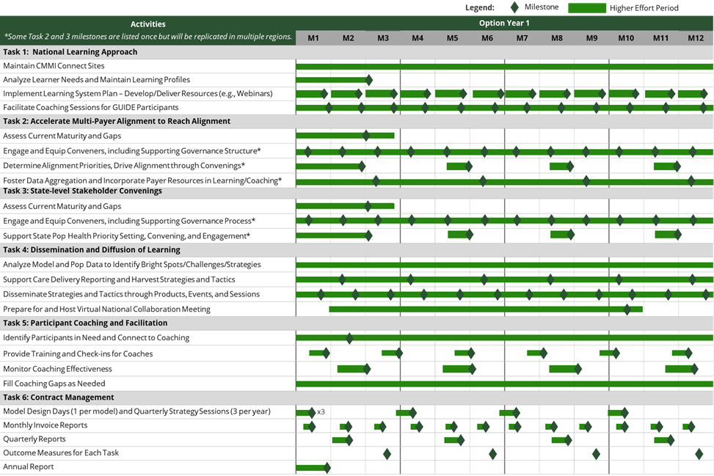

Table X.X-X. Illustrative (not Comprehensive) Milestone Measures by Task..
Task | Illustrative Measures
Task 1: National Learning Approach | - Connect download rates of materials supporting care delivery requirements  - % of participants engaging in peer-to-peer learning events and other webinars
Task 2: Accelerate Multi Payer Alignment | - Meeting agendas regularly include alignment discussion and priority items  - Two or more payers (other than CMS) engaged for each state
Task 3: State-level Stakeholder Convenings | - Meeting agendas regularly include discussion of the agreed upon priority health outcomes  - Participants agree upon measures used to report out on progress towards priority health outcomes
Task 4: Dissemination and Diffusion of Learning to Participants | - # of shared learnings disseminated  - Download/view rates of webinars, podcasts, guides, etc.  - % of states engaged in dissemination activities
Task 5: Participant Coaching and facilitation | - # of participants assessed for coaching needs  - # of local coaches/ facilitators available in each state
Task 6: Performance Requirements | - On time submission rate of reports  - Consistent meeting schedule with CMS

2.1.2 Task 11: Transition-Out (Optional) ^{(SOW 3.11)}
Our Understanding: We understand that supporting a transition-out to a new vendor is a high-visibility, time-bound effort that must balance rapid execution with uninterrupted mission support, clear accountability, and strict compliance. Success depends on establishing a COR-approved operating framework quickly, coordinating closely with the incoming vendor while managing dual operations during the overlap period, and transferring in-flight work, documentation, and operational knowledge in a complete, orderly, and verifiable manner. We also understand that transition-out introduces heightened risk around ownership of work products, version control across repositories, and cutover sequencing, particularly when security, ATO, PII, GFE, GFI, and access approvals are on the critical path. In this environment, CMS needs a transition partner that can maintain continuity, reduce rework and service disruption, and provide the governance, transparency, and discipline required to enable a smooth, compliant handoff to the successor vendor.
Our Approach: We create a detailed Transition-Out Plan to ensure a seamless handover of responsibilities to the incoming contractor or CMS is essential to prevent disruptions and maintain operational excellence. This plan will focus on documentation, knowledge transfer, and alignment of operational priorities, ensuring the continuity of services and adherence to CMS objectives.
Potential Roadblocks: When supporting a transition-out of another vendor, Deloitte recognizes that the most common challenges are compressed transition timelines, the need to coordinate dual operations while maintaining service continuity, incomplete or uneven transfer of in-flight work and operational artifacts, and security and ATO constraints tied to PII, GFE, GFI, and access changes. We mitigate these risks through a disciplined, transparent transition approach that begins with Day 1 governance, a JOA-ready operating framework, and an integrated RAID log, decision log, and milestone-based transition plan to keep all parties aligned and issues escalated quickly. To enable an orderly handoff, we use a structured artifact transfer register with defined completeness criteria, version control, owner-of-record accountability, and formal handoff thresholds, reinforced through knowledge transfer sessions, shadow operations, and phased cutover readiness reviews to reduce rework and avoid disruption. In parallel, we establish a dedicated security and privacy workstream to baseline sensitive assets, map approval dependencies, maintain POA&M discipline, and enforce security readiness gates so that access changes, cutovers, and final turnover occur in a controlled, compliant, and low-risk manner.
Our Successes: Deloitte successfully supported the transition-out of the previous system integrator vendor on California state-based marketplace project in 2020 in less time than expected and during a global pandemic. The successful transition-out of the previous vendor is a testament to the dedication Deloitte has to close collaboration, coordination, and knowledge transfer with the outgoing vendor.
The Transition-Out Plan will begin with comprehensive documentation of all processes, workflows, and system configurations. This includes maintaining and continuously updating project documentation throughout the contract period to provide a solid foundation for the incoming contractor. The documentation will encompass Tier 2 Help Desk processes, key points of contact, the location of relevant documentation, the status of ongoing tickets and initiatives, and a comprehensive inventory of technical and project management artifacts. Knowledge transfer will be supported through shadowing, reverse shadowing, and walkthrough sessions. The Transition-Out Plan will include establishing governing forums with senior leaders from CMS, the outgoing team, and the incoming contractor to guide, direct, and escalate transition activities. Regular status meetings, steering committee discussions, and transition review meetings will ensure alignment of operational priorities and provide a platform for addressing challenges promptly. Detailed process maps, workflow documentation, and project deliverables will be shared with the successor contractor, alongside a clear communication and issue resolution protocol to minimize misunderstandings and delays.
Throughout the transition, the integrity and continuity of CMS operations will remain a priority. By adhering to a rigorous, disciplined approach and maintaining ongoing communication and collaboration, the outgoing contractor will ensure a seamless transfer of responsibilities that aligns with CMS’s strategic goals without disrupting ongoing operations or compromising objectives.

2.1.3 Task 12: Transition-In (Optional) ^{(SOW 3.12)}
Our Understanding: We understand the CMS Transition-In as a time-bound, high-visibility effort that must preserve operational continuity while establishing the foundation for long-term delivery success. A successful transition will require close coordination among CMS, the incumbent, and our team across four interconnected dimensions:
- Governance and Agreement: Timely execution of the Joint Operating Agreement (JOA) within 7 calendar days, supported by disciplined transition governance, RAID management, and a decision log aligned to the Task 1 Project Implementation and Oversight Plan (PIOP).
- Integrated Planning: Rapid development of an initial Transition Management Plan – delivered within 8 business days – that integrates with the PIOP and reflects a realistic critical path with COR-aligned milestones.
- Comprehensive Discovery: Establishment of a clear baseline of the current environment – covering systems, interfaces, data (including PII), in-flight activities, licenses, warranties, SOPs, and security/ATO status – so that responsibilities can be transferred with full operational, technical, and compliance visibility.
- Phased Operational Handoff: A structured 12-week transition that progressively shifts accountability from the incumbent to our team through shadow operations, artifact validation, and workstream-level cutovers, concluding with COR-accepted exit criteria and a smooth handoff to steady-state operations.
Deloitte brings proven experience executing complex government transitions – including the Wyoming integrated eligibility and data center transition, Texas DIR transitions, and California infrastructure migration to cloud operations – and our existing familiarity with CMS systems and environments means we can compress the early discovery and access provisioning phases that typically consume the first weeks of a transition. Our methodology is built on rigorous entry and exit criteria, continuous risk evaluation, and disciplined knowledge transfer, and our head start positions us to deliver a faster, lower-risk transition from day one.
Our Approach: Our approach is to execute the transition in a structured, low-risk manner that combines strong governance, rigorous discovery, and phased operational handoff. We will quickly stand-up transition governance with the CMS COR and incumbent, establish RAID and decision logs, and complete JOA review and execution within the required timeframe to support dual-operations management and coordinated communications. In parallel, we will submit an initial Transition-In Plan, conduct structured knowledge transfer and walkthroughs, enable controlled access, and progressively assume responsibilities over the three-month transition period. We will then manage phased cutovers by workstream or system, validate exit criteria with the COR, and focus on stabilization to ensure a smooth transition to steady-state operations. The table below outlines the four phases of our Transition-In methodology, the key activities within each, and the outcomes we commit to deliver.
Table X.X-X. Provide Title.
Phase / Step | Key Activities | Proposed Outcomes
Phase 1: Governance & Mobilization (Days 0–7) | - Stand up transition governance cadence with CMS COR and incumbent  - Execute Joint Operating Agreement (JOA) within 7 calendar days  - Establish RAID and decision logs; define single-intake rules and owner-of-record per work item  - Submit Day 1 critical path and timeline realism check | - JOA executed; dual-ops protocols active  - Governance structure and escalation paths in place  - RAID and decision logs initialized  - COR-aligned communication cadence established
Phase 2: Discovery & Baseline (Days 8–14) | - Deliver initial Transition Management Plan (within 8 business days); integrate with Task 1 PIOP  - Inventory systems, interfaces, data (PII), in-flight work, licenses/warranties, SOPs, and ATO status  - Establish security/ATO workstream; map HSPD-12/PIV access as critical-path dependencies | - Integrated Transition Management Plan delivered  - Complete baseline inventory established  - Security readiness gaps identified and tracked in POA&M
Phase 3: Knowledge Transfer & Shadow Ops (Weeks 2–8) | - Conduct structured KT sessions, walkthroughs, and shadowing/reverse-shadowing exercises  - Enable controlled access; progressively assume responsibility by workstream  - Apply WIP handling rules (handoff thresholds, freeze windows, backlog burn-down)  - Validate readiness via KT scorecards and artifact transfer register | - Institutional knowledge captured and documented  - Deloitte team progressively owns queues and processes  - Artifact transfer register validated with completeness evidence
Phase 4: Phased Cutover & Stabilization (Weeks 9–12) | - Execute phased production cutovers by workstream/system  - Run stabilization sprints; confirm exit criteria with COR  - Conduct final transition acceptance review and update documentation  - Identify continuous improvement opportunities; hand off to steady-state operations | - All workstreams transitioned with validated exit criteria  - Steady-state operations established with no service disruption  - Final transition acceptance documented and accepted by COR

Throughout all phases, Deloitte will maintain daily transition standups, milestone dashboards, and RAID log updates to provide CMS COR with real-time visibility into progress, risks, and decisions. Our Transition Manager will serve as the single point of accountability, with escalation paths defined and codified in the JOA from Day 1. Deloitte already has deep knowledge of the CMS System Access process, and we will be able to easily support onboarding of these data access requests.
We have included a proposed high-level timeline for the 90-day transition-in period, see timeline below:
Figure X.X-X. Provide Title.
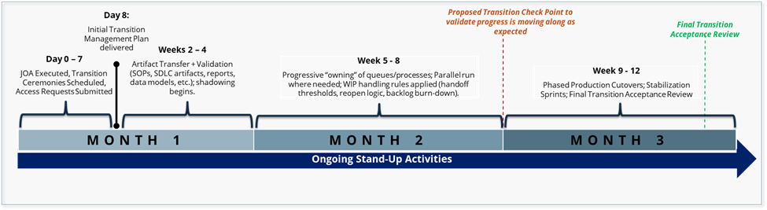

Our Successes: Deloitte's transition methodology ensures continuity of operations, minimizes risks, and achieves a smooth transfer of responsibilities within the designated timeframe. This process was successfully implemented in projects such as the Wyoming integrated eligibility application and data center transition, Texas Department of Information Resources (DIR) transitions, and California infrastructure migration to cloud operations. These experiences inform our approach, emphasizing rigorous entry and exit criteria for each phase, feedback loops, and constant risk evaluation.
Potential Roadblocks: We will support CMS through a disciplined, low-risk Transition-In approach designed to protect continuity of operations, accelerate transfer of responsibility, and maintain compliance from Day 1.
Table X.X-X. Provide Title.
Challenge | Mitigation Strategy
Compressed Start-Up Timeline & Dual-Ops Coordination  The JOA must be executed within 7 calendar days and an integrated Transition Plan delivered within 8 business days, while simultaneously managing workload with the incumbent under active dual-ops. Delays in the incumbent's JOA response or misaligned "rules of the road" can cascade into schedule and service disruptions. | Deloitte will pre-stage a Day 0–7 "JOA-ready" package including redlines, roles, single-intake workflow, WIP ownership rules, and escalation paths. A Day 1 critical-path and timeline realism check will validate dependencies and COR decision points, enabling JOA execution on time even if the incumbent is delayed. Daily transition governance, a RAID log, and a decision log aligned to the PIOP will maintain continuity throughout.
Incomplete or Uneven Transfer of In-Flight Work and Artifacts  The SOW requires the incumbent to hand over a broad set of work products (SDLC artifacts, SOPs, reports, data models, test cases). Documentation gaps, unclear WIP ownership, or version mismatches can introduce rework and cutover delays. | We will enforce a structured artifact transfer register with defined completeness criteria (minimum SDLC set, SOPs, reports, test assets) and version control. Structured KT and shadow ops will validate transfer quality, while JOA-defined owner-of-record rules, freeze windows, and parallel-run exit criteria will prevent duplication and rework prior to each phased cutover.
Security, ATO, and Sensitive-Asset Inventory Constraints  Transition activities must address PII, GFE, and GFI inventories alongside stringent FedRAMP/A&A and ATO obligations — including POA&M tracking, scanning, configuration baselines, and access onboarding (HSPD-12/PIV) — which can become a critical-path dependency. | A dedicated security/privacy and ATO workstream will be established on Day 1 to baseline PII, GFE, and GFI inventories, map access and approval dependencies as critical-path items, and maintain A&A/FedRAMP-aligned controls with continuous monitoring and POA&M discipline. Production cutovers will only proceed after security readiness gates are met.
Stakeholder Alignment and Incumbent Cooperation  A successful transition depends on sustained cooperation from the incumbent contractor — timely artifact handover, responsive KT participation, and adherence to JOA protocols. Adversarial dynamics or disengagement can stall knowledge transfer and create gaps in operational continuity. | We will establish a structured cadence of transition standups and COR touchpoints from Day 1, with escalation paths codified in the JOA. Milestone dashboards and RAID logs will provide COR visibility into incumbent performance, and clear contractual obligations for artifact delivery and KT participation will be reinforced through COR-approved acceptance criteria.

2.2 Sub-Section 2B: Quality Assurance Approach (3 Pages)
Performance Management and Quality Control Methodologies and Approach
Our performance management and quality control approach is aligned with CMS program integrity, oversight, and quality expectations, ensuring consistent compliance with SOW requirements, SLAs, Acceptable Quality Levels (AQLs), and applicable CMS guidance. Through proactive monitoring, clearly defined accountability, and disciplined governance, we provide transparency, early risk identification, and corrective action to support high-quality, timely, and compliant service delivery. Our approach will be as follows:
- Integrated Performance Framework: Translate SOW, SLA, and AQL requirements into defined KPIs with established targets, thresholds, monitoring cadence, and early-warning indicators to proactively manage performance.
- Monitoring, Reporting, and Governance: Use standardized dashboards and regular operational, management, and client governance reviews to track performance, address risks, and enforce clear escalation and accountability.
- Quality Control Methodology: Apply “quality built in” practices combined with independent QC reviews, standardized acceptance criteria, documented sign-offs, and traceability to ensure deliverables meet contractual and quality requirements.
- Defect Management and Continuous Improvement: Utilize disciplined defect tracking, root cause analysis, and corrective/preventive action processes, leveraging trend analysis to drive efficiency, reduce rework, and improve outcomes.
- Risk Management and Transparency: Integrate performance and QC metrics with risk management, capacity planning, and audit-ready documentation, supported by transparent reporting and collaborative client engagement.
Performance Controls and Monitoring Techniques
We understand that our project performance is monitored by CMS through deliverable review, direct observation, stakeholder feedback, and other methods of quality assurance surveillance. Depending on CMS’ preference, evaluation of our work could be completed at pre-determined intervals (e.g., at a monthly or quarterly performance review), during the weekly meeting following delivery of the activity, or over email as deliverables are reviewed. To reduce CMS’ management burden, at CMS’ request, Deloitte could also perform a self-assessment at set intervals. We also understand that we are responsible for project quality control and will implement and adhere to a Quality Control Plan.
Quality Control Governance and Accountability
We will implement a defined Quality Control structure with clear accountability, separation of duties, and documented approval pathways so deliverables consistently meet SOW requirements and Acceptable Quality Levels (AQLs). QC accountability will be assigned to roles, supported by standardized checklists, peer reviews, and management sign-off prior to submission. This structure confirms quality is built into execution, issues are detected early, and corrective actions are implemented rapidly.
Acceptable Quality Levels (AQLs)
We will confirm all deliverables meet or exceed the Acceptable Quality Levels (AQLs) defined in the SOW through standardized quality controls, ongoing monitoring, and corrective action processes. Quality metrics will be clearly defined, measured, and reviewed regularly to reinforce consistent compliance and continuous improvement.
Contractor Performance Analysis
Deloitte will develop and implement a performance management processes to assess and report its performance to the designated Government representative. Government representative(s) will monitor performance and review performance reports furnished by Deloitte to determine how Deloitte is performing against communicated performance objectives. Deloitte will be responsible for making required changes in processes and practices to confirm performance is managed effectively.
Performance Reporting
Deloitte will review performance data and feedback regularly and incorporate it into the monthly progress report to CMS to help detect potential quality issues/risks and track them to resolution. If necessary, we will implement an optional remediation or CMS-approved corrective action plan. This plan may include re-alignment of resources, schedule adjustments, or updates to deliverables.
Performance Correction Mechanisms
Identifying and addressing issues in a timely manner is a fundamental project management best practice and critical to successful delivery. Once identified, issues will be prioritized for corrective action. Our corrective action approach drives early detection of problems, delays, and inefficiencies through execution of our quality processes. Issues are documented and tracked through closure. Corrective actions requiring CMS approval will be reported to the CMS COR for review. Our PM will maintain and share a register to track the status of corrective actions on a monthly basis with task leads and the CMS COR.
Performance Metrics and Key Performance Indicators (KPIs)
Our team will consistently measure performance metrics and core drivers outlined in [INSERT PERFORMANCE METRICS DOC]. The Quality Oversight Lead and PM will work with CMS to finalize the draft QASP that will propose, capture, and report all task order performance metrics and calculation methods to manage PWS performance requirements. We will develop and implement a performance management system with processes to assess and report its performance to the Government for their review and comment. Deloitte will be responsible for addressing Government feedback.
Service Level Agreements (SLAs)
We will maintain all Service Level Agreements (SLAs) defined in the Statement of Work (SOW) are consistently met through a structured governance, monitoring, and accountability framework. Our approach emphasizes proactive performance management, transparency, and continuous improvement to maintain SLA compliance throughout the contract lifecycle. Key elements of our approach include:
- Formal SLA Governance: Establishment of clearly defined roles and escalation paths, including a designated SLA manager responsible for oversight, issue resolution, and coordination with stakeholders.
- Performance Monitoring and Reporting: Ongoing monitoring of SLA metrics using standardized dashboards and reporting tools, with regular performance reports provided to the client to ensure transparency and early identification of risks.
- Proactive Issue Management: Defined processes for identifying, documenting, and resolving SLA risks or variances before they impact service delivery, including root cause analysis and corrective action plans.
- Regular Reviews and Continuous Improvement: Scheduled operational and monthly/quarterly performance reviews to assess SLA trends, address concerns, and implement process improvements as needed.
- Change and Quality Management Controls: Integration of change management and quality assurance practices to ensure that updates to scope, processes, or staffing do not compromise SLA performance.
This disciplined approach enables consistent SLA compliance, rapid response to issues, and alignment with client expectations throughout the duration of the SOW.
QASP alignment to SLAs, AQLs, KPIs and Escalation Mechanisms
The oversight provided for in the Contract and the QASP will validate that service levels reach and maintain the required levels throughout the Contract term. Further, the QASP provides the ERR COR with a proactive way to avoid unacceptable or deficient performance and provides verifiable input for the Contractor Performance Assessment Reporting System (CPARS). Following the contract award, the Deloitte and appropriate federal staff will review and finalize the performance measurement criteria along with methodology for periodic monitoring. We will also review and approve the draft QASP with CMS and any revisions to the draft QASP will be implemented within a timeframe determined in conjunction with CMS (e.g., within 30-days of the meeting). Additional updates may be made throughout the duration of the contract, if necessary (e.g., PWS changes or CMS feedback), and will be submitted to CMS for review and approval within a predetermined timeframe. Final and subsequent QASPs will be stored in a CMS-approved location.

2.3 Sub-Section 2C: Staffing Plan (2 Pages)
Workforce Delivering the SOW Tasks and Requirements
CMS is seeking a Staffing Plan that demonstrates the Contractor has the appropriate staffing resources at all levels to perform the ER&R scope, with the knowledge, experience, labor mix, and subject matter expertise needed to execute work across Enrollment Resolution and Reconciliation (ER&R), Form 1095-A Data Reconciliation and Reporting, Complex Case Help Center (CCHC), contact center support, system maintenance and operations, enhancements, service desk support, reporting and analytics, quality assurance, and related ad hoc activities. CMS is also requesting a description of the resource management and staffing approach, including recruitment, retention, roles and responsibilities, resource allocations, transitions across lifecycle phases, available resources, labor hours by task/subtask, and surge support during peak operational periods, while maintaining the required technical, security, and SME support across the period of performance. Deloitte’s Staffing Plan responds directly to these requirements through a workload-driven, function-based workforce model aligned to the ER&R operating environment. Deloitte will provide a staffing structure that reflects the scale and complexity of the ER&R environment at contract start, supports continuity of operations across the in-scope systems and workstreams, and positions the program for measured efficiencies over time without introducing avoidable operational risk.
Figure 2.3-1. Organizational Chart.
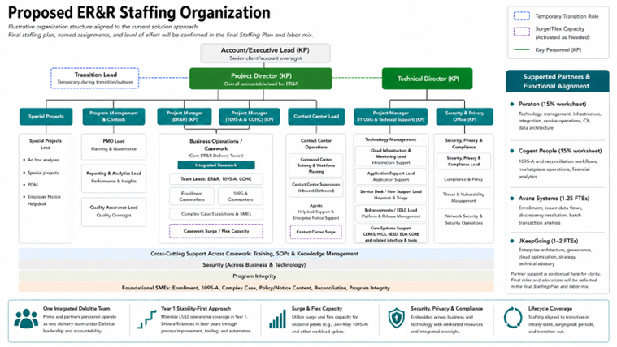
Resource Management and Staffing Approach
Understanding: CMS is requesting a resource management and staffing approach that shows how the Contractor will organize, assign, and manage staff across the ER&R scope while sustaining continuity of service and maintaining the business, technical, operational, security, and SME support needed to perform the work across a multi-system operating environment.
- Organize the workforce into the major delivery towers required to perform the ER&R scope — Business Operations, Technology Management, Program Management / Program Controls, Quality Assurance / SOP / Knowledge Management, and SME / Program Integrity support — so staffing mirrors how work is performed across the ER&R environment rather than grouping unlike functions into a single generalized team.
- Staff Business Operations as the core delivery tower supporting issuer disputes, Form 1095-A disputes, complex case handling, telephone and correspondence support, and related operational analysis, with staffing differentiated by work type and case complexity: call center personnel support front-line telephone and correspondence interactions; caseworkers support dispute research, analysis, case progression, and resolution; senior resources and SMEs support escalated, high-complexity, or high-risk matters; and operational leadership supports workload balancing, quality oversight, and issue escalation.
- Staff Technology Management as a distinct delivery tower supporting CERRS, HICS, SEED, EDA CORE, related interfaces, notice-generation support, telephony/contact-center technologies, and supporting operational tooling, with resources aligned across maintenance and operations, infrastructure and monitoring, application support, service desk / internal user support, enhancements and SDLC support, testing and release support, data and reporting support, security, privacy, and compliance support, notice-related technical support, and coordination across systems, repositories, and interfaces.
- Staff Program Management / Program Controls, Quality Assurance / SOP / Knowledge Management, and SME / Program Integrity support to provide governance, contract management, milestone tracking, issue and risk management, performance reporting, QASP execution, QA reviews, SOP maintenance, training support, validation support, operational consistency, and targeted expertise aligned to enrollment, Form 1095-A, reconciliation, complex case handling, policy/notice-sensitive workflows, and control-oriented support across the environment.
- Align the largest concentrations of staffing to the primary workload drivers of the ER&R scope — dispute resolution, Form 1095-A workstreams, Complex Case Help Center operations, IT systems maintenance and operations, and telephone/correspondence support — so the staffing model reflects where operational demand, technical dependency, and service risk are concentrated.
- Structure the workforce to reflect that ER&R is a multi-system operating environment, not a single-system support model, and therefore requires coordinated staffing across case management, contact center, data/reporting, technical support, and control/support functions to sustain continuity of operations.
- Assign staff by function, complexity, operational demand, and lifecycle phase so personnel are matched to the actual requirements of the work rather than allocated through a flat staffing model; support this approach through recruitment of personnel with the appropriate skills and competencies, retention and continuity practices that sustain workforce stability, role-based assignment, clearly defined responsibilities and allocations, and resource estimation based on workload, complexity, service levels, seasonality, supervision needs, and technical support requirements.
- Apply a phase-based staffing model across transition-in, steady-state operations, peak periods, and transition-out, with transition-in focused on knowledge transfer, documentation review, access setup, incumbent coordination, technical discovery, readiness activities, interface and support validation, repository review, and stabilization support; steady-state focused on workload responsiveness, service continuity, quality, performance management, and controlled enhancement support; and transition-out focused on orderly turnover, documentation capture, continuity preservation, and knowledge transfer.
- Use a labor mix that includes senior staff, leads, SMEs, and operational personnel so complex cases, escalated issues, quality reviews, technical support needs, and high-risk or control-sensitive activities receive the appropriate level of oversight and human review.
- Operate prime and subcontractor personnel as one integrated delivery workforce with defined workshare and responsibilities while maintaining Deloitte accountability for leadership, governance, integration, and performance.
- Staff Year 1 to support stability, service continuity, and full operational coverage across the in-scope systems and support functions rather than immediate staffing reductions, then deliver later-year efficiencies through process improvement, tooling, automation, and streamlined support practices after the operating baseline is established and performance is stabilized.
- Maintain a clear distinction between business-operations staffing and service-desk / technical-user support staffing so internal system-user support is not blended into front-line dispute-resolution staffing; service-desk resources will support internal users of the ER&R applications and reporting environment — including caseworkers, agents, supervisors, and other operational users — and will operate with their own staffing model, skill mix, and escalation paths.
Description of Available Resources and Labor Hours
Understanding: CMS is asking Offerors to describe the available resources and labor hours that will support performance of the ER&R scope. The Staffing Plan must show the breadth of labor categories and resource groupings supporting the work, while the final staffing plan and labor mix provide the detailed allocation of labor categories, labor hours, and task/subtask support.
- Provide resources across the labor categories needed to perform the ER&R scope, including project leadership and program-control personnel, case analysts and caseworkers, call center personnel, technical staff, service desk / user support personnel, reporting and analytics personnel, quality assurance resources, training and knowledge-management support, and subject matter experts aligned to enrollment, Form 1095-A, reconciliation, complex case handling, policy/notice-sensitive workflows, and program integrity.
- Use the narrative staffing model to show how resources are aligned across the major delivery towers and task areas and reflect the detailed level-of-effort allocations in the final Staffing Plan and labor mix.
- Identify in the final Staffing Plan whether proposed resources are currently on staff, proposed under the prime, or proposed under subcontractors, and describe how each resource grouping is utilized across business operations, contact center support, technical support, reporting and analytics, quality assurance, program controls, and SME support.
- Provide a final labor-hours matrix by labor category and task/subtask showing labor mix by task/subtask, availability of senior, junior, and SME resources, and distribution of work between prime and subcontractor personnel.
- Integrate subcontractor capabilities in targeted areas that strengthen delivery across specialized functions, including technology support, FORM 1095-A and reconciliation workflows, data architecture and systems integration, and special projects/architecture advisory support, while maintaining Deloitte accountability for leadership, governance, integration, and performance.
- Align the technical labor mix to the actual ER&R systems landscape and support footprint, including Microsoft Dynamics /.NET support, infrastructure and monitoring support, application support, service desk / user support, release and enhancement support, security/compliance support, and data/reporting support, so the proposed workforce is aligned not only to the business scope of ER&R, but also to the technical stack, tools, interfaces, repositories, and multi-system support environment required to sustain service.
- Present enhancement-related support as a managed delivery capacity aligned to backlog management, prioritization, and sprint-based execution needs so CMS has a flexible and credible model for enhancement delivery while stable operations are preserved across the core environment.
Surge Support
Understanding: ER&R workload is not static. CMS requires a staffing model that can respond to seasonal peaks, surges in operational demand, escalations, and other events without compromising continuity, quality, or compliance.
- Maintain visible surge and flex capacity to support peak operational periods, including heightened demand associated with Form 1095-A support during January through May and other workload spikes driven by seasonal activity, escalations, operational events, incident response, or release activity.
- Recognize that several ER&R workstreams are inherently seasonal or volume-sensitive — including Form 1095-A disputes, Complex Case Help Center support, and telephone/correspondence support — and apply a controlled surge approach that flexes staffing in response while maintaining quality, technical compliance, and continuity of service.
- Differentiate surge support between casework surge, focused on queue balancing, backlog management, triage support, escalation coverage, and higher-complexity workload absorption, and contact center surge, focused on staffing coverage, supervisor support, workforce planning, and operational monitoring.
- Support surge personnel with appropriate subject matter expertise, training and SOP guidance, supervision and quality oversight, role-based access controls, and compliance with applicable technical procedures and security requirements, and reflect final surge staffing levels and labor allocations in the final Staffing Plan and labor mix.
- Maintain the ability to flex technical support where needed to preserve continuity of operations during periods of elevated demand, release activity, incident response, or other operational events affecting the in-scope systems, including scalable support across service desk, application support, monitoring, and security-related functions so higher technical demand does not compromise business operations, casework throughput, or contact center performance.

3.0 Section 3: Key Personnel Qualifications and Corporate Experience (Total 8 Pages)

3.1 Sub-Section 3A: Key Personnel Qualifications (4 Pages)
Key Personnel Roles and Responsibilities
Deloitte has assembled a proven leadership team with deep, direct experience supporting CMS Marketplace operations, enrollment reconciliation, and federal healthcare data systems. Each proposed key personnel member brings specific, hands-on experience directly aligned to the requirements of this SOW. Our team is ready to lead from day one, ensuring continuity, accountability, and expert execution across all ER&R tasks.
The following individuals are designated as Key Personnel for this task order. Current resumes are in Appendix A.
Table 3.1-1. Key Personnel – Education, Professional Experience, & Availability
Personnel, Education & Availability | Professional Experience & Qualifications
[FIRST LAST, Degrees]
Project Director
(Key Personnel)
[X]% | Base Period – OP4
[Degree, Field] [University Name]
[FIRST LAST, PMP]
Project Manager (ER&R)
(Key Personnel)
[X]% | Base Period – OP4
[Degree, Field] [University Name]
[FIRST LAST, PMP]
Project Manager (Form 1095-A & CCHC)
(Key Personnel)
[X]% | Base Period – OP4
[Degree, Field] [University Name]
[FIRST LAST, Degrees]
Project Manager (IT Data & Technical Support)
(Key Personnel)
[X]% | Base Period – OP4
[Degree, Field] [University Name]
[FIRST LAST, Degrees]
Technical Director
(Key Personnel)
[X]% | Base Period – OP4
[Degree, Field] [University Name]
[FIRST LAST, CISSP]
Security & Privacy Officer
(Key Personnel)
[X]% | Base Period – OP4
[Degree] [University Name]

Significant Leads and Responsibilities
In addition to designated Key Personnel, Deloitte will leverage the expertise of the following significant leads who play critical roles in delivering SOW requirements. These individuals bring deep subject matter expertise and will be actively engaged throughout the contract period.
Table 3.1-2. Significant Leads — Roles, Qualifications & Availability.
Personnel, Education & Availability | Professional Experience & Qualifications
[FIRST LAST, Degrees]
Program Integrity Lead
[X]% | Base Period – OP4
[Degree, Field] [University Name]
[FIRST LAST, Degrees]
Call Center Lead
[X]% | Base Period – OP4
[Degree, Field] [University Name]
[FIRST LAST, Degrees]
[Lead Title/Role — PLACEHOLDER]
[X]% | Base Period – OP4
[Degree, Field] [University Name]
[FIRST LAST, Degrees]
[Lead Title/Role — PLACEHOLDER]
[X]% | Base Period – OP4
[Degree, Field] [University Name]
[FIRST LAST, Degrees]
[Lead Title/Role — PLACEHOLDER]
[X]% | Base Period – OP4
[Degree, Field] [University Name]

Retention and Replacement Approach
Retaining qualified key personnel is critical to uninterrupted ER&R program operations. Deloitte has institutionalized robust succession processes to minimize disruption in the event of departures:
- Pre-qualified bench of successors: Deloitte maintains a pipeline of CMS-experienced professionals for each key position. At least one qualified backup candidate has been identified in advance for each key role [ADD DETAIL ON BENCH DEPTH].
- Living transition documentation: All key personnel maintain current documentation of responsibilities, ongoing deliverables, CMS relationships, and open case status, enabling rapid knowledge transfer.
- COR notification and prior approval: Any key personnel substitution will be promptly communicated to the COR. Proposed replacements will meet or exceed all minimum qualifications for the position prior to assuming responsibilities.
- Transition overlap period: Where advance notice is available, Deloitte ensures a minimum [X]-day co-performance period so outgoing and incoming personnel work in parallel, preserving operational continuity and institutional knowledge.
Level of Effort
[Placeholder for LCAT/OY/Task table]

3.2 Sub-Section 3B: Corporate Experience (4 Pages)
We understand why change feels risky. Transition issues, delayed eligibility determinations, or call center disruptions can mean consumers can't get answers about their health coverage, benefits, or enrollment status. Legislative and public scrutiny leaves no margin for disruption. But continuity and change are not mutually exclusive. Team Deloitte has the experience, methodology, and proven track record to make change invisible to the consumer, protecting consumer experience while modernizing the systems underneath it.
Table 3.2-1. Corporate Experience Matrix
Project Name & Client / Agency | Period of Performance | Project Description & Relevance to SOW | ER&R Issuer Disputes | 1095-A Consumer Disputes | IT Systems O&M | Data Analytics & BI Reporting |  | Contact Center Support |  | Security & Compliance |  | Eligibility & Enrollment Systems |  | Healthcare Exchange Platform Dev & Ops
XX / U.S. Office of Personnel Management (OPM) | Aug 2023 – Aug 2025 | Deloitte delivers and operates a large-scale federal health benefits enrollment platform supporting 1.9 million USPS employees and retirees across 17 carriers and 69 plan options. The platform is available 24/7 and serves as the authoritative system for enrollment, eligibility, and benefits management for one of the largest employer-sponsored health programs in the federal government. Deloitte provides system development, maintenance, and operations services, including automated fraud, waste, and abuse detection controls projected to save $3 billion annually, demonstrating automation-first processing capability in a complex, highly regulated environment.  Size: Federal; $175M contract value  Scope: Full platform delivery and operations, including maintenance of 8 integrated applications and 20 interfaces, member record management, carrier and plan administration across 17 carriers and 69 plan options, and automated FWA detection and controls.  Complexity: 8 Applications, 20 External Interfaces, 1.9M Members, 113M+ Annual Transactions, peak single-hour active user count of 4,690, migration of 2.25 million member records at 99.6% accuracy  Technological Landscape: Azure FedRAMP Commercial Cloud, API integration (average response time 0.255 seconds against a 2-second SLA), NIST 800-53 compliance, FedRAMP authorization, automated FWA detection controls
Department of State, Bureau of Consular Affairs (CA) | Sep 2019 – Sep 2026 | Deloitte provides operations, maintenance, and modernization support for 80+ mission-critical applications across 240+ global posts, resolving 21K+ tickets annually under a 24/7/365 operational support model with 200+ deployments managed annually using Agile principles. The engagement encompasses system operations, software development, Tier III production support, and mission-critical system transitions from incumbent vendors, demonstrating Deloitte's ability to manage large-scale federal IT portfolios under demanding service-level and compliance requirements.  Size: Federal; $430M projected contract value  Scope: Operations, maintenance, and modernization of 80+ mission-critical applications. Scope includes system operations, software development, Tier III production support, DevSecOps delivery, and mission-critical system transitions.  Complexity: 80+ applications, 240+ global posts, 21K+ tickets annually, 200+ deployments per year, geographically dispersed multi-system environment, FISMA Moderate compliance  Technological Landscape: FISMA Moderate, DevSecOps, Agile delivery, continuous deployment pipelines
State of Washington | Apr 2012 – Jun 2028 | Deloitte provides continuous 24/7 O&M support for a fully functional state-based exchange (SBE) supporting 1.5 million Medicaid enrollees, maintaining 99.9% high availability and deploying major enhancement releases every six weeks. The engagement scope mirrors the FFE including eligibility, enrollment, interfaces, correspondence, plan management, administration, reporting, and Form 1095-A generation and validation delivered directly to consumers.  Size: State; $196.5M contract value  Scope: Full O&M support for state-based exchange including eligibility, enrollment, interfaces, correspondence, plan management, administration, reporting, and Form 1095-A generation.  Complexity: 1.5M Medicaid enrollees, 99.9% availability SLA, bi-weekly release cadences, cyclical Open Enrollment peak demand, multi-stakeholder coordination across state and federal entities  Technological Landscape: FedRAMP Moderate, public-facing health insurance exchange environment
California Healthcare Eligibility, Enrollment, and Retention System (CalHEERS) / State of California | Sep 2019 – Jun 2027 | CalHEERS is a critical public-facing platform available to all 39 million Californians 24/7 to search, compare, and access affordable health care options that meet their unique health care needs. CalHEERS provides functionality to support a multitude of programs related to health care enrollment, including eligibility, plan preview and selection, and ongoing retention including management of available health care plans and affordability options. Deloitte serves as the System Integrator (SI) vendor for CalHEERS and provides system development, maintenance, and operations (SDMO) services. Deloitte modernized CalHEERS to support over 55 million daily transactions and over 36,000 daily users on average during OE periods, serving 149,000 user visits and 112 million transactions per day at peak OE. Deloitte has also transitioned CalHEERS to a modernized cloud data and analytics platform capable of tackling complex business questions related to eligibility analytics, enrollment analytics, plan choice analytics, and transition analytics.  Size: State; $900+ million, 7-year program, 800+ FTEs  Scope: Deloitte serves as the System Integrator (SI) vendor for CalHEERS and provides system development, maintenance, and operations (SDMO) services. Deloitte also provides enhancements, security, maintenance, subcontractor, and product vendor management, 24/7 help desk support, and ongoing operations of core applications.  Complexity: 10 Applications (2 COTS), 41 External Systems (30 Real Time), 7.7M Users, Multiple locations, working with 10+ contractors, supporting 100+ SW products across vendors in this multi-vendor environment  Technological Landscape: Microservice architecture, Java, OpenShift, Aurora PostgresSQL, Oracle, Amazon Web Services (AWS) – Amazon EC2, AWS Snowball, Amazon S3, Amazon EBS, Amazon EFS, AWS Direct Connect, Salesforce, GitLab, SonarQube, Splunk, Jenkins, Selenium, Dynatrace, LoadRunner, Snowflake, Tableau Server, Autosys, Databricks, PySpark Data Lake Builder
Veteran Benefits Administration / VA Medical Disability Examination (MDE) | Oct 2024 – Dec 2026 | Cogent serves as the prime contractor on CMS's PPFMG Financial Management Operational Analytics (FMOA) program, a mission-critical Marketplace platform supporting issuer payment validation, reconciliation, and financial data integrity across systems that directly interface with ER&R and the Federally Facilitated Exchange (FFE). The program requires deep knowledge of CMS/CCIIO operations, regulatory compliance, and the complex financial and enrollment data flows that underpin the Marketplace. Cogent has supported CMS and CCIIO continuously since 2009, bringing institutional knowledge of core Marketplace platforms and the financial management processes that directly align with ER&R operational requirements.  Size: Federal; $31M contract value  Scope: IT consulting, business consulting, software engineering, data analytics, program management, data strategy, and architecture integration. Scope includes issuer payment validation, reconciliation analytics, dispute resolution, 1095-A processing, root cause analysis, and rules automation across core Marketplace platforms.  Complexity: Multi-system integration environment spanning DSH, MSI, MIDCAP, MIDAS, ES, FFE, ER&R, and FFE interfaces; audit readiness and ongoing operational support across financial and enrollment data streams; continuous CMS/CCIIO engagement since 2009 across multiple program iterations  Technological Landscape: CMS Marketplace platforms (DSH, MSI, MIDCAP, MIDAS, ES, FFE), ER&R and FFE system interfaces, reconciliation analytics, rules automation, financial data integrity controls, enrollment reconciliation architecture
Veteran Health Administration / VA Connect | Jun 2022 – Sep 2024
Financial Management Operational Analytics (FMOA) / CCIIO
Project name / Client | MM/YYYY – MM/YYYY | Project Description: Cogent Project 2  Size:  Scope:  Complexity:  Technological Landscape:
Project name / Client | MM/YYYY – MM/YYYY | Project Description: Peraton Project 1  Size:  Scope:  Complexity:  Technological Landscape:
Project name / Client | MM/YYYY – MM/YYYY | Project Description: Peraton Project 2  Size:  Scope:  Complexity:  Technological Landscape:

The experience matrix that follows demonstrates exactly that. Team Deloitte has successfully transitioned 40+ large, complex systems, including six State-Based Exchanges, without downtime or negative impacts to user access. We hold the only other federal exchange contract, operate large-volume call centers receiving upwards of 55,000 contacts per week, and have surged 900 staff in three days to meet emergency demand. We develop 1095-A forms for state-based exchanges including Covered California, delivering over 1.5 million forms last year with a dispute rate of just 0.20% far outperforming industry baselines. We have deep FFE expertise, including former CCIIO leaders, and work regularly to reconcile enrollment and exchange data across five state-based exchanges.

4.0 Section 4: Small Business Utilization (5 Pages)

Appendix A Key Personnel Resumes (2 Pages Each)

A.1 Project Director
Name Legal Entity, Title
Labor Category:

Experience Summary
CALLOUT 2 BOX TITLE TEXT
Lorem ipsum dolor sit amet, consectetuer adipiscing elit. Maecenas porttitor congue massa. Fusce posuere, magna sed pulvinar ultricies, purus lectus malesuada libero, sit amet commodo magna eros quis urna.
Give a synopsis of candidate's experience with focus on relevant tasks, duties, work, accomplishments. Spell out numbers zero to nine; use numerical values for 10 and higher, unless the number represents a dollar amount (i.e., $1 Million). Also, please refer to the candidate as Title plus Last Name, for example: Ms. Smith has over 15 years of experience in financial management.
Example: Mr. Smith has more than 12 years of extensive IT experience, specializing in complex programs. He has experience with data governance, data management, meta-data management, data warehousing, data cleansing and enterprise reporting. Mr. Smith has worked in many industries and environments, including past experience working with DHS. He has a demonstrated track record of program management as well as bringing projects to closure in challenging environments.
Recent Experience
Resume Job Title Dates

Employment History
- Company, Title, (From – To)

Education
- Degree, Field, School

A.2 Project Manager (ER&R)
Name Legal Entity, Title
Labor Category:

Experience Summary
CALLOUT 2 BOX TITLE TEXT
Lorem ipsum dolor sit amet, consectetuer adipiscing elit. Maecenas porttitor congue massa. Fusce posuere, magna sed pulvinar ultricies, purus lectus malesuada libero, sit amet commodo magna eros quis urna.
Give a synopsis of candidate's experience with focus on relevant tasks, duties, work, accomplishments. Spell out numbers zero to nine; use numerical values for 10 and higher, unless the number represents a dollar amount (i.e., $1 Million). Also, please refer to the candidate as Title plus Last Name, for example: Ms. Smith has over 15 years of experience in financial management.
Example: Mr. Smith has more than 12 years of extensive IT experience, specializing in complex programs. He has experience with data governance, data management, meta-data management, data warehousing, data cleansing and enterprise reporting. Mr. Smith has worked in many industries and environments, including past experience working with DHS. He has a demonstrated track record of program management as well as bringing projects to closure in challenging environments.
Recent Experience
Resume Job Title Dates

Employment History
- Company, Title, (From – To)

Education
- Degree, Field, School

A.3 Project Manager (Form 1095-A & CCHC)
Name Legal Entity, Title
Labor Category:

Experience Summary
CALLOUT 2 BOX TITLE TEXT
Lorem ipsum dolor sit amet, consectetuer adipiscing elit. Maecenas porttitor congue massa. Fusce posuere, magna sed pulvinar ultricies, purus lectus malesuada libero, sit amet commodo magna eros quis urna.
Give a synopsis of candidate's experience with focus on relevant tasks, duties, work, accomplishments. Spell out numbers zero to nine; use numerical values for 10 and higher, unless the number represents a dollar amount (i.e., $1 Million). Also, please refer to the candidate as Title plus Last Name, for example: Ms. Smith has over 15 years of experience in financial management.
Example: Mr. Smith has more than 12 years of extensive IT experience, specializing in complex programs. He has experience with data governance, data management, meta-data management, data warehousing, data cleansing and enterprise reporting. Mr. Smith has worked in many industries and environments, including past experience working with DHS. He has a demonstrated track record of program management as well as bringing projects to closure in challenging environments.
Recent Experience
Resume Job Title Dates

Employment History
- Company, Title, (From – To)

Education
- Degree, Field, School

A.4 Project Manager (IT Data and Technical Support)
Name Legal Entity, Title
Labor Category:

Experience Summary
CALLOUT 2 BOX TITLE TEXT
Lorem ipsum dolor sit amet, consectetuer adipiscing elit. Maecenas porttitor congue massa. Fusce posuere, magna sed pulvinar ultricies, purus lectus malesuada libero, sit amet commodo magna eros quis urna.
Give a synopsis of candidate's experience with focus on relevant tasks, duties, work, accomplishments. Spell out numbers zero to nine; use numerical values for 10 and higher, unless the number represents a dollar amount (i.e., $1 Million). Also, please refer to the candidate as Title plus Last Name, for example: Ms. Smith has over 15 years of experience in financial management.
Example: Mr. Smith has more than 12 years of extensive IT experience, specializing in complex programs. He has experience with data governance, data management, meta-data management, data warehousing, data cleansing and enterprise reporting. Mr. Smith has worked in many industries and environments, including past experience working with DHS. He has a demonstrated track record of program management as well as bringing projects to closure in challenging environments.
Recent Experience
Resume Job Title Dates

Employment History
- Company, Title, (From – To)

Education
- Degree, Field, School

A.5 Technical Director
Name Legal Entity, Title
Labor Category:

Experience Summary
CALLOUT 2 BOX TITLE TEXT
Lorem ipsum dolor sit amet, consectetuer adipiscing elit. Maecenas porttitor congue massa. Fusce posuere, magna sed pulvinar ultricies, purus lectus malesuada libero, sit amet commodo magna eros quis urna.
Give a synopsis of candidate's experience with focus on relevant tasks, duties, work, accomplishments. Spell out numbers zero to nine; use numerical values for 10 and higher, unless the number represents a dollar amount (i.e., $1 Million). Also, please refer to the candidate as Title plus Last Name, for example: Ms. Smith has over 15 years of experience in financial management.
Example: Mr. Smith has more than 12 years of extensive IT experience, specializing in complex programs. He has experience with data governance, data management, meta-data management, data warehousing, data cleansing and enterprise reporting. Mr. Smith has worked in many industries and environments, including past experience working with DHS. He has a demonstrated track record of program management as well as bringing projects to closure in challenging environments.
Recent Experience
Resume Job Title Dates

Employment History
- Company, Title, (From – To)

Education
- Degree, Field, School

A.6 Security and Privacy Officer
Name Legal Entity, Title
Labor Category:

Experience Summary
CALLOUT 2 BOX TITLE TEXT
Lorem ipsum dolor sit amet, consectetuer adipiscing elit. Maecenas porttitor congue massa. Fusce posuere, magna sed pulvinar ultricies, purus lectus malesuada libero, sit amet commodo magna eros quis urna.
Give a synopsis of candidate's experience with focus on relevant tasks, duties, work, accomplishments. Spell out numbers zero to nine; use numerical values for 10 and higher, unless the number represents a dollar amount (i.e., $1 Million). Also, please refer to the candidate as Title plus Last Name, for example: Ms. Smith has over 15 years of experience in financial management.
Example: Mr. Smith has more than 12 years of extensive IT experience, specializing in complex programs. He has experience with data governance, data management, meta-data management, data warehousing, data cleansing and enterprise reporting. Mr. Smith has worked in many industries and environments, including past experience working with DHS. He has a demonstrated track record of program management as well as bringing projects to closure in challenging environments.
Recent Experience
Resume Job Title Dates

Employment History
- Company, Title, (From – To)

Education
- Degree, Field, School

1.0 Heading 1 Style example
Callout 1 Title
Callout2 Body
- Callout2 Checkmark Bullet
- Callout2 Bullet
- Callout2 Bullet2

1.1 Heading 2

1.1.1 Heading 3

1.1.1.1 Heading 4

1.1.1.1.1 Heading 5

1.1.1.1.1.1 Heading 6

1.1.1.1.1.1.1 Heading 7

1.1.1.1.1.1.1.1 Heading 8
CALLOUT 2 BOX TITLE TEXT
Lorem ipsum dolor sit amet, consectetuer adipiscing elit. Maecenas porttitor congue massa. Fusce posuere, magna sed pulvinar ultricies, purus lectus malesuada libero, sit amet commodo magna eros quis urna.

1.1.1.1.1.1.1.1.1 Heading 9
Subheading 1
Body Text

Callout 3 Box  Title Text | Lorem ipsum dolor sit amet, consectetuer adipiscing elit. Maecenas porttitor congue massa. Fusce posuere, magna sed pulvinar ultricies, purus lectus malesuada libero, sit amet commodo magna eros quis urna.

Subheading 2
Body Text Bullet Intro
- Bullet level 1
- Bullet level 2
Bullet level 3

Figure X.X-X. Provide Title.
Action caption, if needed
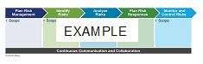

Table X.X-X. Provide Title.
Action caption, if needed.

Table Heading | Table Heading | Table Heading | Table Heading
Table Row Heading | Table body | Table Column Heading | - Table Checkmark
 | - Table Bullet 1 | Table Body Centered
 | - Table Bullet 2
 | Table Bullet 3

Name Legal Entity, Title
Proposed Project Role: Title

Experience Summary
CALLOUT 2 BOX TITLE TEXT
Lorem ipsum dolor sit amet, consectetuer adipiscing elit. Maecenas porttitor congue massa. Fusce posuere, magna sed pulvinar ultricies, purus lectus malesuada libero, sit amet commodo magna eros quis urna.
Give a synopsis of candidate's experience with focus on relevant tasks, duties, work, accomplishments. Spell out numbers zero to nine; use numerical values for 10 and higher, unless the number represents a dollar amount (i.e., $1 Million). Also, please refer to the candidate as Title plus Last Name, for example: Ms. Smith has over 15 years of experience in financial management.
Example: Mr. Smith has more than 12 years of extensive IT experience, specializing in complex programs. He has experience with data governance, data management, meta-data management, data warehousing, data cleansing and enterprise reporting. Mr. Smith has worked in many industries and environments, including past experience working with DHS. He has a demonstrated track record of program management as well as bringing projects to closure in challenging environments.
Recent Experience
Resume Job Title Dates

Employment History
- Company, Title, (From – To)

Education
- Degree, Field, School

Past Performance1-Paragraph
Offeror | Deloitte |  | Client | Name of Agency, Company, or Organization
Project Name
Contract Number(s): |  |  |  | Value of Contract:
Contract Type: |  | e.g., T&M, FFP |  | Period of Performance: | MM/YYYY – MM/YYYY
Client Point of Contact: |  | Name ,Agency, Phone, Number, Email Address

Relevance to Agency Name:
Describe in a few bullets the relevance of the project to the opportunity. See generic examples below.
- (Example A) Relevance to Agency Name:
- Large-scale project with significant financial, reporting, and management implications.
- COTS implementation; replacement of legacy systems.
- BPA with multiple task orders, similar to an IDIQ contract.
- (Example B) Relevance to Agency Name:
- [Industry name] project with performance, reporting, and maintenance aspects.
- Similar organizational, technical, and operational requirements.
- COTS integration solution.
Narrative:
Description of work performed—briefly outlining the client’s challenge/situation and what you were hired to do. Please describe the scope of the project, noting broad similarities with Agency Name activity requirements. Describe magnitude in terms of dollar amounts, number of personnel fielded, etc. Describe the project’s complexity in reference to Agency Name or task order requirements and similarities of work performed. Note things delivered, results provided, etc.
(Example A) The ABC project encompasses a wide range of activities, from documentation and user/data requirements tasks to deployment and training. The project’s scope is comparable to Agency Name IDIQ requirements, with similar staffing and technical needs and a similar management methodology used. The ABC project has involved multiple sites and approximately 120 Deloitte team members at peak; it will affect some 6,000 users at full deployment.
Similar to Agency Name requirements, the project includes a variety of planning, design, development, and integration activities. Work has been performed under a blanket purchase agreement (BPA) with multiple delivery orders. The Deloitte team worked closely with Agency Name management to build support for the implementation and develop a communications strategy for informing employees about the upcoming transition and provide specialized instruction and support for staff in new roles. As the lead systems integrator and program manager, the Deloitte team was responsible for the following:
- Establishing a program governance process and developing a program management office to coordinate this large-scale Oracle roll-out.
- Developing and deploying the Oracle-based system at client locations, including replacing and retiring legacy financial systems.
(Example B) Support of the Agency Name included a variety of activities similar to Agency Name Task Order Name requirements. This $15 million, multi-year project covers both agency and enterprise-wide technology and management issues.
- The development and implementation of a COTS-based solution during this project is comparable to activities described in the Agency Name RFP. Deloitte developed and deployed a Microsoft Project Server, Web-based tool (Tool Name). The Deloitte team adapted and enhanced the tool to support program plan management and collaboration in accordance with requirements provided by the X Business Unit. The team provides advice and planning on communications and audit strategy, analyzes plan thoroughness and feasibility, and assists in content development for best practices guides and methodologies. Deloitte supports compliance efforts to implement methodology for management in assessment, documentation, and reporting on the internal controls over financial reporting. Additional actions and results:
- Bullet 1 text.
- Bullet 2 text.
- Etc.
Solution Benefits:
Short description, in bullets, describing benefits provided. Please try to provide hard evidence of measurable results—e.g., saved $X, reduced errors Y percent, increased efficiency Z percent, etc. See example below.
(Example) In addition to the engagement goals, the client has benefited from the project by:
- Eliminating redundant and outdated financial systems.
- Implementing a centralized financial platform, which increases compliance with federal accounting standards and management process improvement initiatives.
- Streamlining of operations, resulting in a 30-percent increase in productivity and savings of $4.6 million.
- Enhancing ability to obtain enterprise-wide financial information.
- Retirement of more than 45 applications, saving the client over $7 million in maintenance, upgrades, and licenses associated with legacy systems.
Quality of Work Performed:
Describe the quality of work—e.g., value added to client, add-on work, accolades, client quote, etc. Demonstrate customer satisfaction and excellence in delivery. Be brief. See examples below.
- (Example A) Deloitte delivered significant value to the client throughout the project, as noted above. The client awarded Deloitte additional work: PMO and OCM support were extended from April 1 to September 30, 2006.
- (Example B) Deloitte’s excellence in delivery has been recognized numerous times—for example:
“Deloitte is fantastic. Deloitte team members worked above and beyond, providing innovative and valuable solutions to meet our needs.”
—First and Last Name of Individual, Job Title, Agency Name
Names of subcontractors used, if any, and description of extent of work performed:
If none, write “None.” If subcontractors were used, list the companies, work, and approximate value—e.g., “ABC Company: software development, $2 million total value to date; XYZ Corporation: back-file conversion, $1 million total value to date.” If there were too many subcontractors to list, try something like this: “More than 20 subcontractors were used on this project. The total value of work performed by subcontractors was approximately $5 million. Of the total work performed on the contract, approximately 20 percent was subcontracted to historically underutilized businesses.”
Number, type, and severity of any quality, delivery, or cost problems in performing the contract, the corrective action taken, and the effectiveness of the corrective action:
If none, write “None.” If applicable, provide an example of a problem, corrective action taken, and so on. Demonstrate flexibility, a proactive and cooperative approach, effective program/project management, and responsiveness to contract/client requirements.

Past Performance2-Table
Offeror | Deloitte |  | Client | Name of Agency, Company, or Organization
Project Name
Contract Number(s): |  |  |  | Value of Contract:
Contract Type: |  | e.g., T&M, FFP |  | Period of Performance: | MM/YYYY – MM/YYYY
Client Point of Contact: |  | Name ,Agency, Phone, Number, Email Address

Relevance to Agency Name:
Past Perf Table Subheading
Past Perf Table Body
Narrative:
Solution Benefits:
Quality of Work Performed:
Names of subcontractors used, if any, and description of extent of work performed:
Number, type, and severity of any quality, delivery, or cost problems in performing the contract, the corrective action taken, and the effectiveness of the corrective action:

List of Acronyms and Abbreviations
Acronym | Definition

As used in this document, “Deloitte” means Deloitte Consulting LLP, a subsidiary of Deloitte LLP. Please see www.deloitte.com/us/about for a detailed description of our legal structure. Certain services may not be available to attest clients under the rules and regulations of public accounting

